

|  |  |
| --- | --- |
| Course work: | ***The rating system for Math Olympiad*** |
| Student: | *Iyembergen Dastan* |
| Teachers: | *Omarova Zhanna*  *Leonard Minesha* |
| Grade: | *12b* |
|  |  |

2015

CONTENT

DEFINITION 4

Description of the organization: 4

Methods currently used: 4

Origin of the data: 4

From the data takes: 5

INVESTIGATION 6

Interview: 6

Collecting existing documents: 7

ANALYSIS 10

Flow chart: 10

Data flow diagram: 11

Data capture methods 11

Alternative approaches 12

User requirements 13

Software and hardware requirements 15

DESIGN 16

Objectives of the data 16

Entity relationship diagram 16

Proposed record and data structure 17

Data input forms 19

Data output forms 23

Data Flow Diagram 24

Flowchart 25

Module design 26

Menu design 26

Benefits and limitations 27

DEVELOPMENT 28

System design 28

Relationship 28

System design 29

PROGRAMMING 57

TESTING 61

Tests 61

Evidences 63

INSTALLATION 77

System changeover 77

Installation plan 77

Training plan 77

Evidence of user testing 78

DOCUMENTATION 80

Record and file structures used and other reference example 80

Data dictionary 80

Adaptive maintenance 87

Back-Up procedure and storage media 87

USER DOCUMENTATION 88

User guide 88

Error Guide 98

Back-up 99

Glossary 100

EVALUATION 101

Discussion of the degree of success in meeting the original objectives 101

Evaluate the client’s and user’s response to the system 103

# DEFINITION

## Description of the organization:

The organization is Nazarbayev Intellectual Schools, which are schools of the first president of the Republic of Kazakhstan. There are 16 NIS schools in different cities. About 120 teachers work in each school, and every school has more than 800 students. All students should pass admission to study in NIS. There is teaching in 3 languages: Kazakh, Russian and English. All subjects are studied deeper, academic program has differences from other common schools. Schools have laboratories, assembly hall, library, gym, music studio, football field and one school, located in Taldykorgan, has swimming pool. First NIS schools started work in 2010, in this year there was only 5 NIS schools.

NIS schools have students who participate in competitions in different subjects including math. Students of math Olympiads are trained by Sergey Polyanskih, teacher of Math in English in NIS in Taldykorgan. Since students are from different cities, Mr. Polyanskih gives students lectures and problems with edmodo.com and students should pass solutions and earn points. Mr. Polyanskih creates rating according to these points. He trains students of 7-12 grades. Students who scored most points go to Olympiads.

## Methods currently used:

Trainer gives the lecture and problems to this lecture every week. Then Mr. Polyanskih checks works of students and set points to each topic for each student and adds these points to total points of each student. All this data is written in Microsoft Word and calculations are done manually. Mr. Polyanskih chooses students who have the most points, to send them to competition.

## Origin of the data:

The data is created according to student’s solutions. Maximum points for every problem are 7. There is one table for every topic which contains points for every problem for each student, and one table for total rating.

## From the data takes:

This is the example of one table.

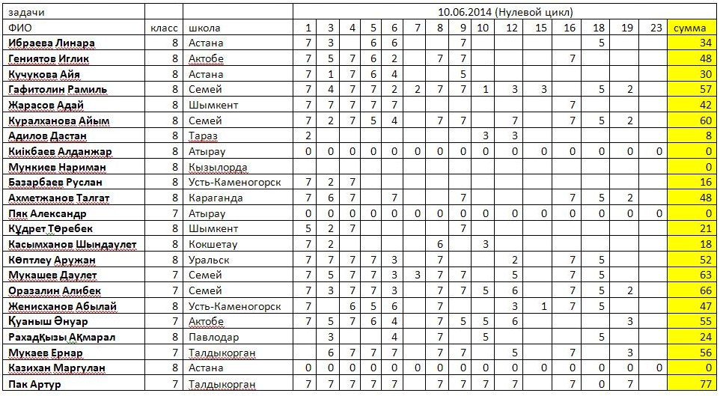

The table below illustrates the total points.

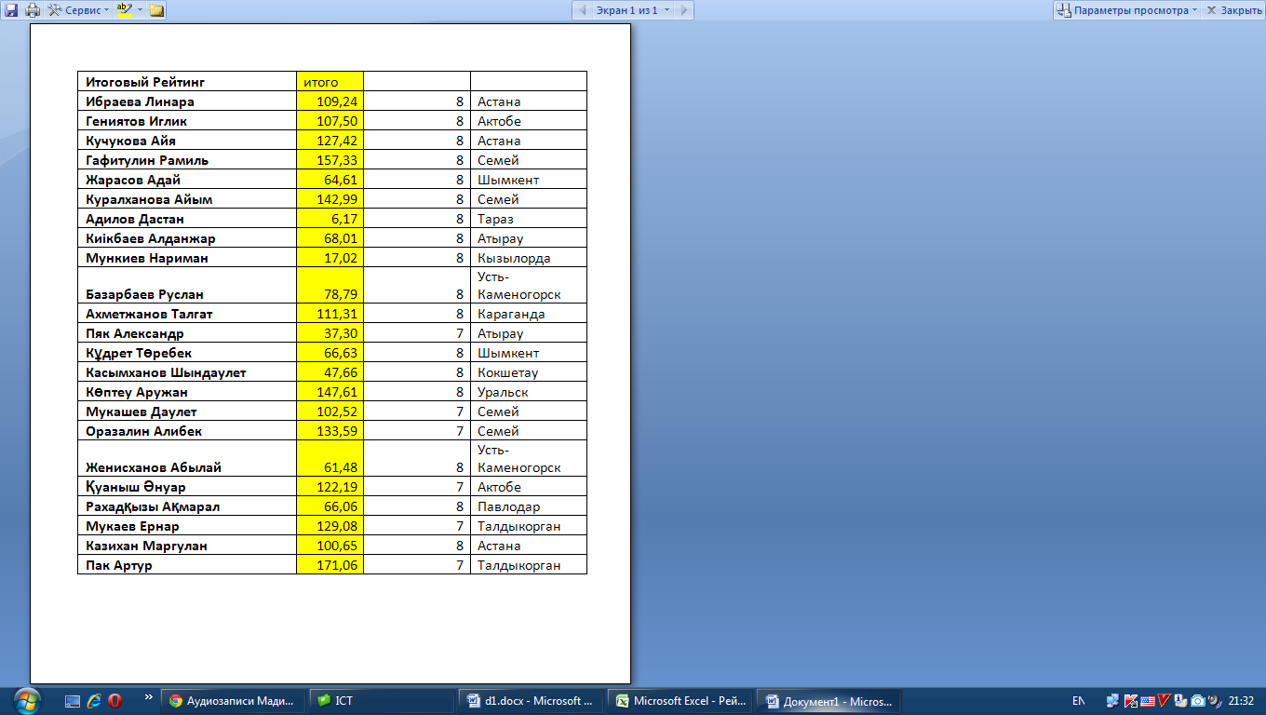

# INVESTIGATION

## Interview:

To learn more about current system and how it works, client was interviewed. There were questions about details in current system and requirements to new system. Mr. Polyanskih gave answers to questions below.

Question 1: Were name list of students come from?

*At the beginning of academic year teachers in math in NIS schools send me name list of students who want to participate in competitions in math. This name list contains names of students, their grades and city where the student studies.*

Question 2: How do you set points? Which criteria do you use?

*I send the lecture and problems to each student in edmodo.com. Edmodo.com is the web site where teachers can work with students in the internet. Then every student sends me problem solutions before deadline. After deadline they cannot send. I check works. Each problem is worth a maximum of 7 points. If solution is right I set 7 points, if solution is right but has mistakes or if solution has important details, I set 6-5 points.*

Question3: Do you work alone?

*Sometimes I work with other teachers.*

Question 4: Is the data checked after entering?

*I try not to make mistakes and check the points after each student’s line, where I set points, was filled. But if I did mistake, students can ask me to recheck the solution.*

Question 6: Where does the data stored?

*The data is stored in my laptop and printed on papers and stored in archive in my room.*

Question 7: Do you use any security methods?

*I don’t use any security methods. Unfortunately, all data is in my laptop, everyone can open it.*

Question 8: Is there backups of the data?

*As I said there are only word documents on my laptop and printed versions.*

Question 9: What do you do with points after checking?

*I send table with points for the lecture and the total scores (rating) to edmodo.com to all students after each lecture.*

Question 10: Why do you do the rating?

*I decide who will participate in competitions with this rating. Students who earned most points will take a part in competitions.*

Question 11: What are the problems of the current system?

*The first problem is calculations. I do all calculations manually. The second problem is security. As I said, I do not use any security methods.*

Question 12: Do you have any requirements?

*The new system should solve problems of the currents system. There should be security methods. All calculations should be done automatically. And one more thing, I wish that the data was stored in the internet, because if my laptop was broken, I might lose all my documents.*

Question 13: Do you have any ideas for new outputs?

*Yes, I have. It would be good to output average points and overage productivity in percent.*

Question 14: Did you search software which can solve your problems in shop?

*No, I didn’t. I had not got time for it.*

## Collecting existing documents:

To know more about the current system, documents were collected.

|  |  |  |
| --- | --- | --- |
| **Ф. И. (Name)** | **Класс (Grade)** | **Город (city)** |
| Кучукова Айя | 8 | Астана |
| Ибраева Линара | 8 | Астана |
| Казихан Маргулан | 8 | Астана |

The table below is the name list which came from Astana.

This is the table for points for one lecture.

- The number of problems

- Total points

- Points for problems

- Information about student (name, grade, city)

- Topic

|  |  |  |  |  |  |  |  |  |  |  |  |  |  |  |  |  |  |  |
| --- | --- | --- | --- | --- | --- | --- | --- | --- | --- | --- | --- | --- | --- | --- | --- | --- | --- | --- |
| (Name)  ФИО | (grade)  класс | (city)  город | 10.06.2014 (Нулевой цикл) (The date and the name of the lecture) | | | | | | | | | | | | | | | |
| 1 | 3 | 4 | 5 | 6 | 7 | 8 | 9 | 10 | 12 | 15 | 16 | 18 | 19 | 23 | сумма |
| **Ибраева Линара** | 8 | Астана | 7 | 3 |  | 6 | 6 |  |  | 7 |  |  |  |  | 5 |  |  | 34 |
| **Кучукова Айя** | 8 | Астана | 7 | 1 | 7 | 6 | 4 |  |  | 5 |  |  |  |  |  |  |  | 30 |
| **Гафитолин Рамиль** | 8 | Семей | 7 | 4 | 7 | 7 | 2 | 2 | 7 | 7 | 1 | 3 | 3 |  | 5 | 2 |  | 57 |
| **Жарасов Адай** | 8 | Шымкент | 7 | 7 | 7 | 7 | 7 |  |  |  |  |  |  | 7 |  |  |  | 42 |
| **Куралханова Айым** | 8 | Семей | 7 | 2 | 7 | 5 | 4 |  | 7 | 7 |  | 7 |  | 7 | 5 | 2 |  | 60 |
| **Адилов Дастан** | 8 | Тараз | 2 |  |  |  |  |  |  |  | 3 | 3 |  |  |  |  |  | 8 |
| **Киiкбаев Алданжар** | 8 | Атырау | 0 | 0 | 0 | 0 | 0 | 0 | 0 | 0 | 0 | 0 | 0 | 0 | 0 | 0 | 0 | 0 |
| **Мункиев Нариман** | 8 | Кызылорда |  |  |  |  |  |  |  |  |  |  |  |  |  |  |  | 0 |
| **Базарбаев Руслан** | 8 | Усть-Каменогорск | 7 | 2 | 7 |  |  |  |  |  |  |  |  |  |  |  |  | 16 |
| **Ахметжанов Талгат** | 8 | Караганда | 7 | 6 | 7 |  | 7 |  |  | 7 |  |  |  | 7 | 5 | 2 |  | 48 |
| **Пяк Александр** | 7 | Атырау | 0 | 0 | 0 | 0 | 0 | 0 | 0 | 0 | 0 | 0 | 0 | 0 | 0 | 0 | 0 | 0 |
| **Кұдрет Төребек** | 8 | Шымкент | 5 | 2 | 7 |  |  |  |  | 7 |  |  |  |  |  |  |  | 21 |
| **Касымханов Шындаулет** | 8 | Кокшетау | 7 | 2 |  |  |  |  | 6 |  | 3 |  |  |  |  |  |  | 18 |
| **Көптлеу Аружан** | 8 | Уральск | 7 | 7 | 7 | 7 | 3 |  | 7 |  |  | 2 |  | 7 | 5 |  |  | 52 |
| **Мукашев Даулет** | 7 | Семей | 7 | 5 | 7 | 7 | 3 | 3 | 7 | 7 |  | 5 |  | 7 | 5 |  |  | 63 |
| **Оразалин Алибек** | 7 | Семей | 7 | 3 | 7 | 7 | 3 |  | 7 | 7 | 5 | 6 |  | 7 | 5 | 2 |  | 66 |
| **Қуаныш Әнуар** | 7 | Актобе | 7 | 5 | 7 | 6 | 4 |  | 7 | 5 | 5 | 6 |  |  |  | 3 |  | 55 |
| **Рахадқызы Ақмарал** | 8 | Павлодар |  | 3 |  |  | 4 |  | 7 |  | 5 |  |  |  | 5 |  |  | 24 |
| **Мукаев Ернар** | 7 | Талдыкорган |  | 6 | 7 | 7 | 7 |  | 7 | 7 |  | 5 |  | 7 |  | 3 |  | 56 |
| **Казихан Маргулан** | 8 | Астана | 0 | 0 | 0 | 0 | 0 | 0 | 0 | 0 | 0 | 0 | 0 | 0 | 0 | 0 | 0 | 0 |
| **Пак Артур** | 7 | Талдыкорган | 7 | 7 | 7 | 7 | 7 |  | 7 | 7 | 7 | 7 |  | 7 | 0 | 7 |  | 77 |
|  |  |  |  |  |  |  |  |  |  |  |  |  |  |  |  |  |  |  |

The table below is the final rating.

|  |  |
| --- | --- |
| **Имя (Name)** | **Итого (total)** |
| **Ибраева Линара** | 109,24 |
| **Гениятов Иглик** | 107,50 |
| **Кучукова Айя** | 127,42 |
| **Гафитулин Рамиль** | 157,33 |
| **Жарасов Адай** | 64,61 |
| **Куралханова Айым** | 142,99 |
| **Адилов Дастан** | 6,17 |
| **Киiкбаев Алданжар** | 68,01 |
| **Мункиев Нариман** | 17,02 |
| **Базарбаев Руслан** | 78,79 |
| **Ахметжанов Талгат** | 111,31 |
| **Пяк Александр** | 37,30 |
| **Кұдрет Төребек** | 66,63 |
| **Касымханов Шындаулет** | 47,66 |
| **Көптеу Аружан** | 147,61 |
| **Мукашев Даулет** | 102,52 |
| **Оразалин Алибек** | 133,59 |
| **Женисханов Абылай** | 61,48 |
| **Қуаныш Әнуар** | 122,19 |
| **Рахадқызы Ақмарал** | 66,06 |
| **Мукаев Ернар** | 129,08 |
| **Казихан Маргулан** | 100,65 |
| **Пак Артур** | 171,06 |

# ANALYSIS

## Flow chart:

The data is saved

End

Right?

The mistake are corrected

Yes

No

Start

The name list comes

The lecture and problems are sent

Students solve the problems and send

Solutions are checked

The results are entered to the data

All points are added to the total rating

The calculations are checked

## Data flow diagram:

Give place

Points for the lecture

Name list

Approved

Mark

Solutions

Marks

Final rating

## Data capture methods

How is the data captured?

At the beginning of academic year, Mr. Polyanskih writes a letter to each school’s e-mail to request name list of students who are the best in math. Then NIS schools send name lists to Mr. Polyanskih’s e-mail.

How is the data processed?

Every student joins to the group in edmodo.com. Then Mr. Polyanskih sends problems to edmodo.com to students every week, and students send solutions. The name list is entered to table where Mr. Polyanskih sets points. Sent solutions are checked and marked. Marks are entered to the table for lecture. Then total points for lecture are added to the final rating.

What works well/does not work well?

An advantage of the current system is that edmodo.com is used. Mr. Polyanskih can communicate and evaluate student’s work in edmodo.com. He does not need to send lecture and problems to each student’s e-mail with this web site. Another advantage is that the data is stored in computer. It is easy to correct mistakes in computer and it is better to work with computer than with papers.

The disadvantage of the current system is that all calculations are done manually. Mistakes may be done. Absence of security is another disadvantage. There are not any passwords to enter the computer and open the data.

Inputs>outputs:

Inputs:

* Name
* Grade
* City
* Topic
* Points

Outputs:

* Total points for each topic
* Total points for all topics

Where/how is the data stored?

The data is stored in Mr. Polyanskih’s laptop hard drive which is always with him. There are not any password and login to enter the computer.

## Alternative approaches

Off the shelf:

Off the shelf software is Microsoft Access, because all calculations are done automatically in Access. There are operations such as: doing connection between tables, search, doing reports, making query. Sometimes Mr. Polyanskih needs to choose some students who have the most points to send them to competition. So, Access can choose group of students, who have the most points, according to client’s query. Access is one of the most useful softwares. In addition, the client has Microsoft Access in his laptop. My client has Word also. We can do new system in word as my client did, however, Word cannot do automatically calculations and there is not ability to connect tables.

Adapting current software:

Delphi is for adapting current software. Security method will be done with Delphi. Those are login and password, adding new user, changing login and password. There will be operation adding new user, because the client may work with other teachers. The client does not need to buy software, because I have Delphi in my computer. The security is easy to adapt. So, this method saves money and time, and we decided to use it.

Creating custom software:

I have not skills to create new software. Creating custom software will take too much time. It will be difficult to create security program. It will be better to just adapt current software. That is why we do not use this method.

## User requirements

The requirements were created according to interview and existing documents. These requirements were discussed with the client and agreed with him.

* Inputs:

The new system should be so that the client could input information: names of students, cities, grade, points and topic.

* Producing:

The new system should automatically calculate average productivity in percent for all topics.

* Search:

My client wishes that there was opportunity to search name of student and the topic.

* Interface:

There should be understandable and easy interface. Forms should have texts, which my client can read.

* Adding new records:

There should be opportunity to add new records such as information about new student, the topic of new lecture.

* Navigation:

The new system should be able to navigate through the data to see result.

* Edit/delete:

There should be ability to edit the results, because there may be done mistakes. Also, the new system should have function to delete records.

* Operating system:

There is windows operating system in my client’s laptop; therefore, the new system should run on windows.

* Report:

The new system should be able to do report of final rating with calculation of productivity.

Agreement with user requirements is shown below.

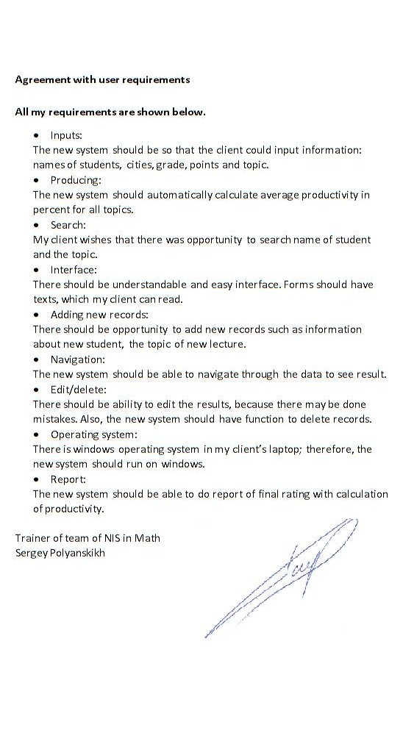

## Software and hardware requirements

Software requirements:

|  |  |
| --- | --- |
| **Software requirement** | **Reason** |
| Windows operating system | The new system will run on windows. My client and most of teachers use windows operating system. |
| Microsoft Access | The new system will have the data base in Access. |

Hardware requirements:

|  |  |  |
| --- | --- | --- |
|  | **Device** | **Function** |
| Input devices | Keyboard | To enter text and numbers to the data |
|  | Laser mouse | To click buttons and control the data |
| Output devices | Monitor | To show the data and other information |
|  | Printer | To print reports |
| Storage | Internal hard drive | To save the data in laptop |
| Processing | Processor | To run the new system |

# DESIGN

## Objectives of the data

The objectives were discussed with the client. The evidence of agreement is in page 14 and 106.

* Use understandable and easy interface to show forms and the data.
* Provide operations such as adding records, deleting, editing.
* Do automatic storage.
* Create the data without duplication. There were many repetitions of the data in the current system, and my client had to write the data more times.
* Use data verification and validation to avoid mistakes. There were too many mistakes because of absence validation in current system.
* Provide effective and fast system.
* Completely replace the current system with adding new operations and simplifying.
* Automatically calculate average productivity. In current system client had to do all calculations manually.
* Provide security method using login and password to enter the data. There were not security methods in current system, therefore the data was at risk.
* To be able to do reports. The current system had not this function.

## Entity relationship diagram

There will be three tables in the new system. They are name list of students, points and list of topics. Students table and points table have relation one-to-many, because one student has points in many topics. Topics table and points table have relation one-to-many, because one topic will be written for each student.

Topics

Students

Points

## Proposed record and data structure

Students table:

|  |  |  |  |  |  |
| --- | --- | --- | --- | --- | --- |
| **Field name** | **Type** | **Length** | **Validations** | **Description** | **Example** |
| StudentID  (primary key) | Auto number | 2 |  | Primary key | 1 |
| First name | text | 10 |  | First name of student | Elaman |
| Last name | text | 10 |  | First name of student | Nayzabekov |
| Grade | number | 2 | >=6 and <=12 | Grade of student | 11 |
| City | text | 10 | Look up wizard (list of cities) | City where student study | Taldykorgan |
| Telephone | text | 13 | Input mask  0000000000000 | Student’s phone number | 87055695918 |
| E-mail | text | 25 | Like "*@*.*" | E-mail address of student | 97_dox@mail.ru |

Topics table:

|  |  |  |  |  |  |
| --- | --- | --- | --- | --- | --- |
| **Field name** | **Type** | **Length** | **Validations** | **Description** | **Example** |
| TopicID  (primary key) | Auto number | 4 |  | Primary key | 3 |
| Topic | text | 30 |  | Name of topic | Divisibility |
| Date of giving | Date/time | 10 |  | Date when the topic is given | 10.09.2014 |
| Deadline | Date/time | 10 |  | Date of deadline | 15.09.2014 |

Points table:

|  |  |  |  |  |  |
| --- | --- | --- | --- | --- | --- |
| **Field name** | **Type** | **Length** | **Validations** | **Description** | **Example** |
| StudentID | Auto number | 2 | Look Up  Students table | Id of student | 2 |
| TopicID | Auto number | 4 | Look Up  Topics table | Id of topic | 23 |
| 1 | number | 1 | <=7 | Points for problem №1 | 4 |
| 2 | number | 1 | <=7 | Points for problem №2 | 7 |
| 3 | number | 1 | <=7 | Points for problem №3 | 0 |
| 4 | number | 1 | <=7 | Points for problem №4 | 1 |
| 5 | number | 1 | <=7 | Points for problem №5 | 2 |
| 6 | number | 1 | <=7 | Points for problem №6 | 5 |
| 7 | number | 1 | <=7 | Points for problem №7 | 0 |
| 8 | number | 1 | <=7 | Points for problem №8 | 6 |
| 9 | number | 1 | <=7 | Points for problem №9 | 3 |
| 10 | number | 1 | <=7 | Points for problem №10 | 4 |

## Data input forms

Data input forms are created to make ability to input for my client. The main requirement for input forms was friendly interface. So, there are some instructions in input forms.

The form below is data input form for Student’s information. There is buttons for adding, changing and deleting. These operations are made according to requirements of client. To use less forms, these operations are put in one form.

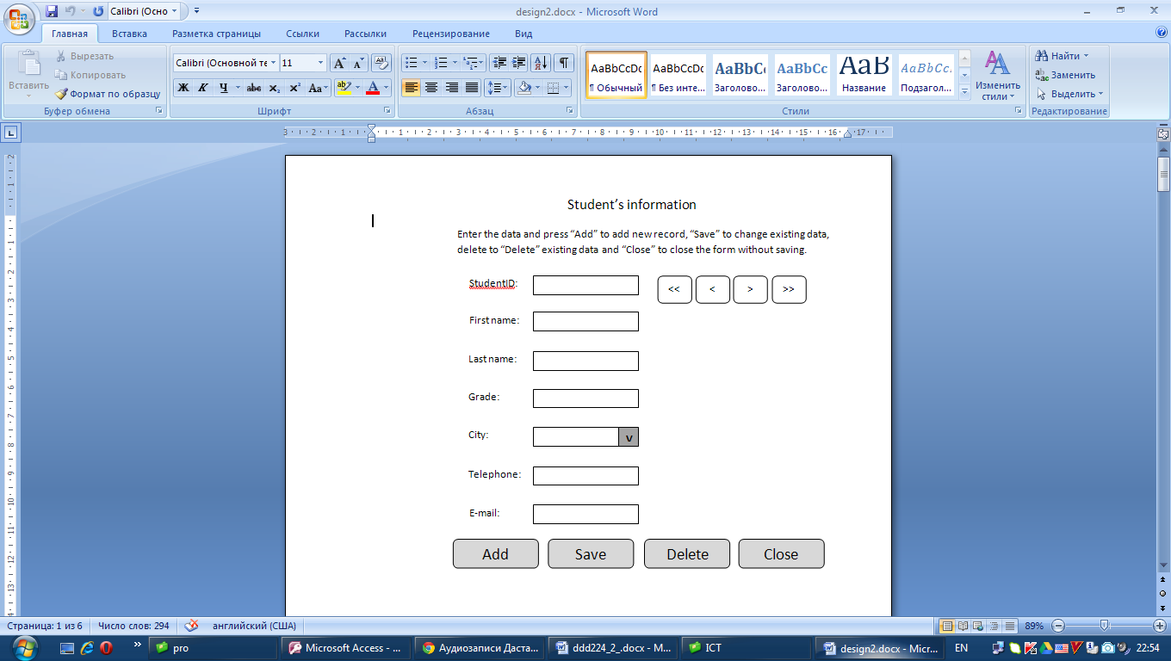

Short instruction of using

Shifting the ID

Input fields

Choosing from cities

Buttons for operations

Background

Color: blue

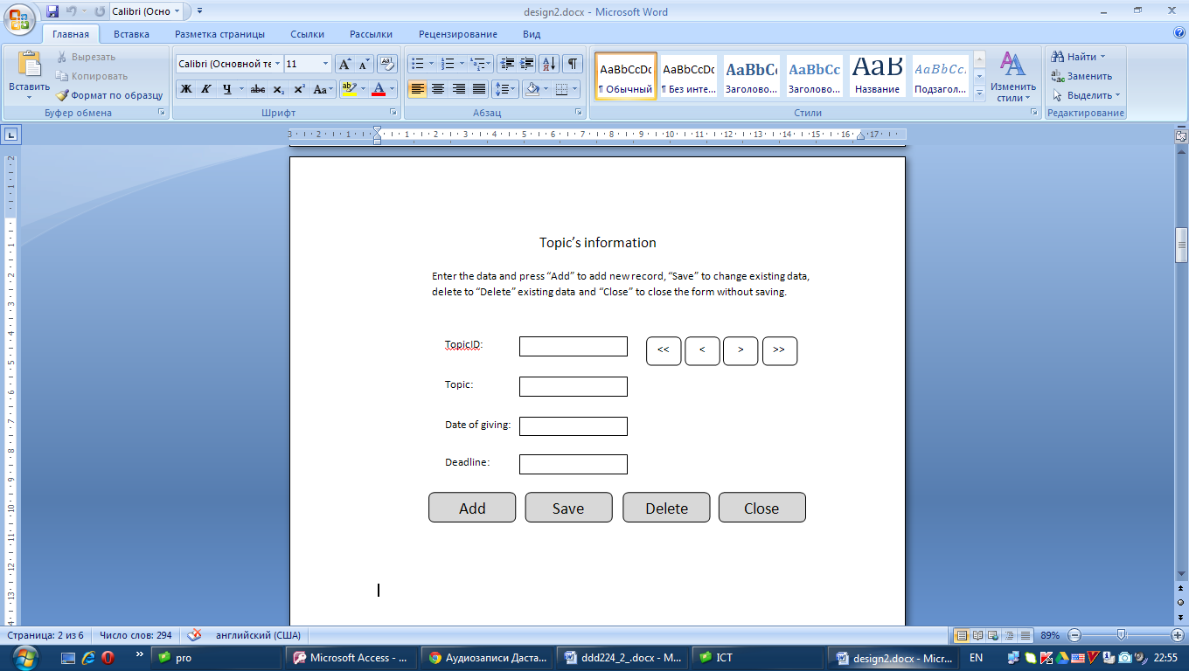The form below is for data input for topic’s information. This form is made as form for students information.

Short instruction of using

Buttons for operations

Shifting the ID

Input fields

Background

Color: blue

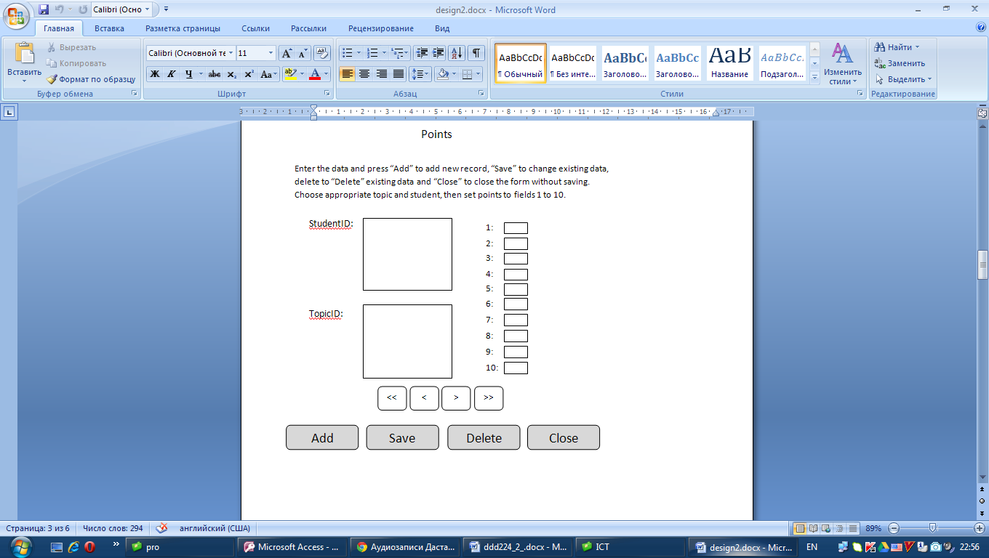The form below is input form for setting points.

Short instruction of using

Background

Color: blue

Look up

Input fields

Look up

Shifting the ID

Buttons for operations

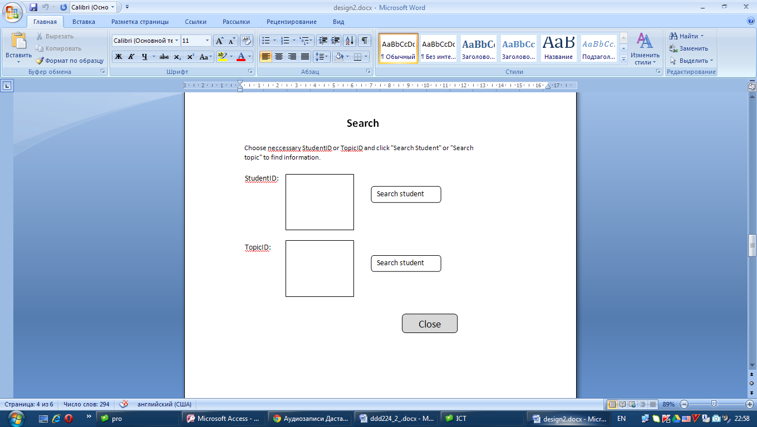This if search form:

Short instruction of using

Components for choosing the ID

Background

Color: blue

Button to close the form

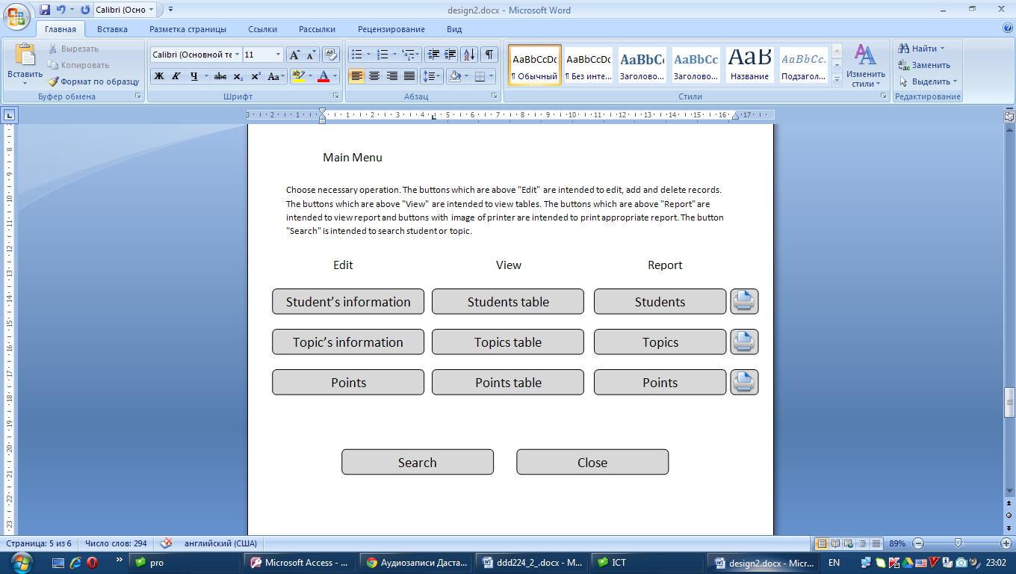Menu form design is illustrated below.

Short instruction of using

Background

Color: blue

Buttons for printing

Buttons

First of all, user should enter login and password to get access to the data base.

Short instruction of using

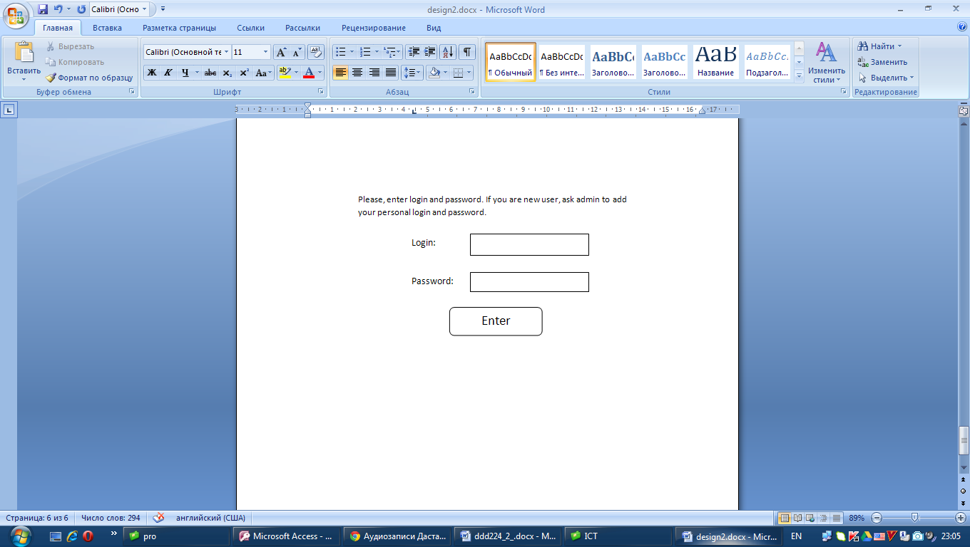

Fields for entering login and password

Button to log in

Background: image of page of notebook

There will be form for user settings.

There will be login of user

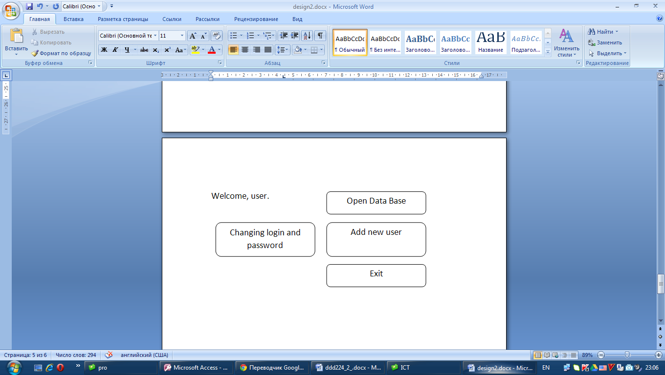

Background: image of page of notebook

## Data output forms

There should be report of all points for all students, according to client’s requirements.

Productivity, total/all points for each student in each topic

Points for problems 1-10

|  |  |  |  |  |  |
| --- | --- | --- | --- | --- | --- |
| StudentID | TopicID | 1 | … | 10 | Productivity, % |
|  |  |  |  |  |  |

Also, there should be report of list of students

Students report

|  |  |  |  |  |  |  |
| --- | --- | --- | --- | --- | --- | --- |
| **StudentID** | **First name** | **Last name** | **Grade** | **City** | **Telephone** | **E-mail** |
|  |  |  |  |  |  |  |

There should be report of list of topics

Topics report

|  |  |  |  |
| --- | --- | --- | --- |
| **TopicID** | **Topic** | **Date of giving** | **Deadline** |
|  |  |  |  |

## Data Flow Diagram

Give place

Points table

Name list

Approved

Mark

Solutions

Marks

Checking

Login and Password

Correct/incorrect

Topics table

Students table

## Flowchart

The new flowchart is similar to current flowchart. However, there is not need to check calculations, because calculations are done automatically.

Start

The name list comes

The lecture and problems are sent

Students solve the problems and send

Solutions are checked

Entering login and password

Are login and password correct?

Name list of students are added to with Input form student’s information

The results are entered to the data base

The data is saved

End

All points are added to the total rating

Yes

No

Name of topic are added to with Input form Topic’s information

Points are set with input form points

## Module design

According to client’s requirements, there should be four modules:

- Adding module

- Changing module

- Deleting module

- Viewing module

## Menu design

Menu

Edit

Student’s information

Adding module

Changing module

Deleting module

Adding module

Changing module

Deleting module

Topic’s information

Points

Adding module

Changing module

Deleting module

Close

Students

Topics

Points

Report

Search

View

Students table

Topics table

Points table

Viewing module

## Benefits and limitations

|  |  |
| --- | --- |
| Benefits | Limitations |
| Benefit from new system is that, all calculations are done automatically. My client will not need do calculations manually and check them after calculations. So, my client will not spend much time to calculations and checking.  Another benefit of new system is that, there is a security method, that is, user should enter login and password to get access to data base. It is to make sure that the data base will be in security and others cannot do harm to data base. | The system is not online. So, the system cannot be used by several users at the same time or the user cannot edit the records online. However, I used the online buck up. So the user can store the system folder manually in the online storage, after editing the records.  The system does not calculate the total amount of points, which was in the old system. However, the new system can calculate the productivity of each student. So, the user cannot see the total points, the user can only see the productivity. |

# DEVELOPMENT

## System design

Main Menu

Points

Search

Student’s information

Topic’s information

Points report

Search student

Students report

Topics report

Points query

Students search

Topics search

Points

Students

Topics

The rating system for math Olympiad

Forms

Reports

Queries

Tables

## Relationship

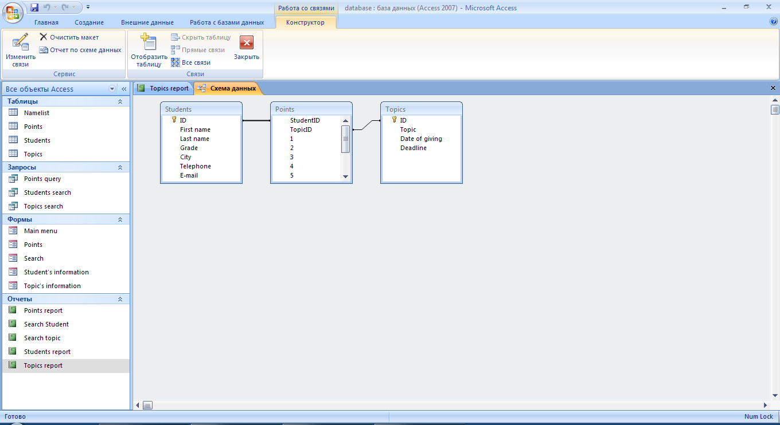

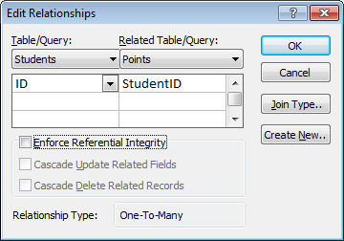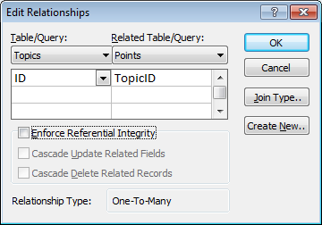

Tables Students and Points are connected with one to many relationship. The tables Topics and Points are connected with one to many relationship.

## System design

1. The first form with login and password was made in Delphi. This form is used for security methods. Form1:

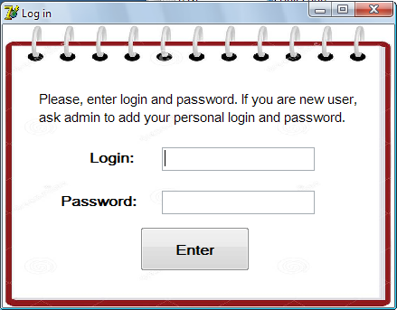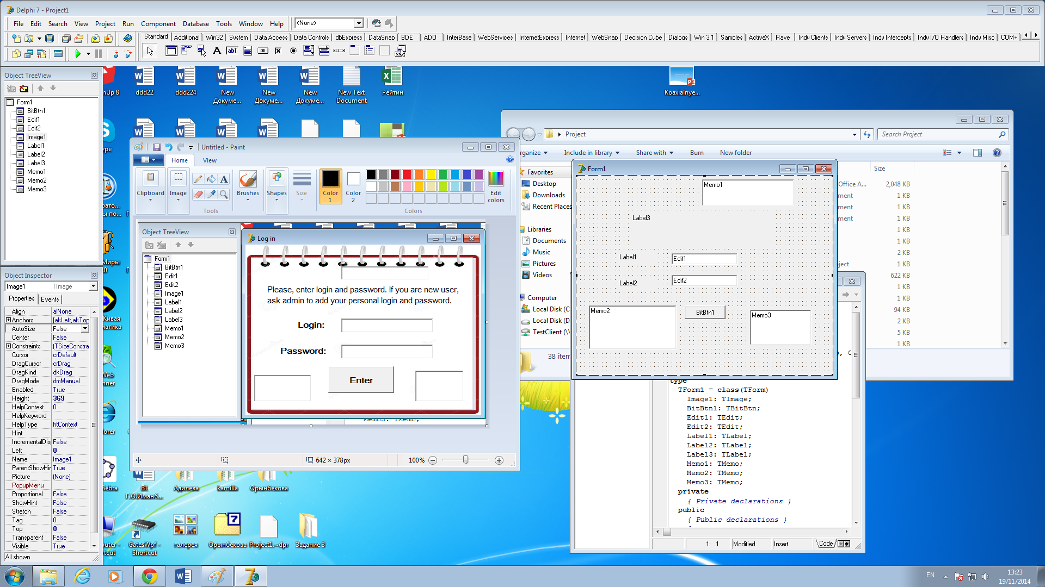

Form1:

* AutoSize: True
* Caption: Log in
* BorderStyle: bsSingle
* Position: poScreenCenter

Memo1, Memo2 and Memo3:

* Visible: False
* Lines: “ “

Label3:

* Caption: “Please, enter login and password. If you are new user, ask admin to add your personal login and password.”
* Height: 40
* Width: 356
* Font: @Arial Unicode MS, regular, 11
* Transparent: True
* WordWrap: True

Label1:

* Caption: “Login:”
* Height: 21
* Width: 49
* Font: @Arial Unicode MS, bold, 12
* Transparent: True

Label2:

* Caption: “Password:”
* Height: 21
* Width: 84
* Font: @Arial Unicode MS, bold, 12
* Transparent: True

Edit1:

* Height: 26
* Width: 169
* Font: @Arial Unicode MS, bold, 10
* Text: “ “

Edit2:

* Height: 26
* Width: 169
* Font: @Arial Unicode MS, bold, 10
* Text: “ “
* PasswordChar: “*”

BitBtn1:

* Caption: “Enter”
* Height: 49
* Width: 121
* Font: @Arial Unicode MS, bold, 12

Image1:

* Height: 313
* Width: 433
* Stretch: True
* Picture: image1

1. After entering correct entering login and password, Form2 will be opened.

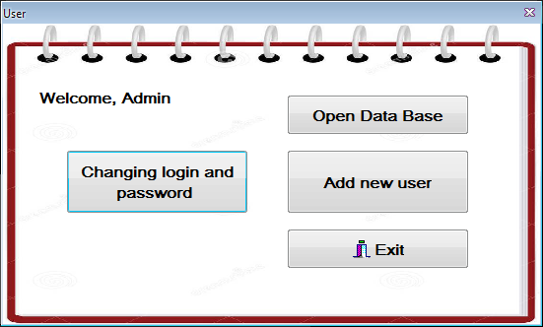

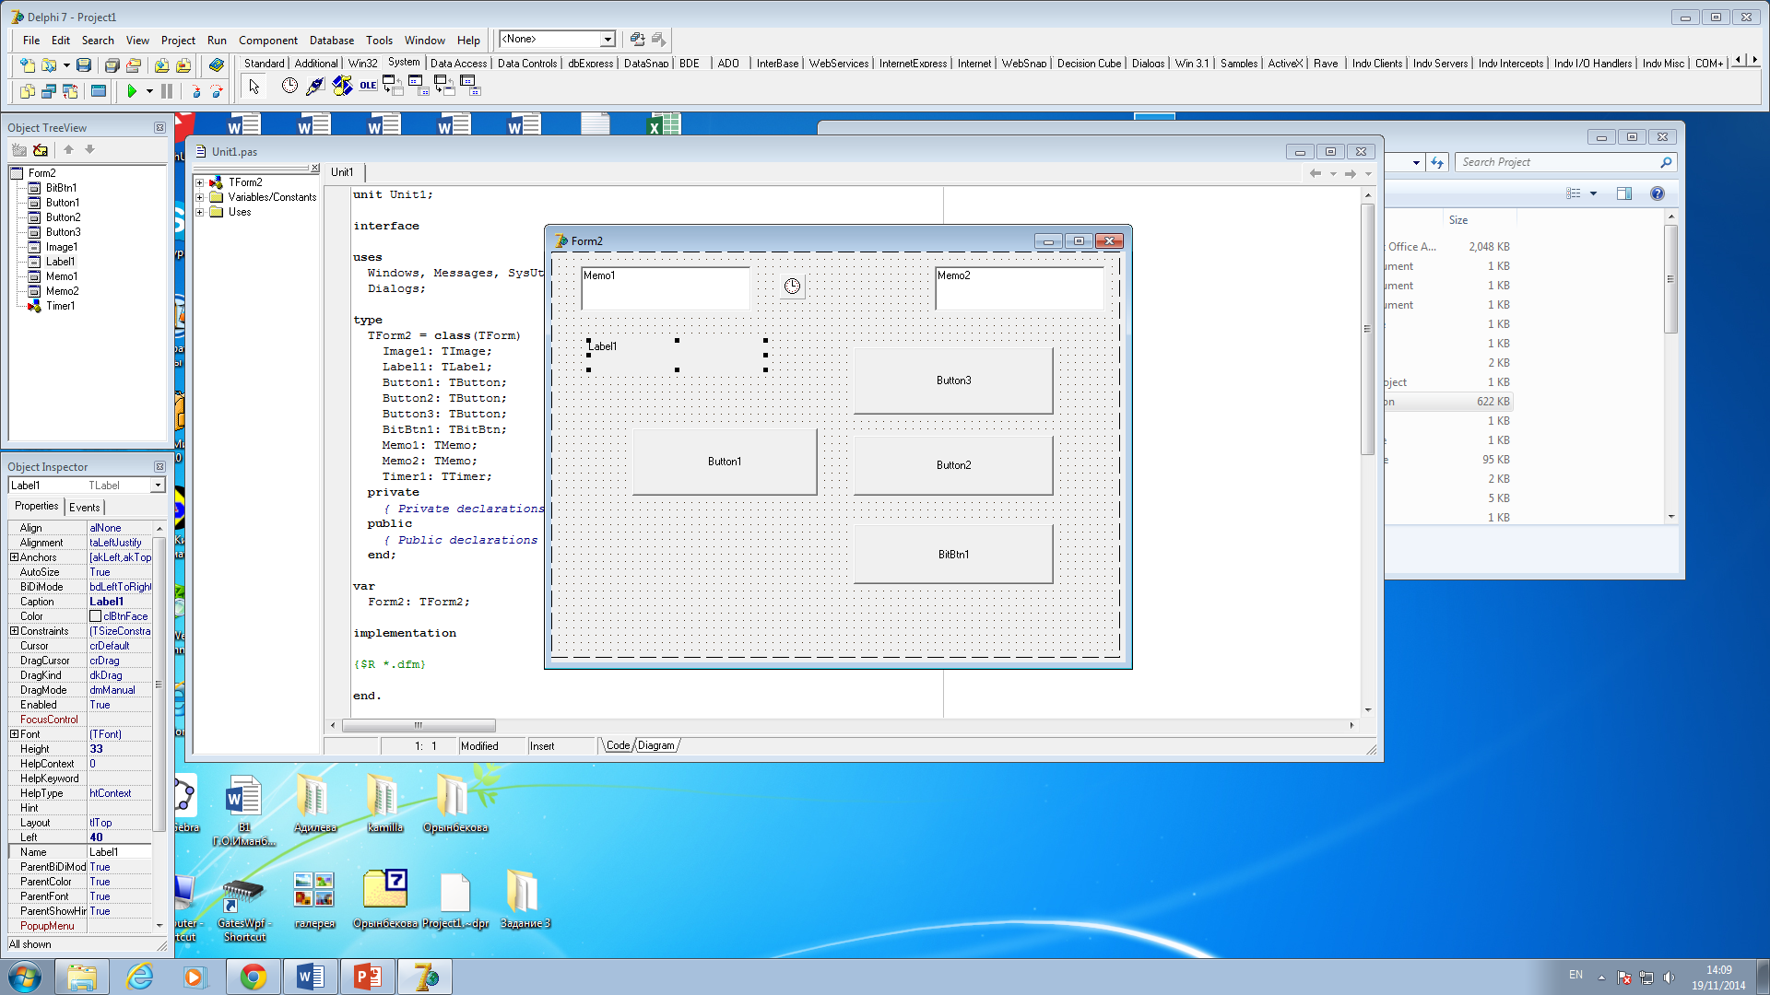

Form2:

* AutoSize: True
* Caption: User
* BorderStyle: bsToolWindow
* Position: poScreenCenter

Timer1:

* Interval: 100

Memo1 and Memo2:

* Visible: False
* Lines: “ “

Label1:

* Caption: “ ”
* Height: 21
* Width: 212
* Font: @Arial Unicode MS, bold, 12
* Transparent: True

Button3:

* Caption: “Open Data Base”
* Height: 41
* Width: 185
* Font: @Arial Unicode MS, bold, 12

Button1:

* Caption: “Changing login and password”
* Height: 65
* Width: 185
* Font: @Arial Unicode MS, bold, 12

Button2:

* Caption: “Add new user”
* Height: 65
* Width: 185
* Font: @Arial Unicode MS, bold, 12

BitBtn1:

* Caption: “Exit”
* Kind: bkClose
* Height: 41
* Width: 185
* Font: @Arial Unicode MS, bold, 12

Image1:

* Height: 305
* Width: 545
* Stretch: True
* Picture: image1

1. The form below was created for changing password and login of user. Form3:

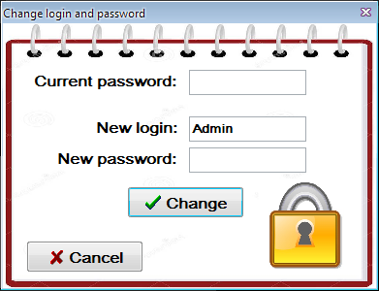

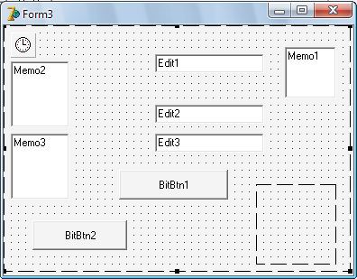

Form3:

* AutoSize: True
* Caption: Change login and password
* BorderStyle: bsToolWindow
* Position: poScreenCenter

Timer1:

* Interval: 100

Label1:

* Caption: “Current password:”
* Height: 21
* Width: 147
* Font: @Arial Unicode MS, bold, 12
* Transparent: True

Label2:

* Caption: “New login:”
* Height: 21
* Width: 84
* Font: @Arial Unicode MS, bold, 12
* Transparent: True

Label3:

* Caption: “New password:”
* Height: 21
* Width: 123
* Font: @Arial Unicode MS, bold, 12
* Transparent: True

Edit1:

* Height: 24
* Width: 121
* Font: @Arial Unicode MS, bold, 10
* Text: “ “
* PasswordChar: “*”

Edit2:

* Height: 24
* Width: 121
* Font: @Arial Unicode MS, bold, 10
* Text: “ “

Edit3:

* Height: 24
* Width: 121
* Font: @Arial Unicode MS, bold, 10
* Text: “ “
* PasswordChar: “*”

BitBtn1:

* Caption: “Change”
* Kind: bkOK
* Height: 33
* Width: 121
* Font: @Arial Unicode MS, bold, 12

BitBtn2:

* Caption: “Cancel”
* Kind: bkCancel
* Height: 33
* Width: 121
* Font: @Arial Unicode MS, bold, 12

Memo1, Memo2 and Memo3:

* Visible: False
* Lines: “ “

Image1:

* Height: 273
* Width: 385
* Stretch: True
* Picture: image1

Image1:

* Height: 97
* Width: 97
* Stretch: True
* Picture: image2

1. The form below is for registering new users. Form4:

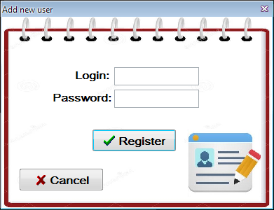

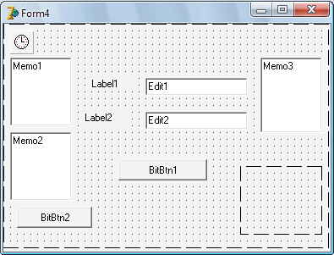

Form4:

* AutoSize: True
* Caption: Add new user
* BorderStyle: bsToolWindow
* Position: poScreenCenter

Timer1:

* Interval: 100

Label1:

* Caption: “Login:”
* Height: 21
* Width: 49
* Font: @Arial Unicode MS, bold, 12
* Transparent: True

Label1:

* Caption: “Password:”
* Height: 21
* Width: 84
* Font: @Arial Unicode MS, bold, 12
* Transparent: True

Edit1:

* Height: 24
* Width: 121
* Font: @Arial Unicode MS, bold, 10
* Text: “ “

Edit2:

* Height: 24
* Width: 121
* Font: @Arial Unicode MS, bold, 10
* Text: “ “
* PasswordChar: “*”

BitBtn1:

* Caption: “Register”
* Kind: bkOK
* Height: 33
* Width: 121
* Font: @Arial Unicode MS, bold, 12

BitBtn2:

* Caption: “Cancel”
* Kind: bkCancel
* Height: 33
* Width: 121
* Font: @Arial Unicode MS, bold, 12

Memo1 and Memo2:

* Visible: False
* Lines: “ “

Image1:

* Height: 273
* Width: 385
* Stretch: True
* Picture: image1

Image1:

* Height: 97
* Width: 105
* Stretch: True
* Picture: image3

Image1, Image2 and Image3 were made by using Photoshop, PowerPoint and Paint.

1. If the button “Open Data Base” was clicked, the Main menu in Access will be shown, as shown below.

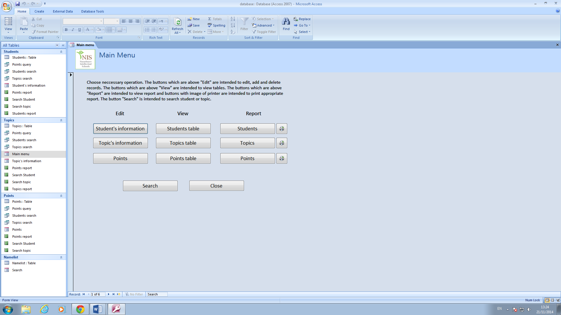

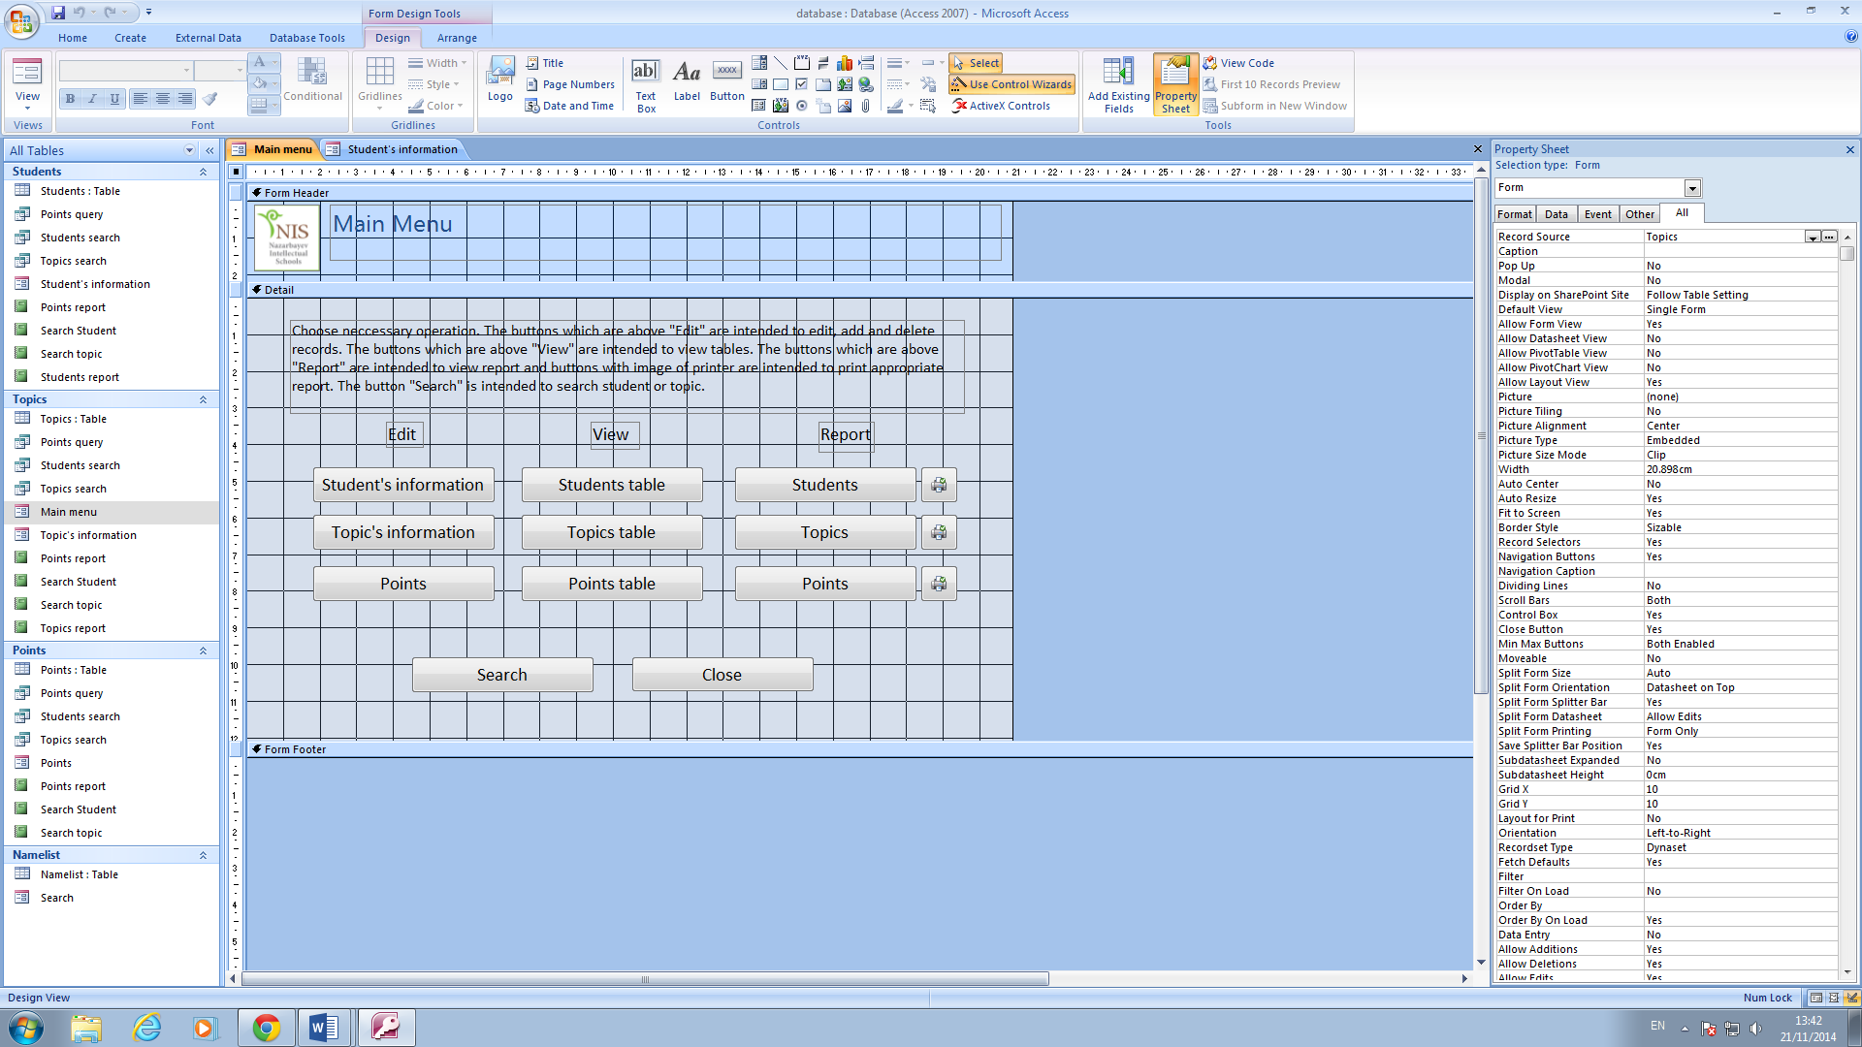

The Main Menu form contains buttons for editing records, viewing tables, doing reports and printing appropriate report. Also, there are buttons for searching and closing the data base. There is short instruction of using the Main menu form.

Buttons: Student’s information, Topic’s information, points, Students table, Topics table, Points table, Students, Topics, points, Search and Close:

* Height: 1cm
* Width: 5cm
* Font size: 14

Buttons with printer:

* Height: 1cm
* Width: 5cm
* Picture: printer

Label with sort instruction:

* Height: 2.54cm
* Width: 18.386cm
* Caption: “Choose necessary operation. The buttons which are above "Edit" are intended to edit, add and delete records. The buttons which are above "View" are intended to view tables. The buttons which are above "Report" are intended to view report and buttons with image of printer are intended to print appropriate report. The button "Search" is intended to search student or topic.”
* Font size: 12

Labels Edit, View and Report:

* Height: 1cm
* Width: 1cm
* Font size: 14

1. The input form Student’s information

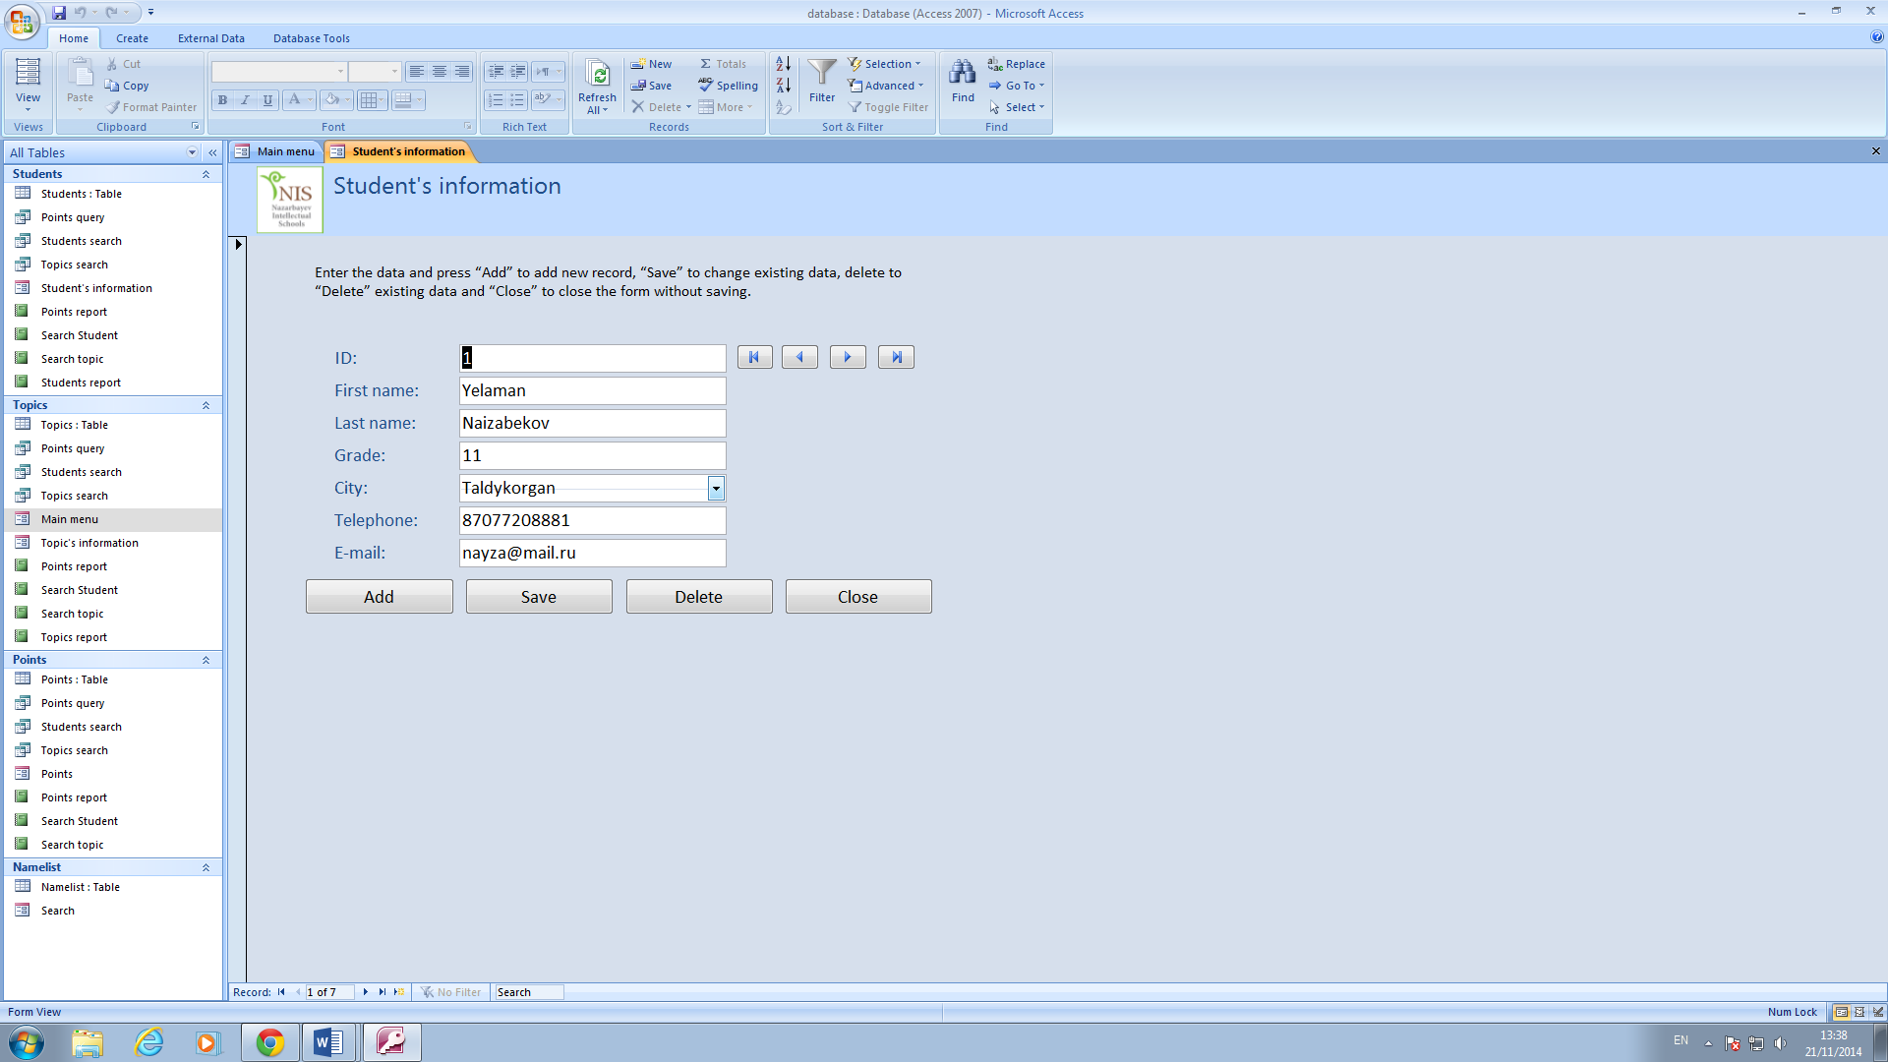

This input form is intended to edit, add or delete information about student.

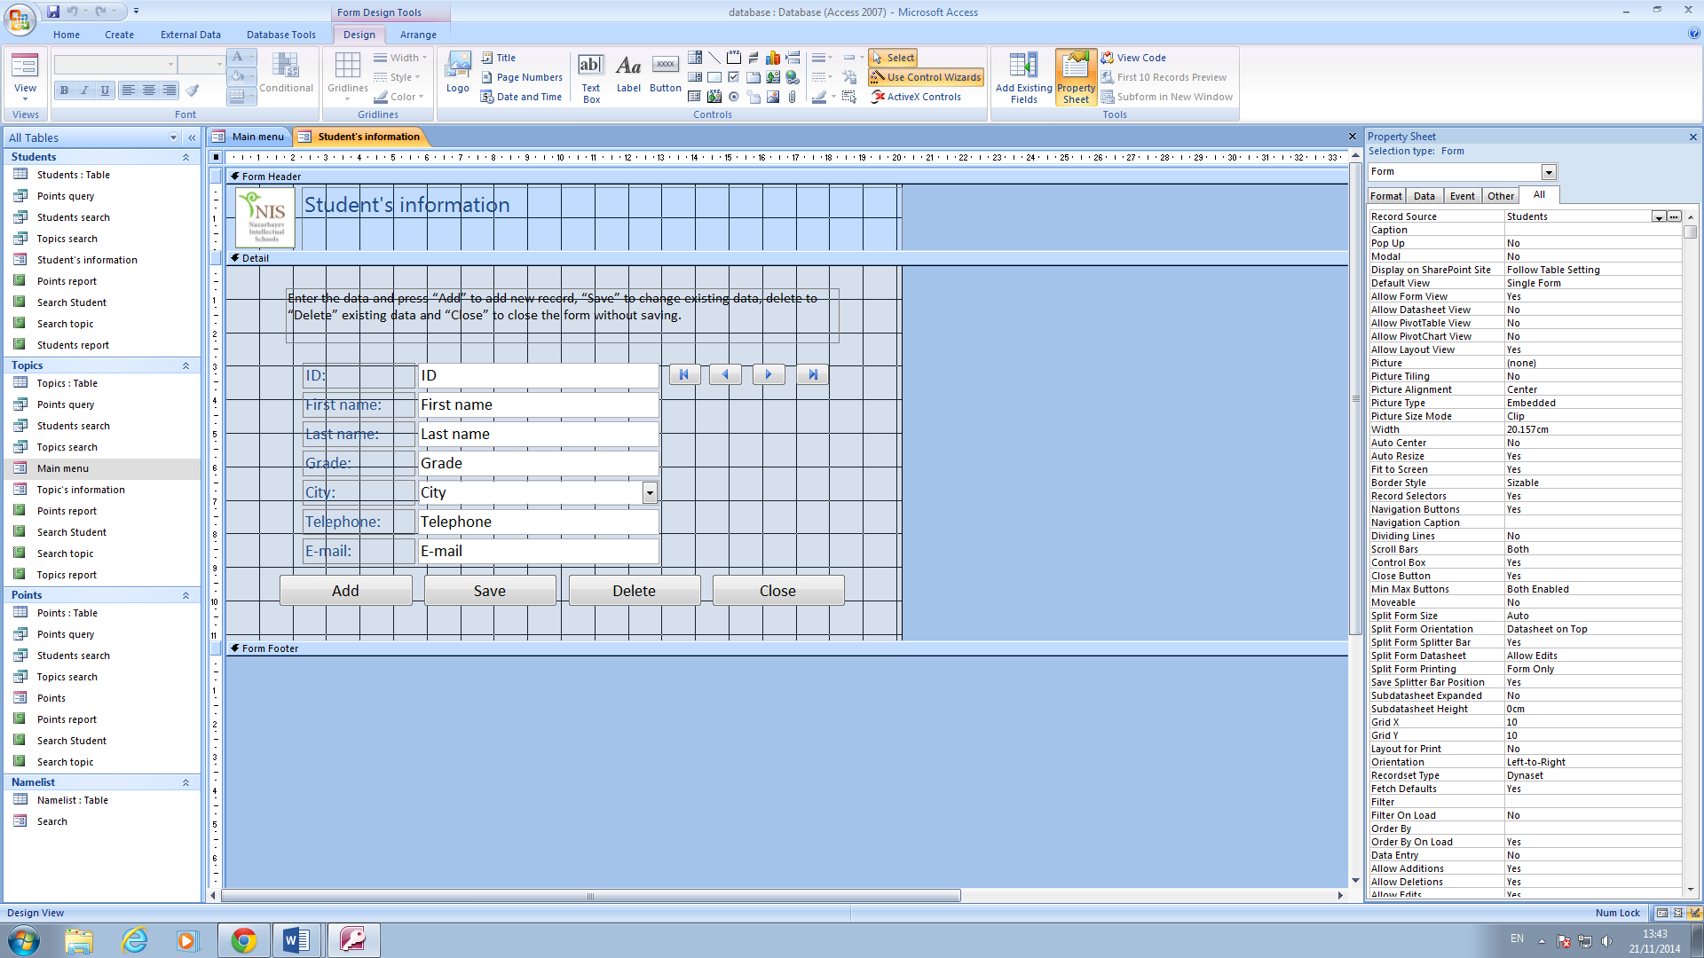

The buttons Add, Save, Delete and Close:

* Height: 1cm
* Width: 4cm
* Font size: 14

Input fields ID, First name, Last name, Grade, City, Telephone and e-mail:

* Height: 0.739cm
* Width: 7.169cm
* Font size: 14

The buttons (⏐<, <, >, >⏐)

* Height: 0.698cm
* Width: 1.016cm
* Picture: First record, Previous record, Next record, Last record.

Label with sort instruction:

* Height: 1.6cm
* Width: 16.481cm
* Caption: “Enter the data and press “Add” to add new record, “Save” to change existing data, delete to “Delete” existing data and “Close” to close the form without saving.”
* Font size: 12

1. The input form Topic’s information

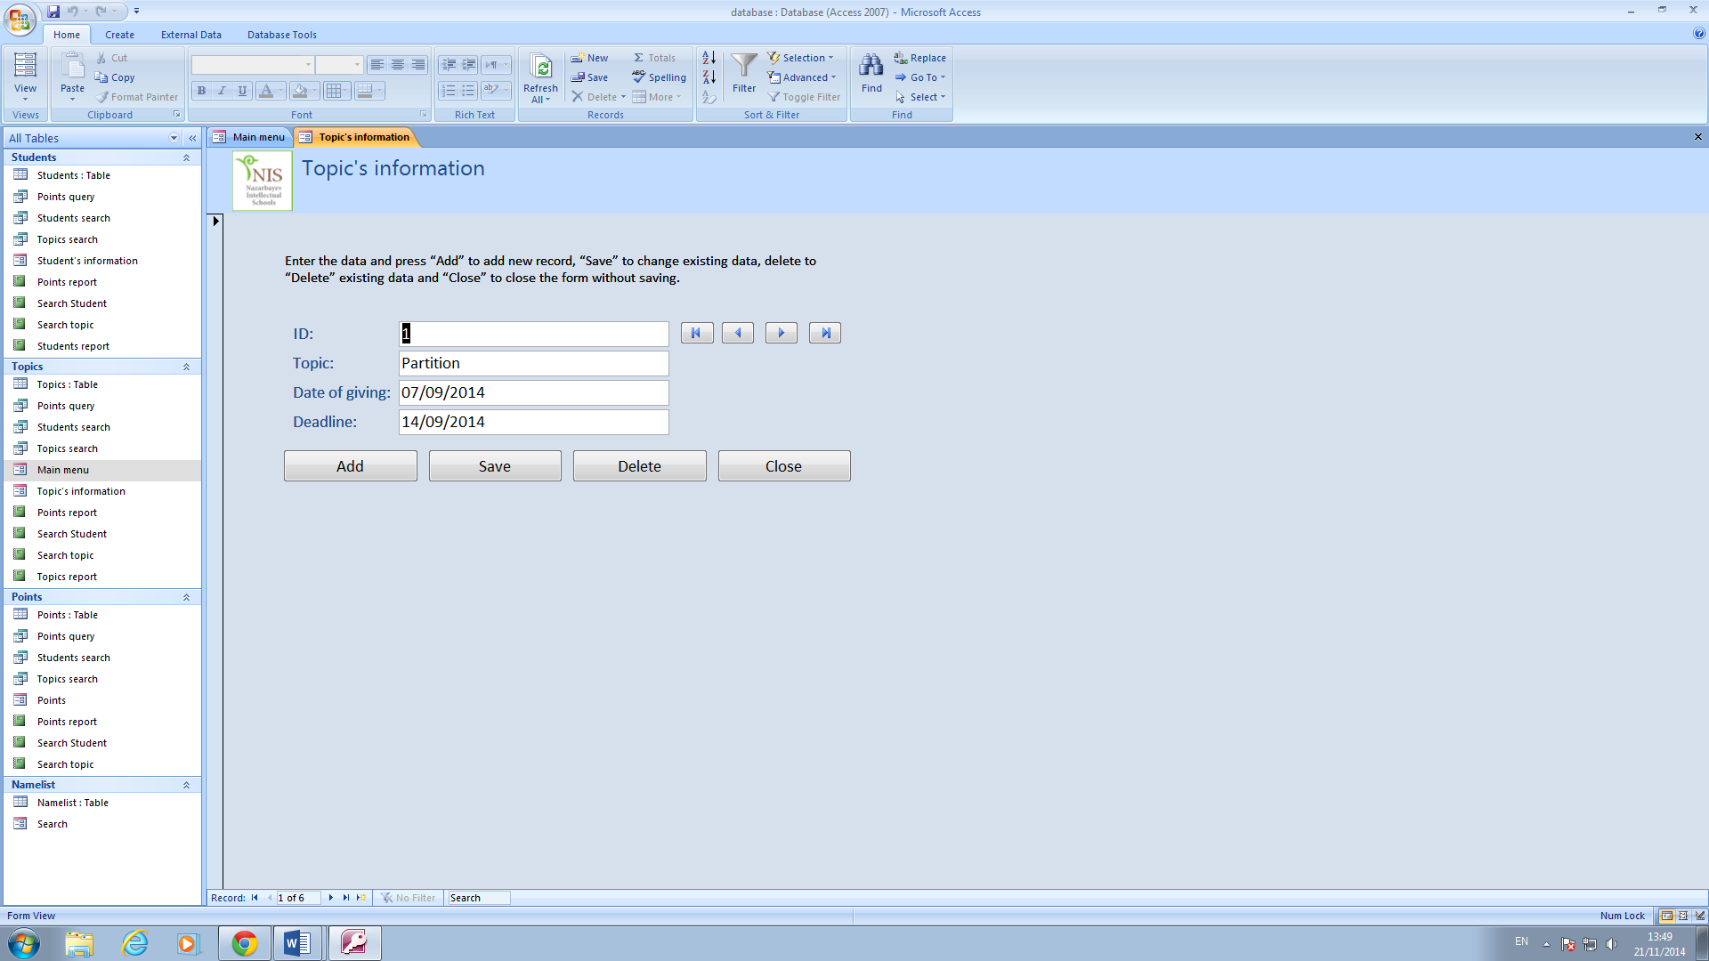

This input form is intended to edit, add or delete information about topic.

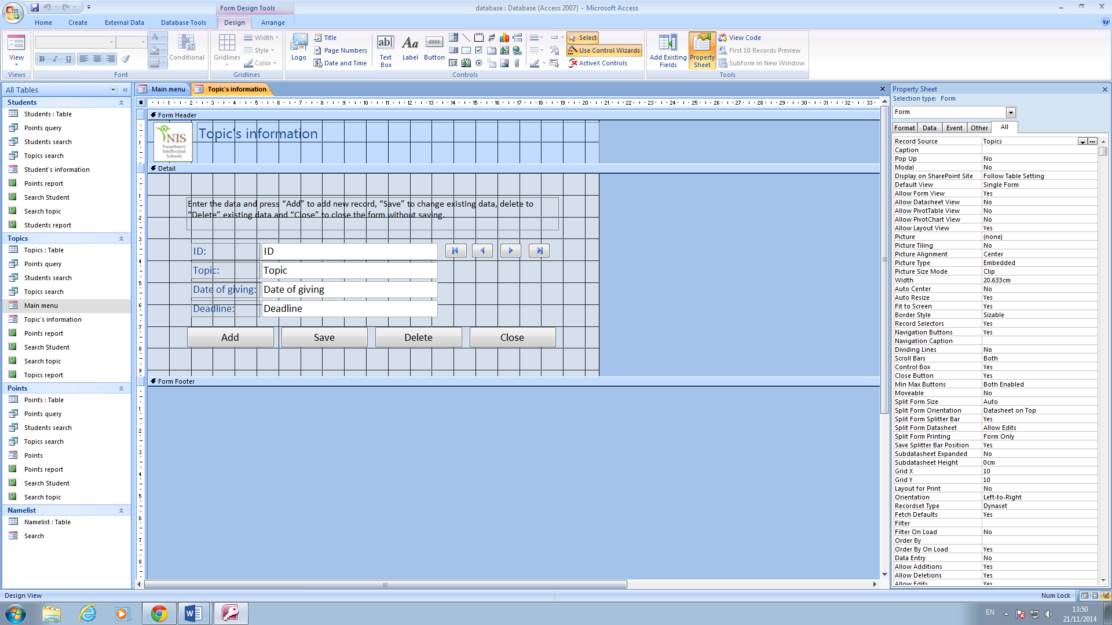

The buttons Add, Save, Delete and Close:

* Height: 1cm
* Width: 4cm
* Font size: 14

Input fields ID, Topic, Date of giving, Deadline:

* Height: 0.739cm
* Width: 8.016cm
* Font size: 14

The buttons (⏐<, <, >, >⏐)

* Height: 0.698cm
* Width: 1.016cm
* Picture: First record, Previous record, Next record, Last record.

Label with sort instruction:

* Height: 1.6cm
* Width: 16.481cm
* Caption: “Enter the data and press “Add” to add new record, “Save” to change existing data, delete to “Delete” existing data and “Close” to close the form without saving.”
* Font size: 12

1. The input form Points

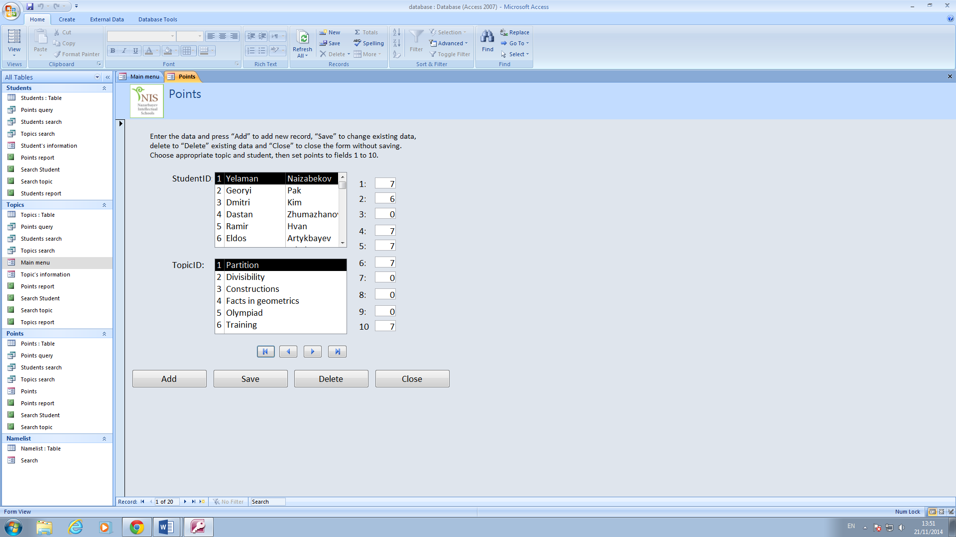

This form is intended to set points.

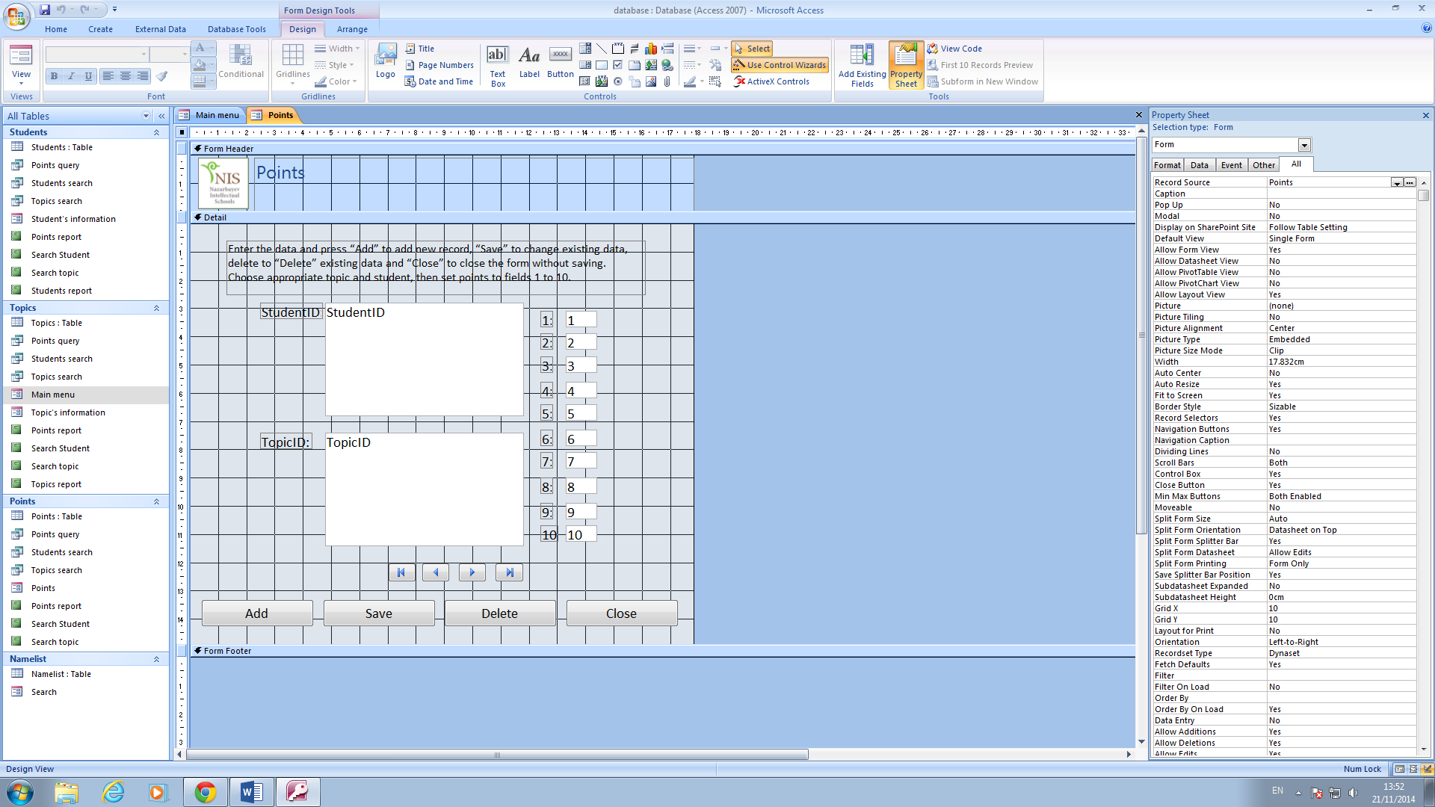

The buttons Add, Save, Delete and Close:

* Height: 1cm
* Width: 4cm
* Font size: 14

Input fields StudentID and TopicID:

* Height: 4cm
* Width: 7cm
* Font size: 14

The buttons (⏐<, <, >, >⏐)

* Height: 0.698cm
* Width: 1.016cm
* Picture: First record, Previous record, Next record, Last record.

Label with sort instruction:

* Height: 1.6cm
* Width: 16.481cm
* Caption: “Enter the data and press “Add” to add new record, “Save” to change existing data, delete to “Delete” existing data and “Close” to close the form without saving. Choose appropriate topic and student, then set points to fields 1 to 10.”
* Font size: 12

1. The form Search

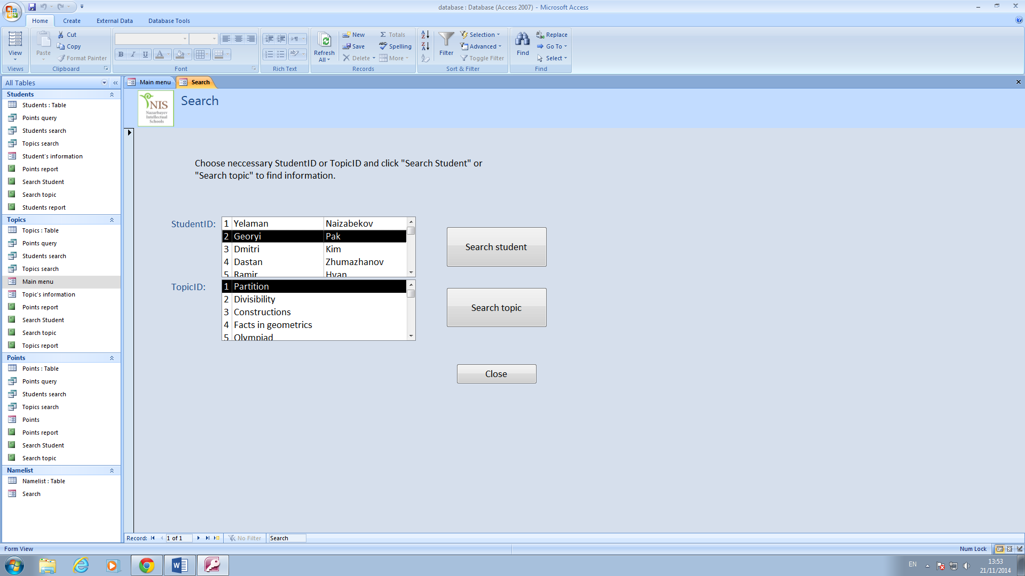

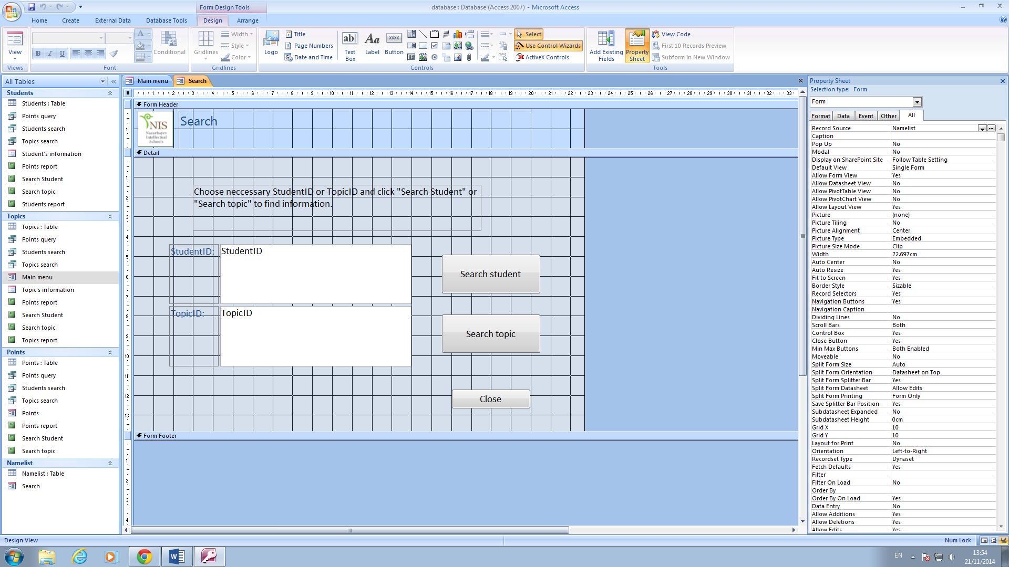

The button Close:

* Height: 1cm
* Width: 4cm
* Font size: 14

Input fields StudentID and TopicID:

* Height: 3cm
* Width: 9.603cm
* Font size: 14

The buttons Search student and Search topic:

* Height: 2cm
* Width: 5cm
* Font size: 14

1. The table Students. There is look up wizard for choosing city.

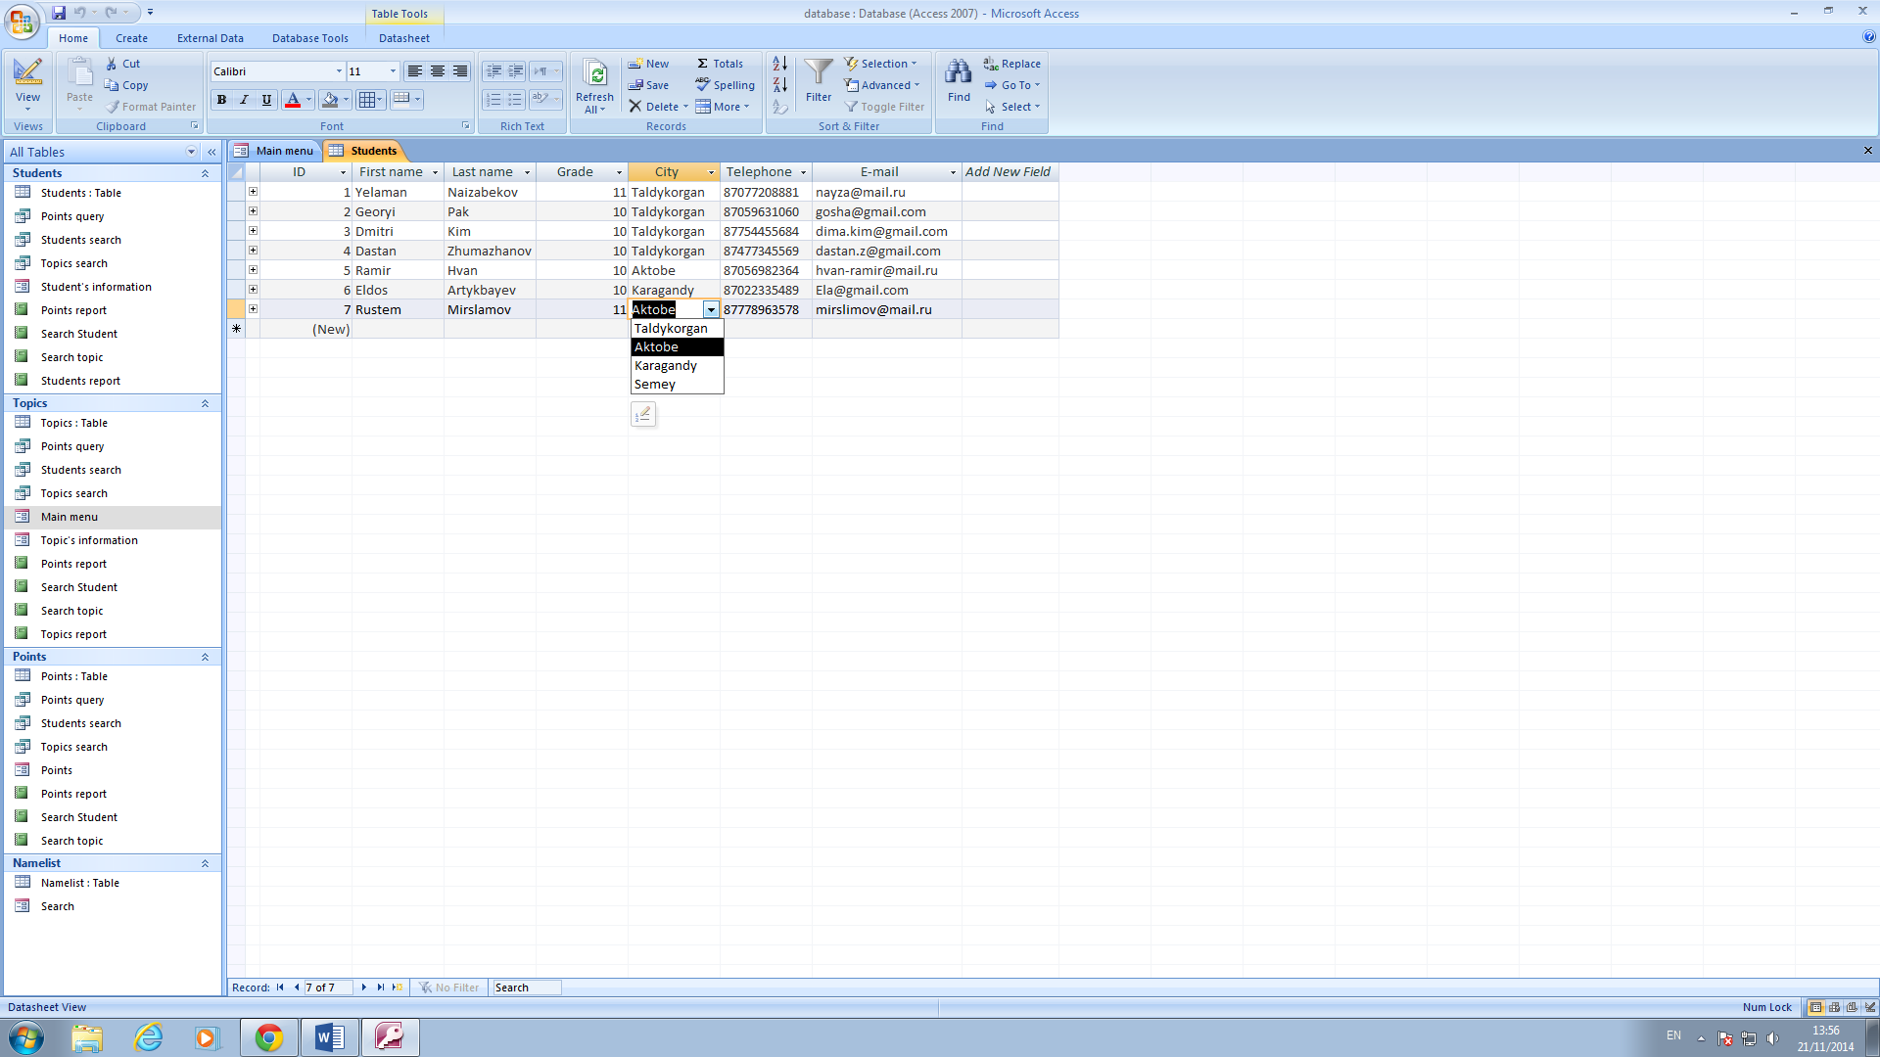

Names of fields and data types are shown below. There is primary key field “ID”.

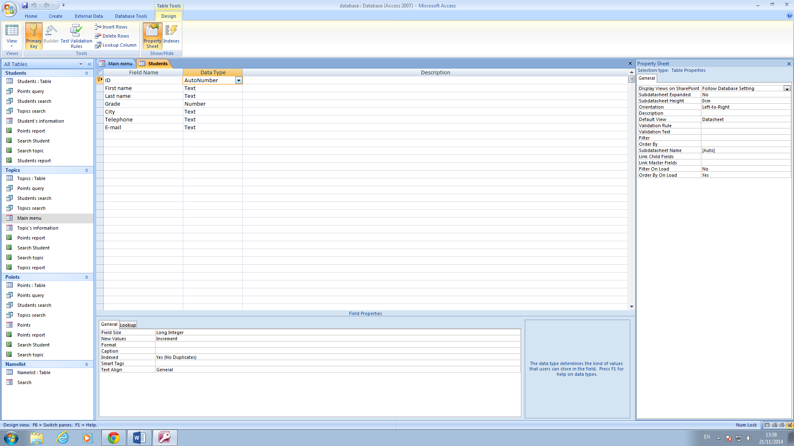

The field “Grade” has a validation rule as it is shown below

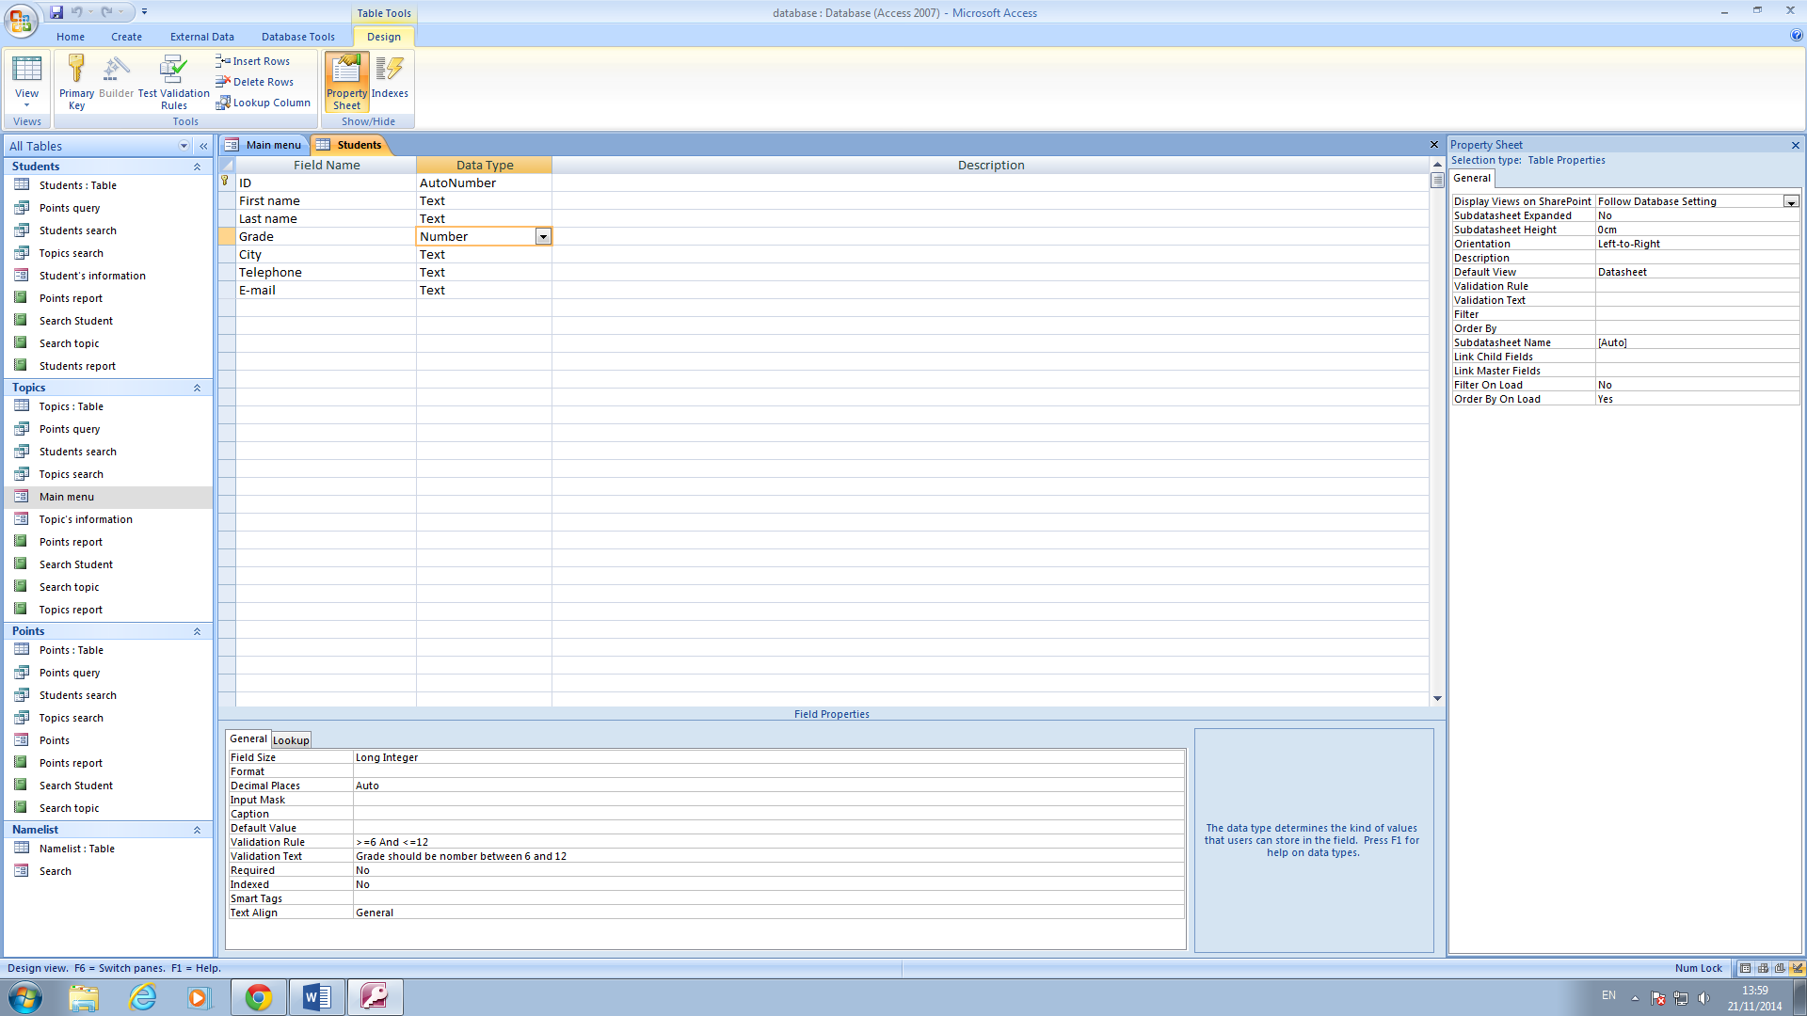

The field “City” has a lookup as it is shown below. There are four cities: Taldykorgan, Aktobe, Karagandy, Semey.

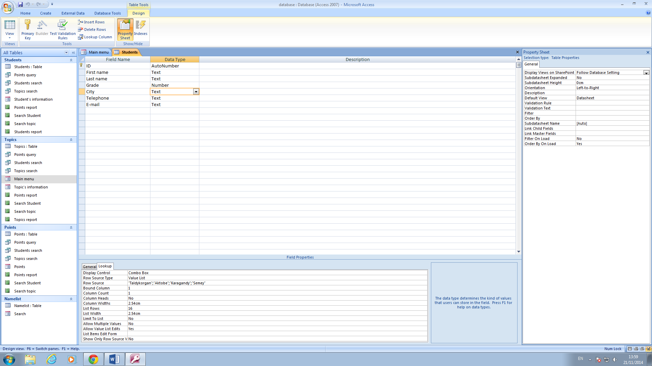

The field “Telephone” has an input mask 00000000000 as it is shown below, because a telephone number contains 11 figures.

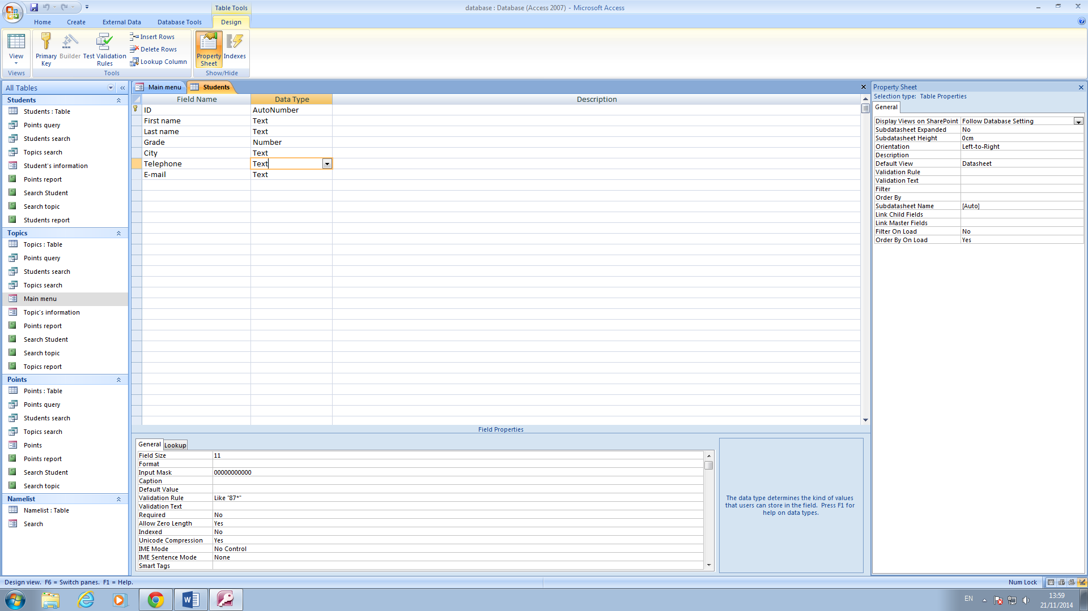

There is validation rule for field “e-mail” as shown below, because every e-mail must have symbols “@” and “.”.

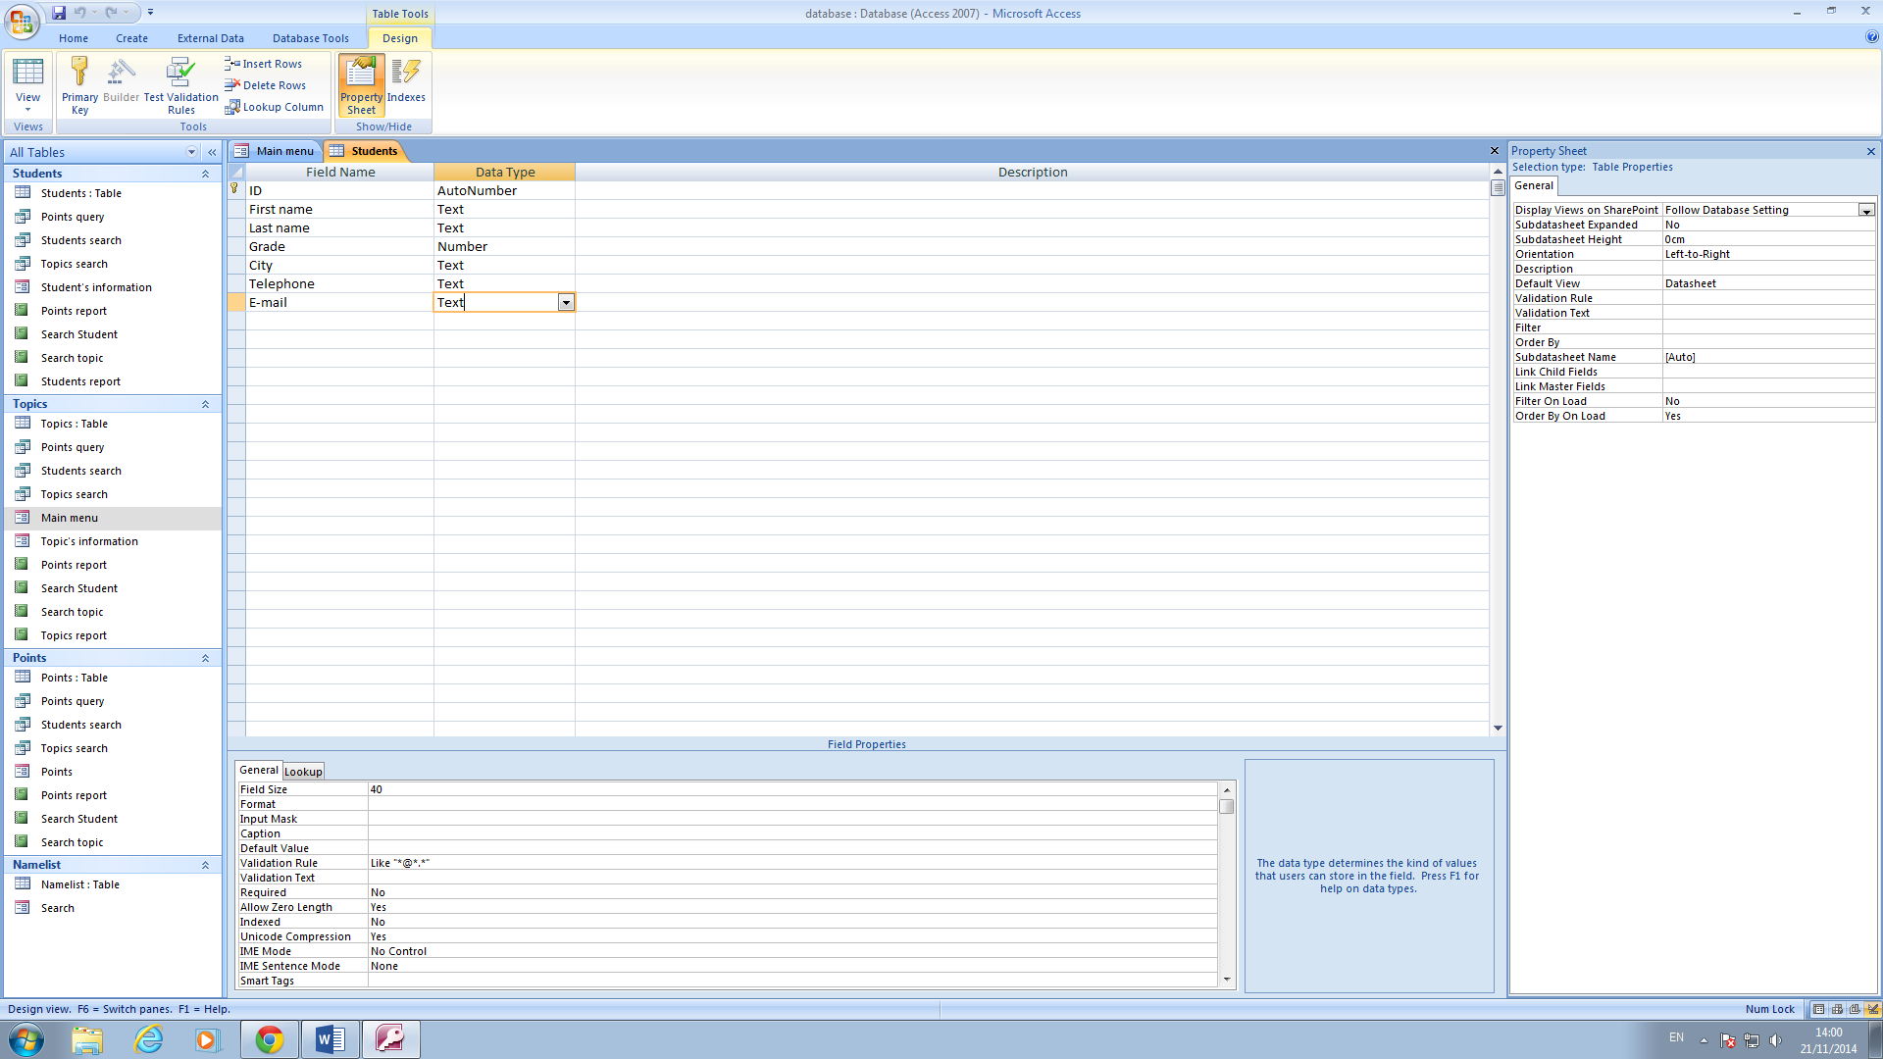

1. The table Topics

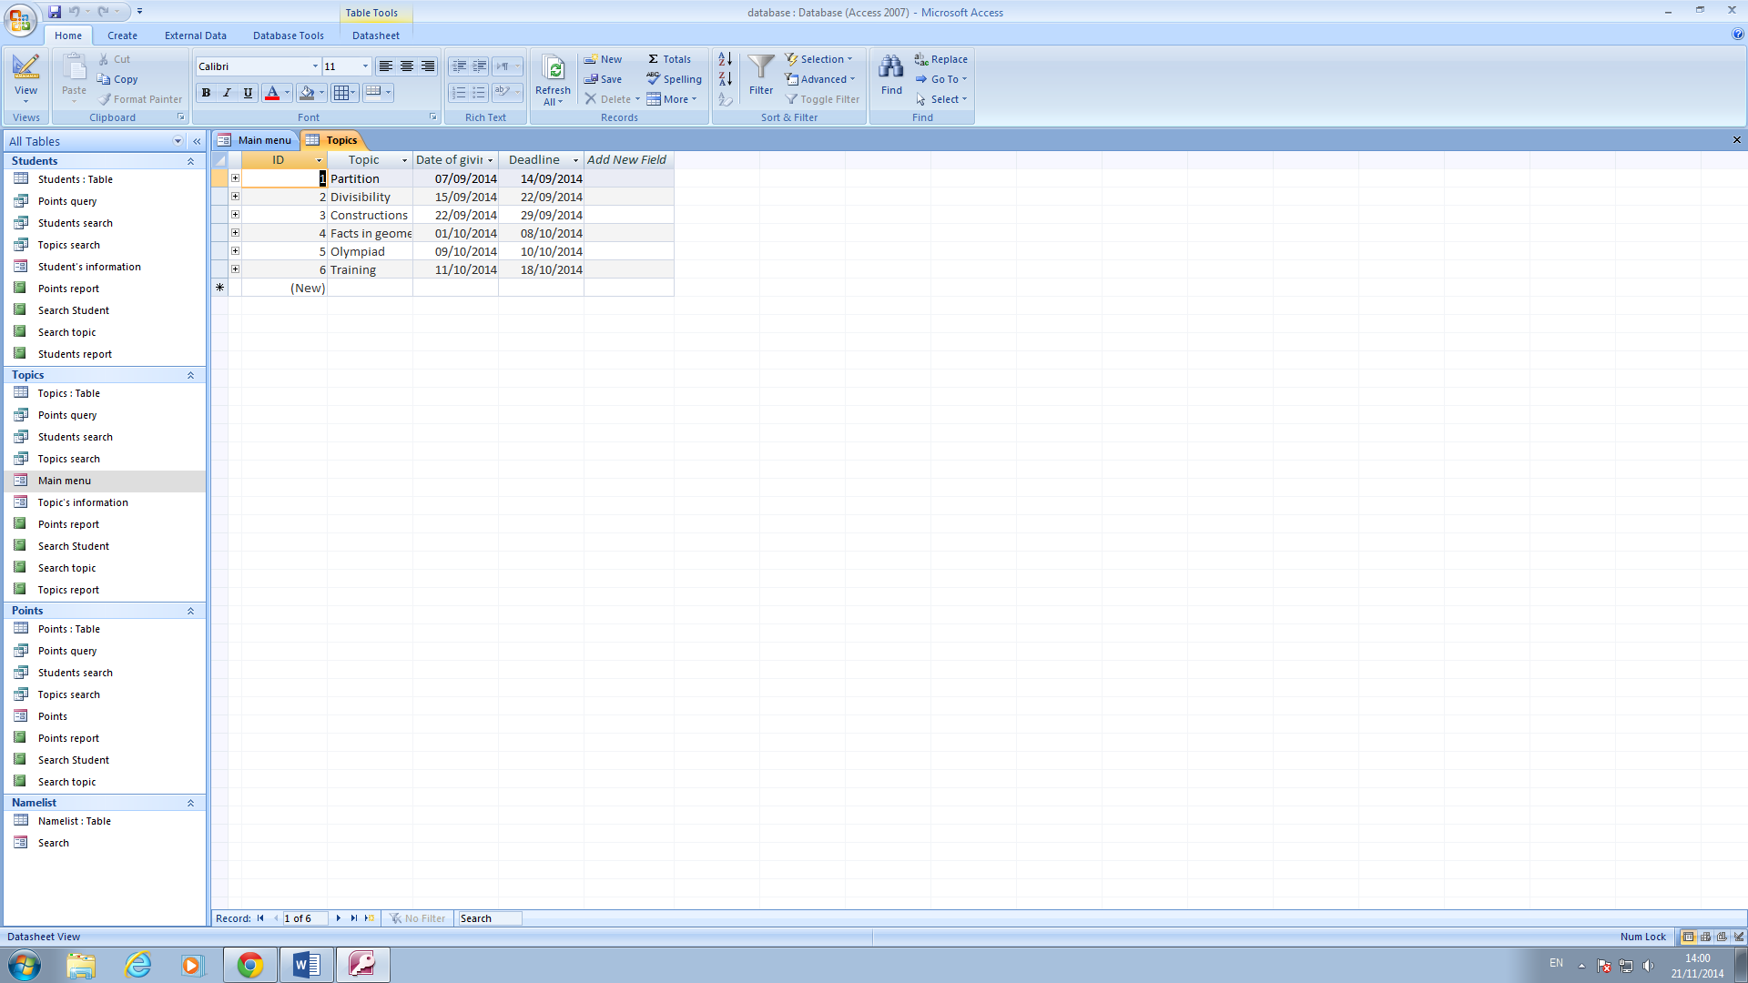

There are 4 fields with primary key ID.

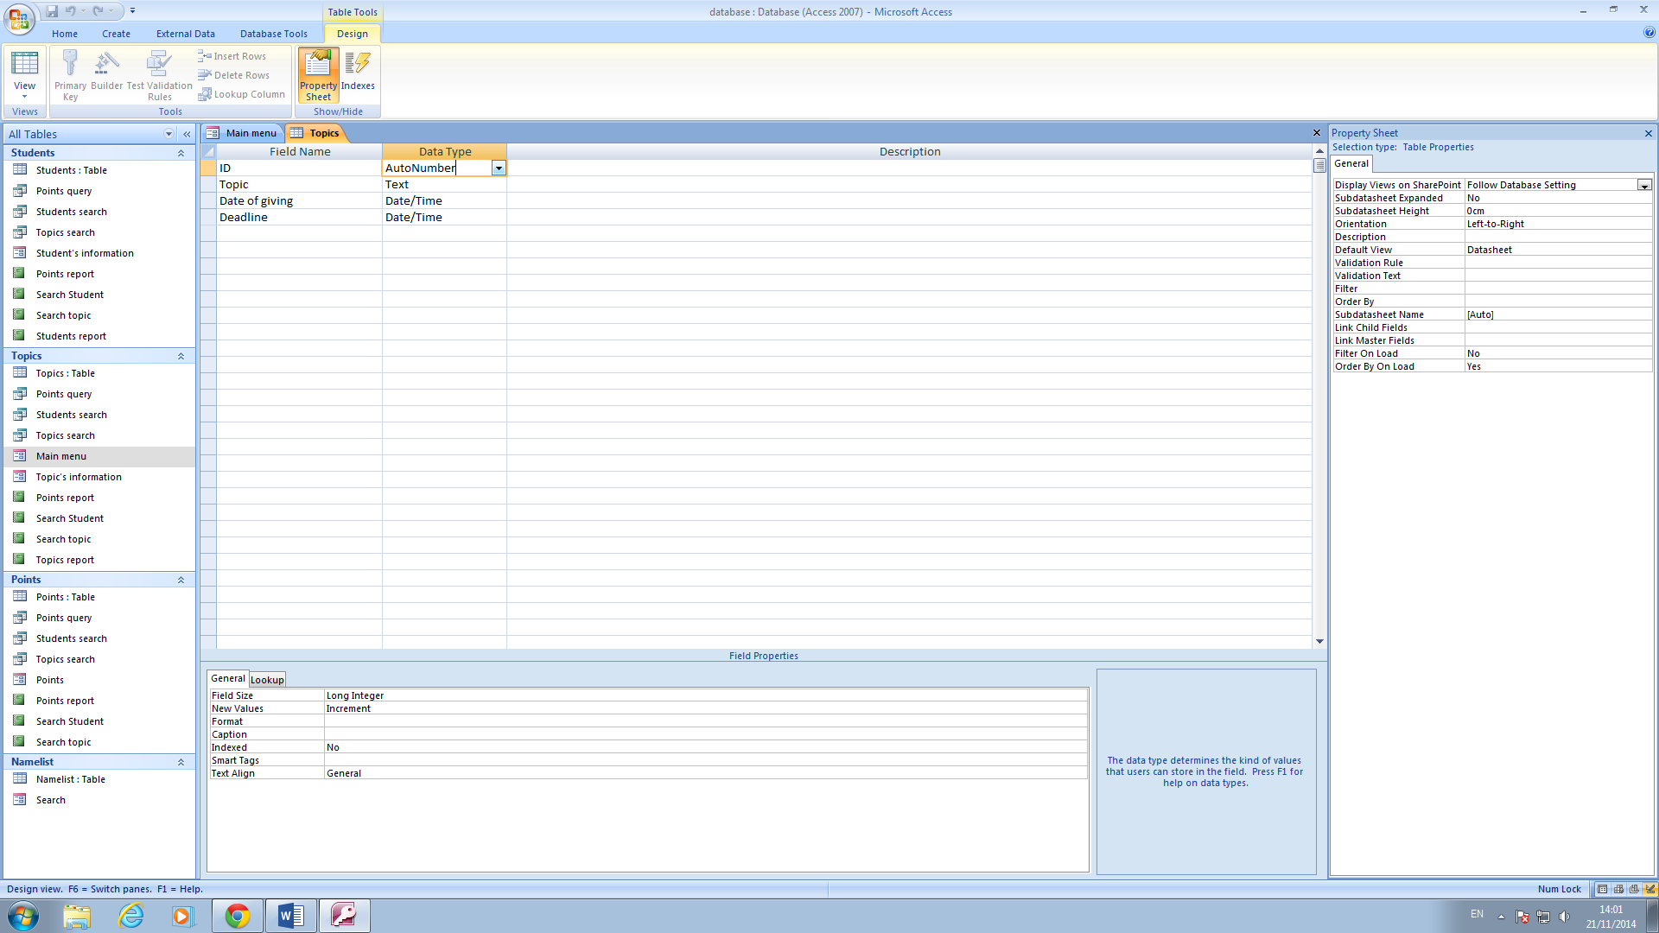

Format of “Date of giving” and “Deadline” fields is general date.

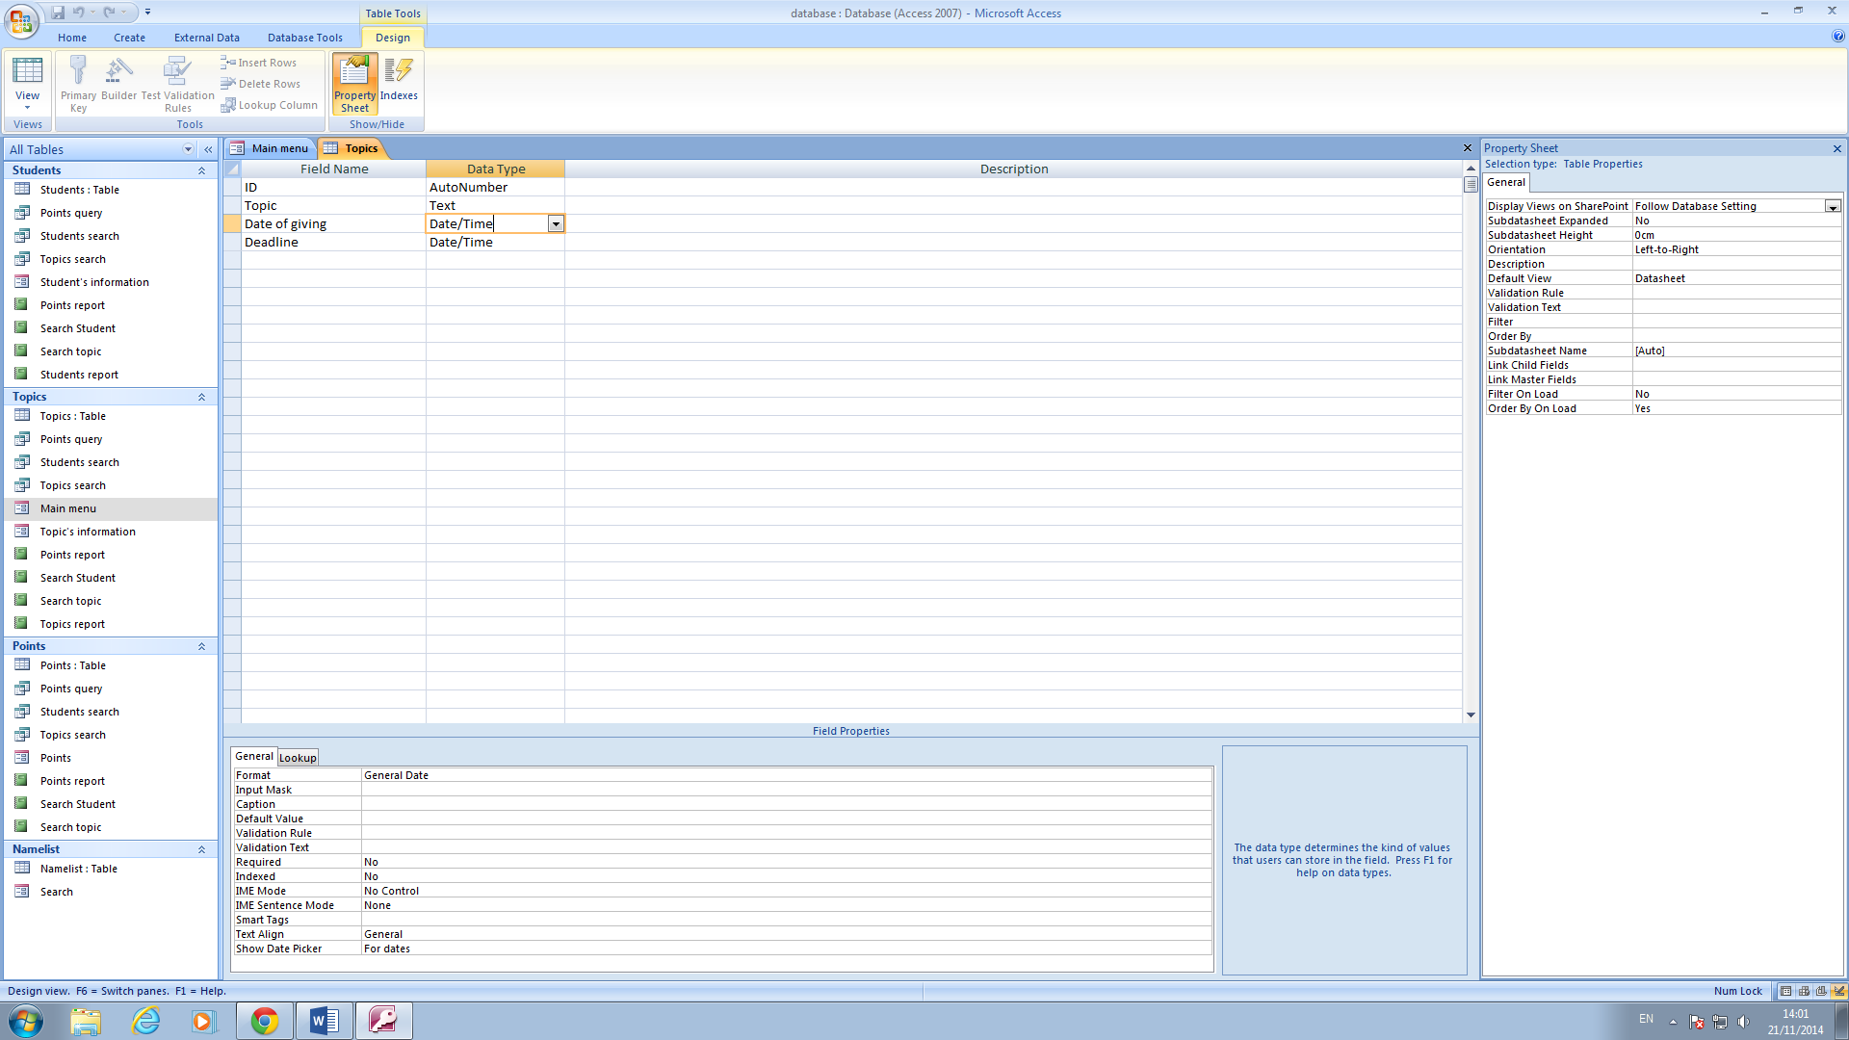

1. The Points table. There is Look Up wizard for choosing StudentID and TopicID.

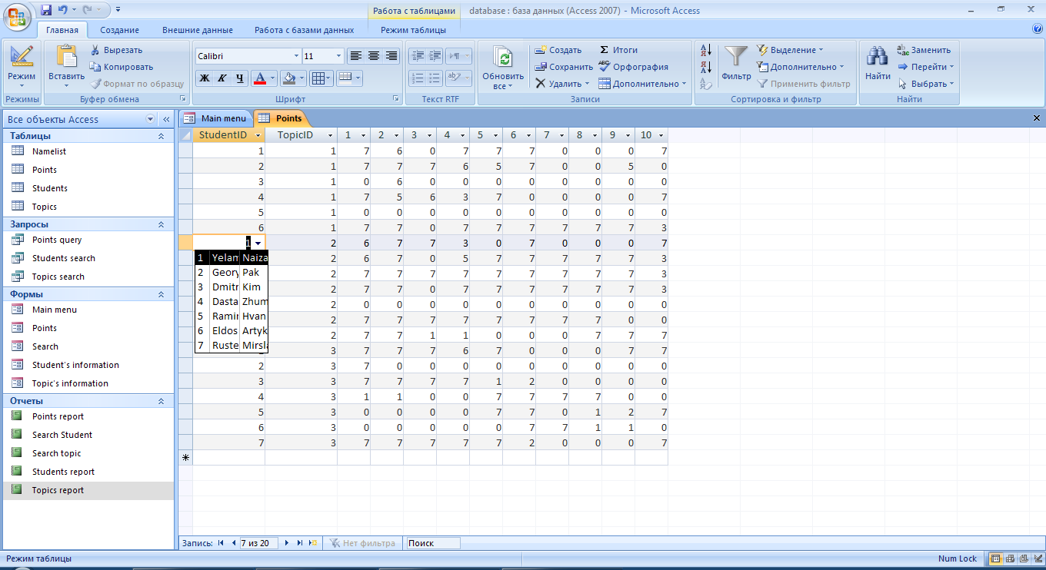

There is look up wizard from Students table for the field StudentID.

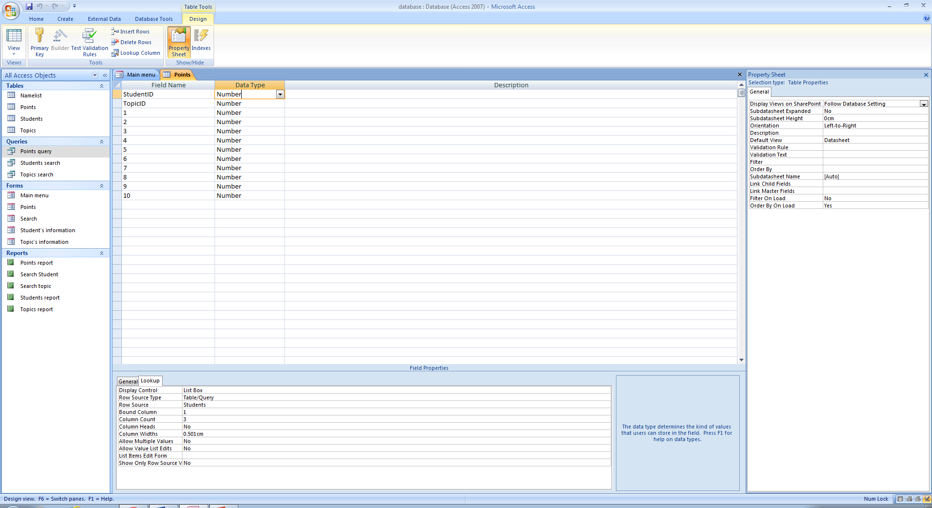



There is look up wizard from Topics table for field TopicID.

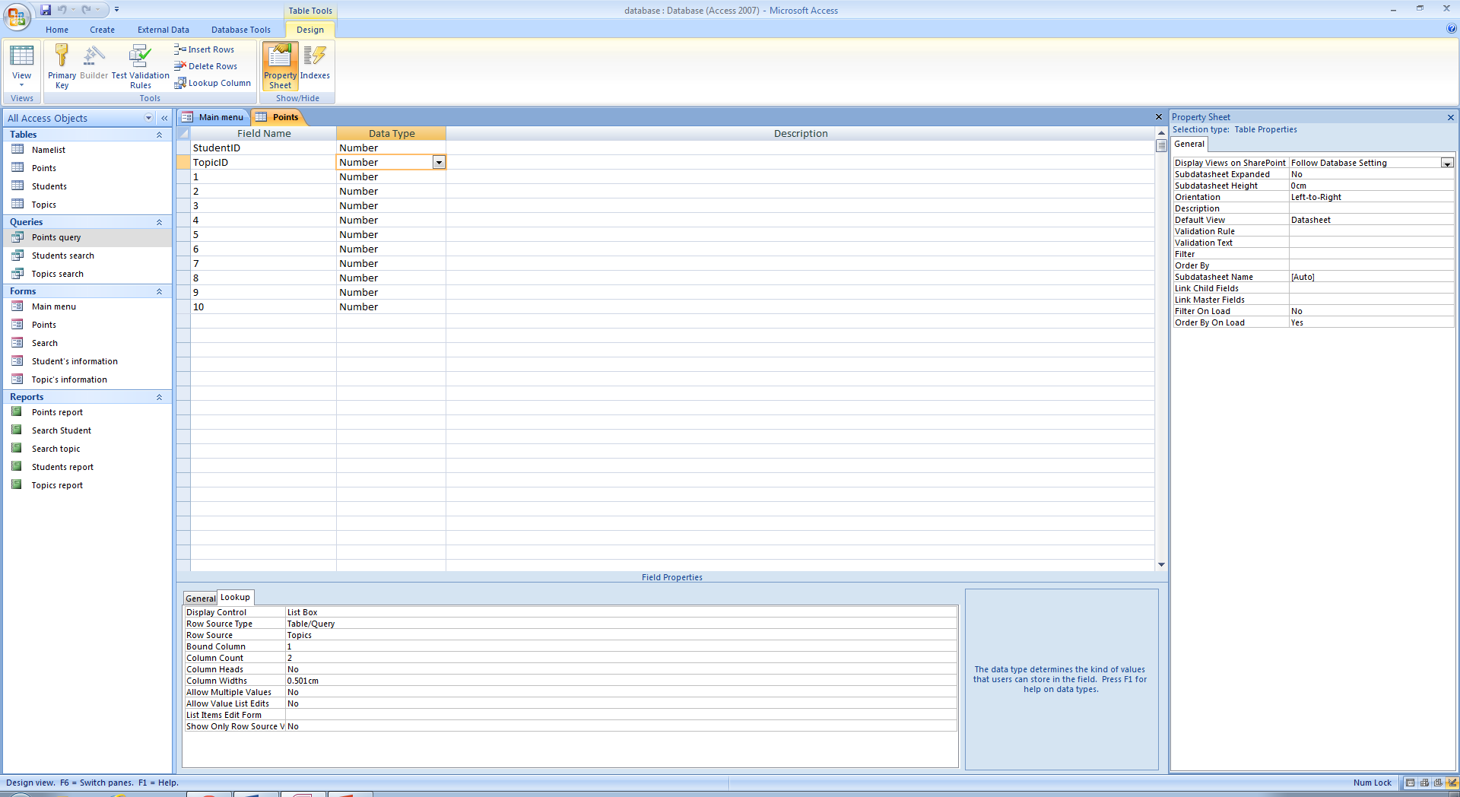



1. The report Students. This report contains all information inputted to the Students table.

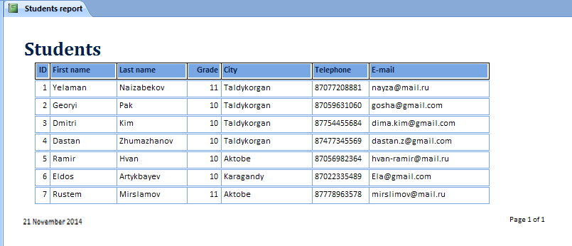

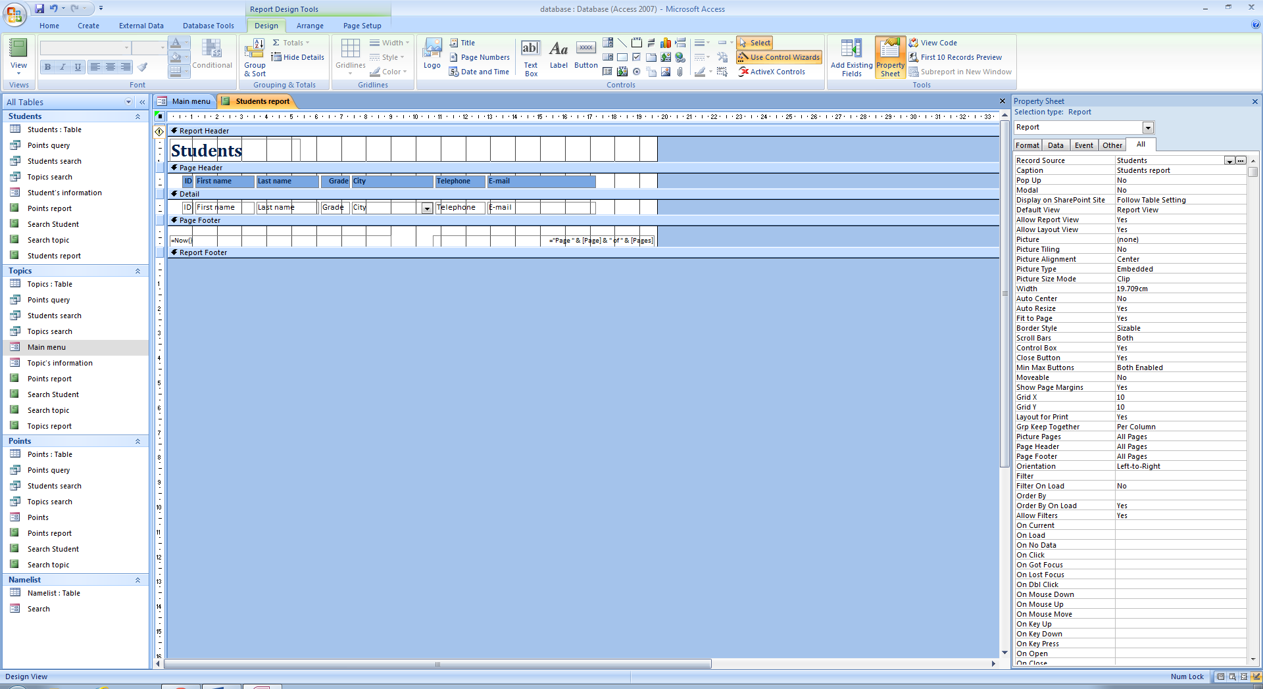

1. The report Topics. This report contains all information inputted to the Topics table.

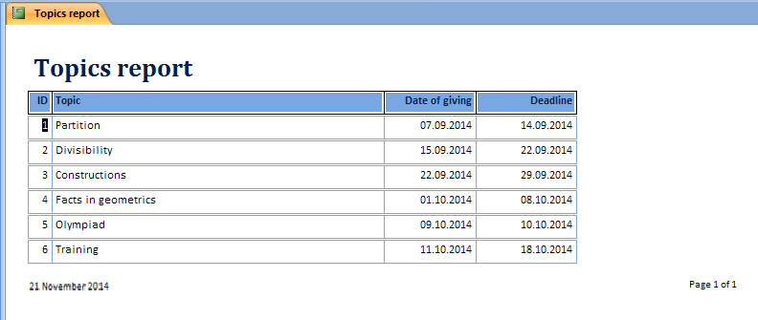

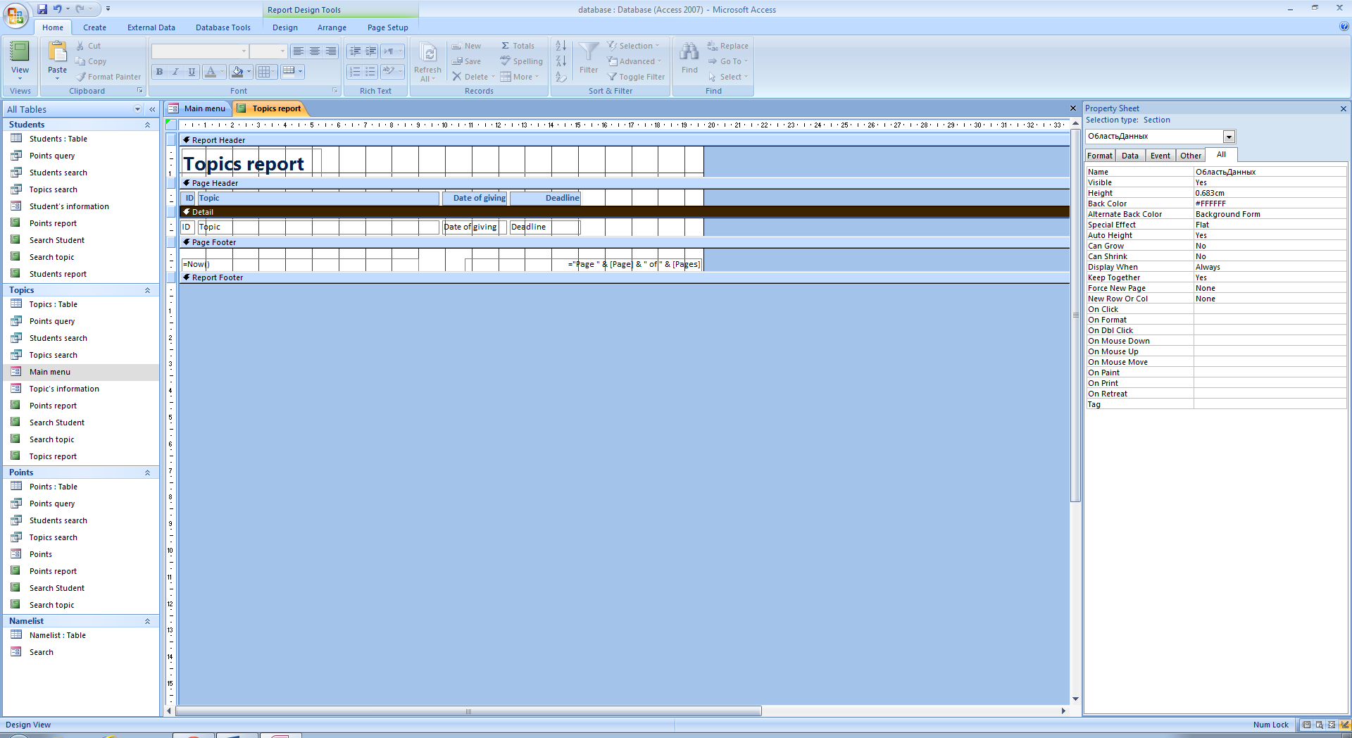

1. The report Points. This report shows all information inputted to the Points table with including first and last names of student, the topic and the productivity.

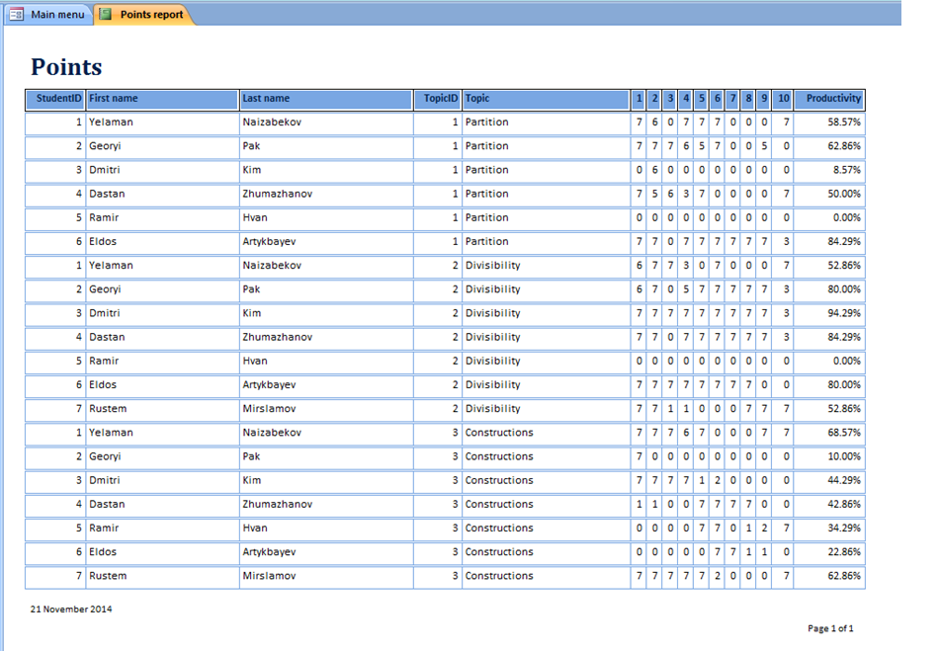

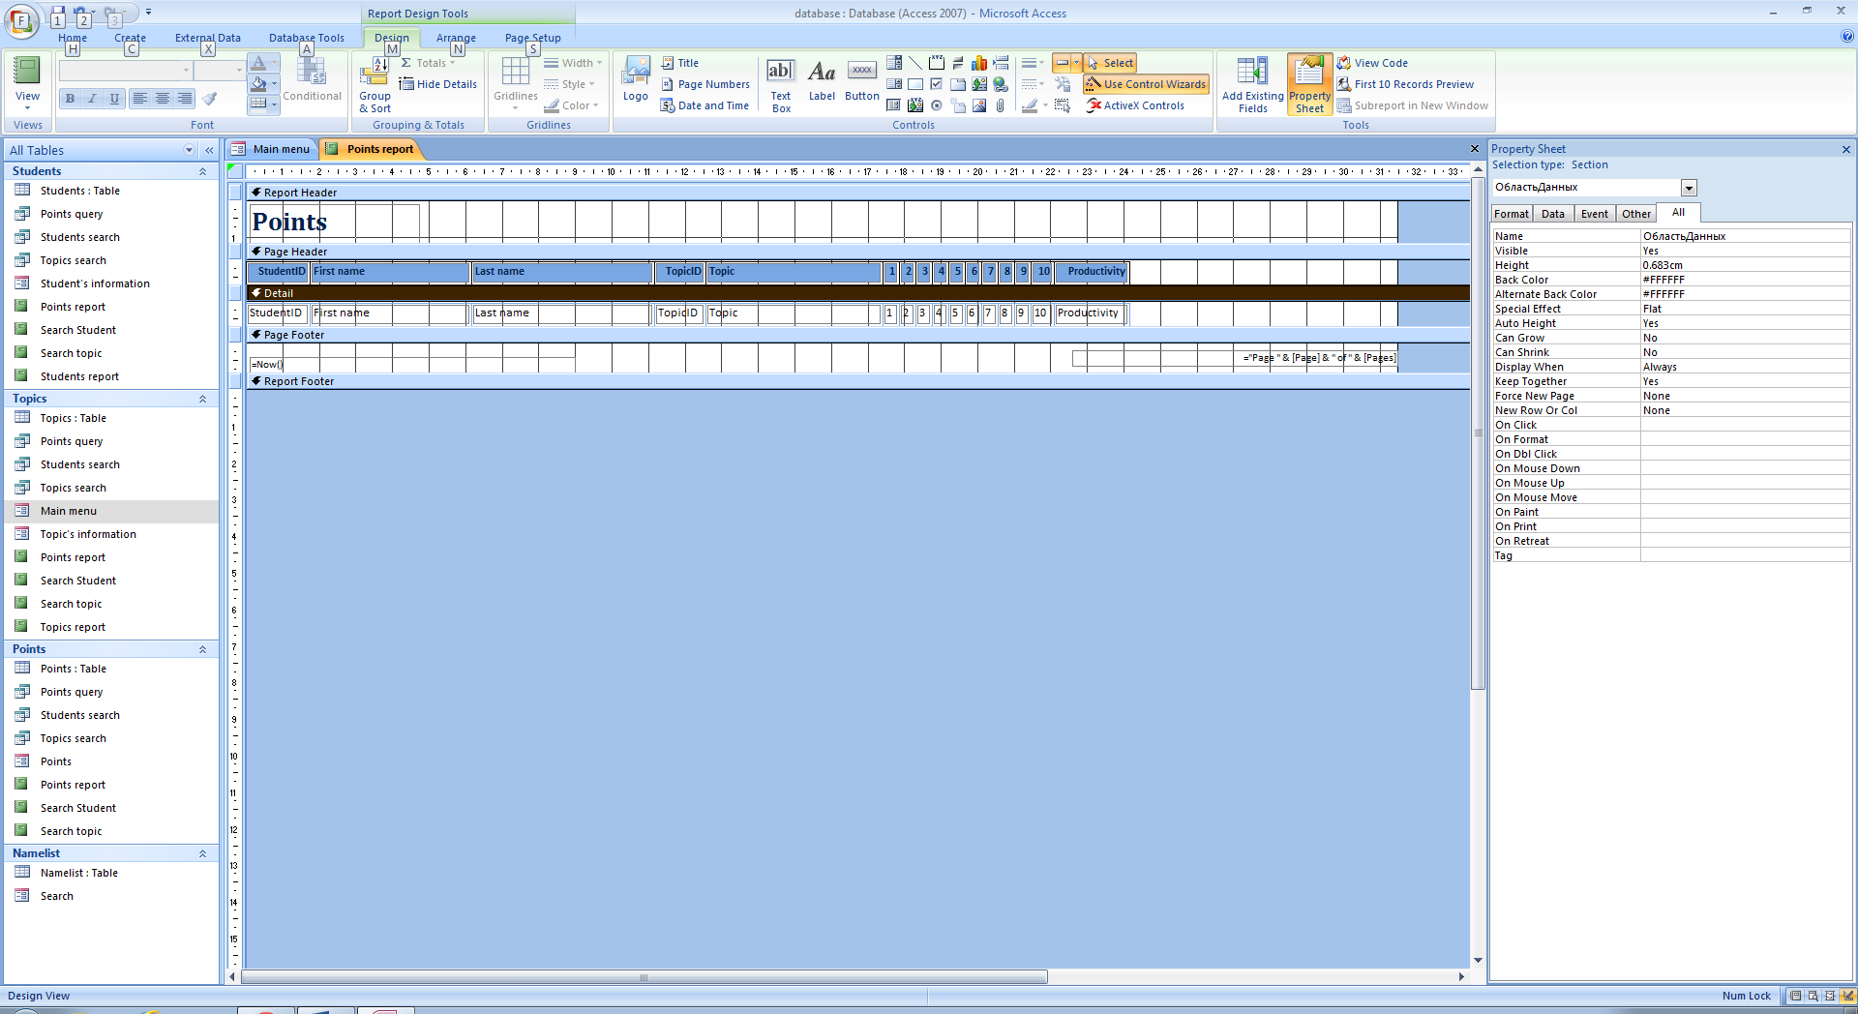

1. The report for results of searching student. This report shows all information about one student with calculating total productivity of student.

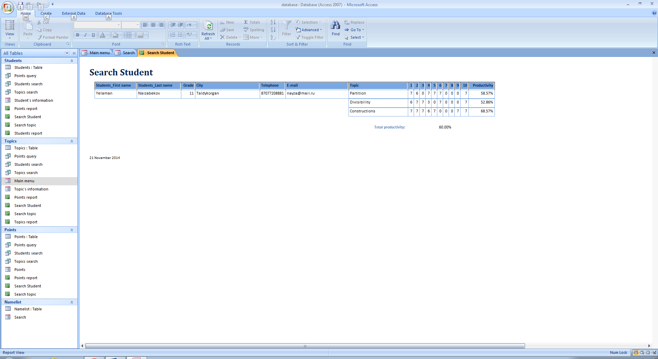

The formula for calculating total productivity: =Avg([Productivity]).

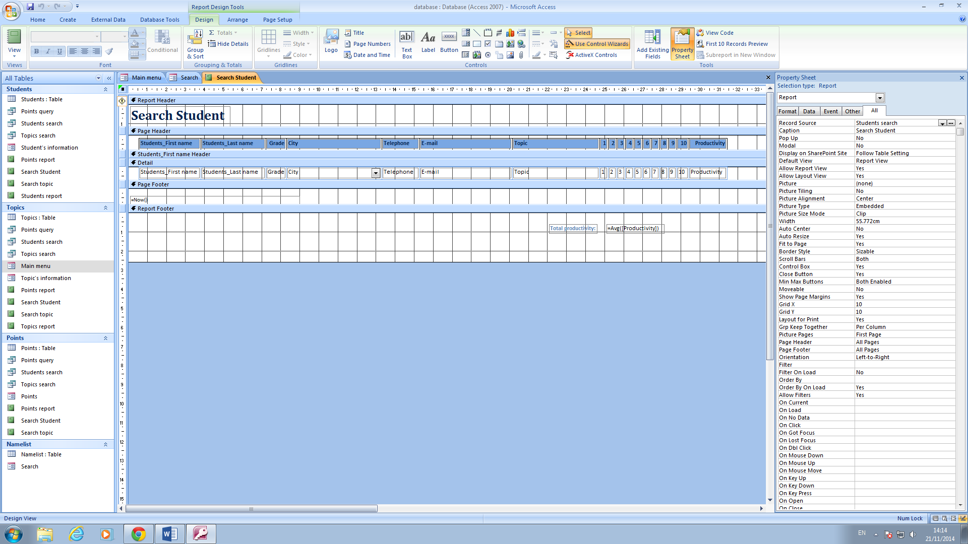

1. The report for results of searching topic. This report shows information about topic which was chosen in search form: Topic, Date of giving, Deadline and points of each student in this topic including productivity.

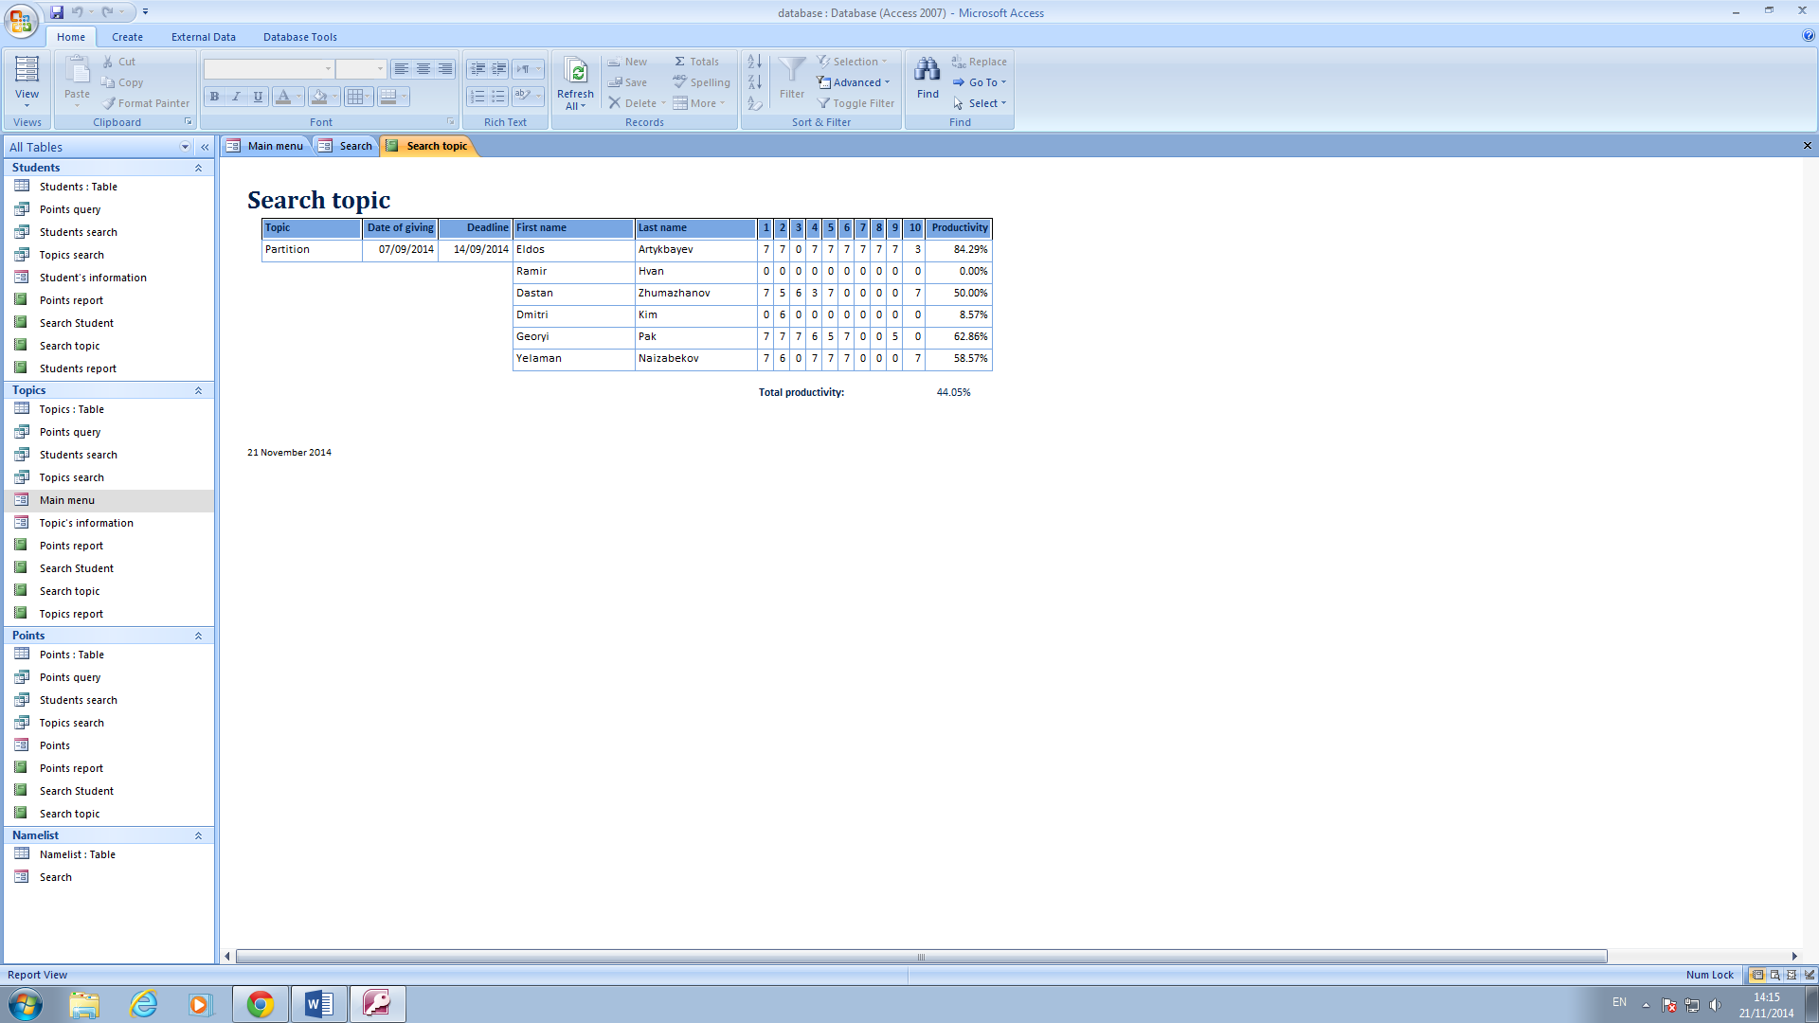

Repot also calculate total productivity of all students in this topic. Formula for calculating total productivity: Avg([Productivity]).

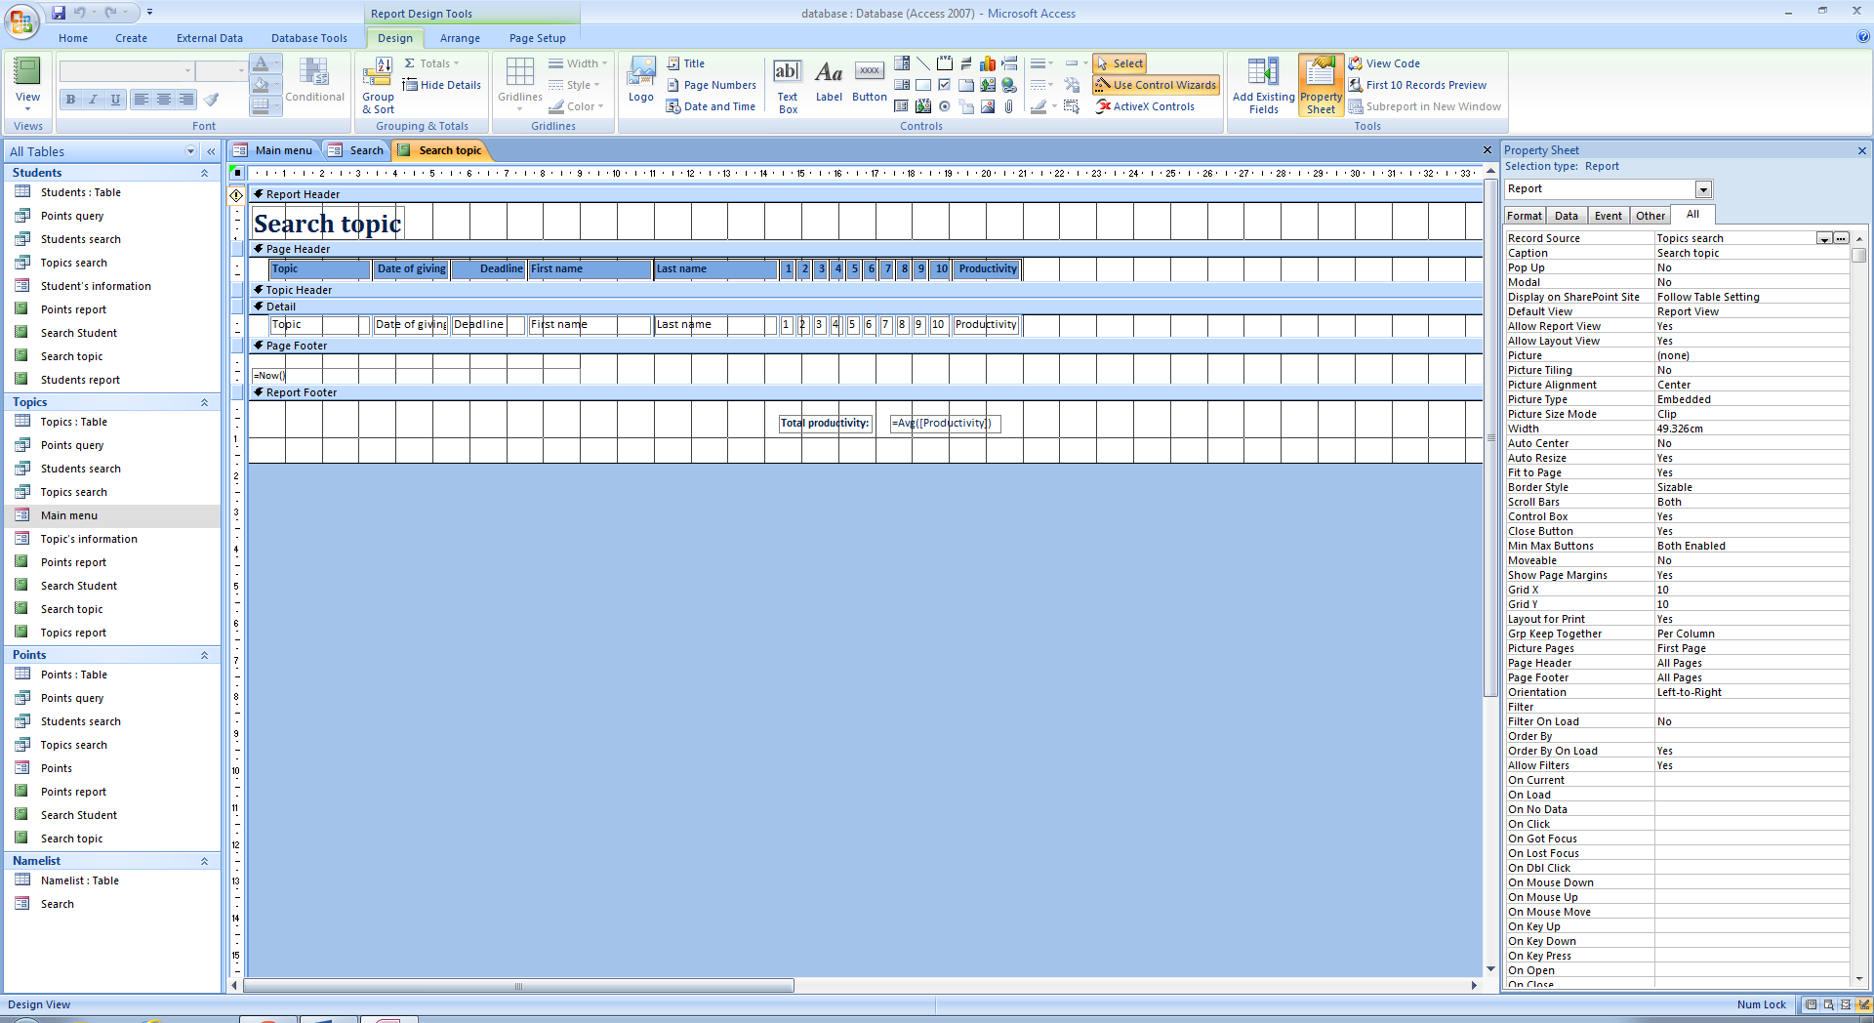

1. The query for report points. This query assemble information about student (ID, First name, Last name), information about topic (ID, Topic) and points including calculation of productivity as shown below.

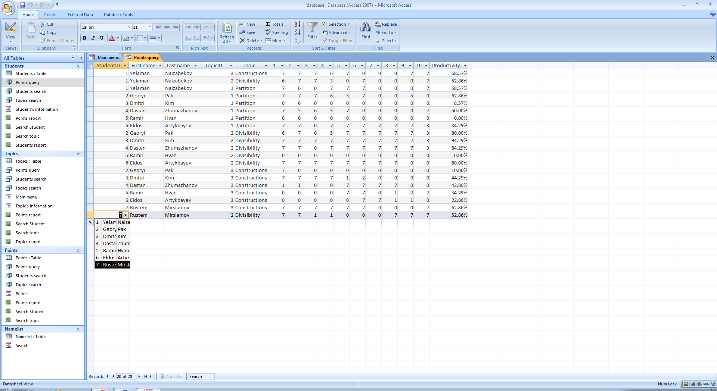

Formula for calculating productivity: Productivity: (([1]+[2]+[3]+[4]+[5]+[6]+[7]+[8]+[9]+[10])/70)

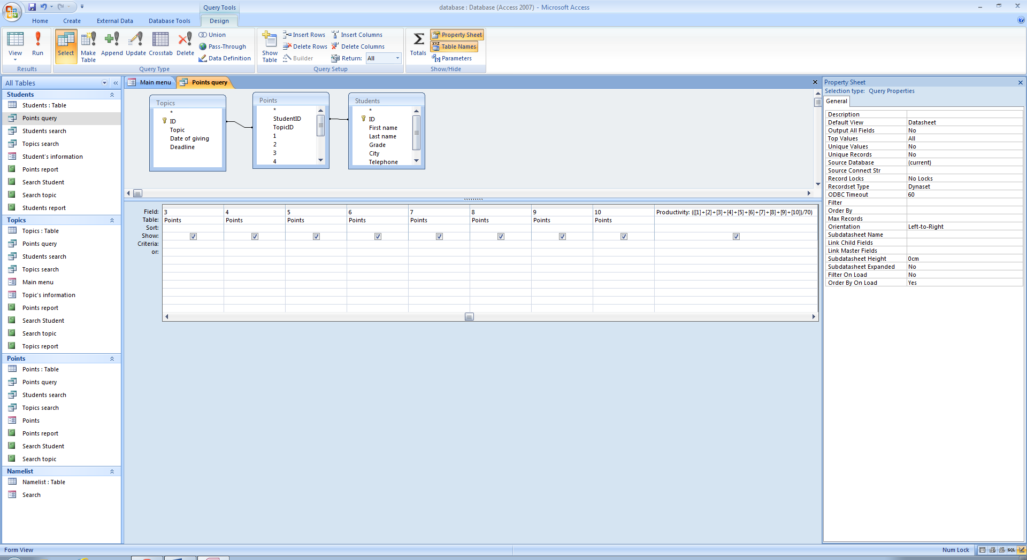

1. The query for searching student. This query shows all information about chosen student from Students table and all points which the student earned from Points table.

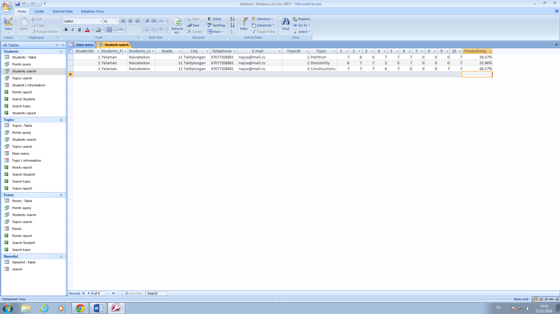

Criteria for StudentID: [Forms]![Search]![StudentID-search]. That is, the query will show only information about student whose ID was chosen in Search form.

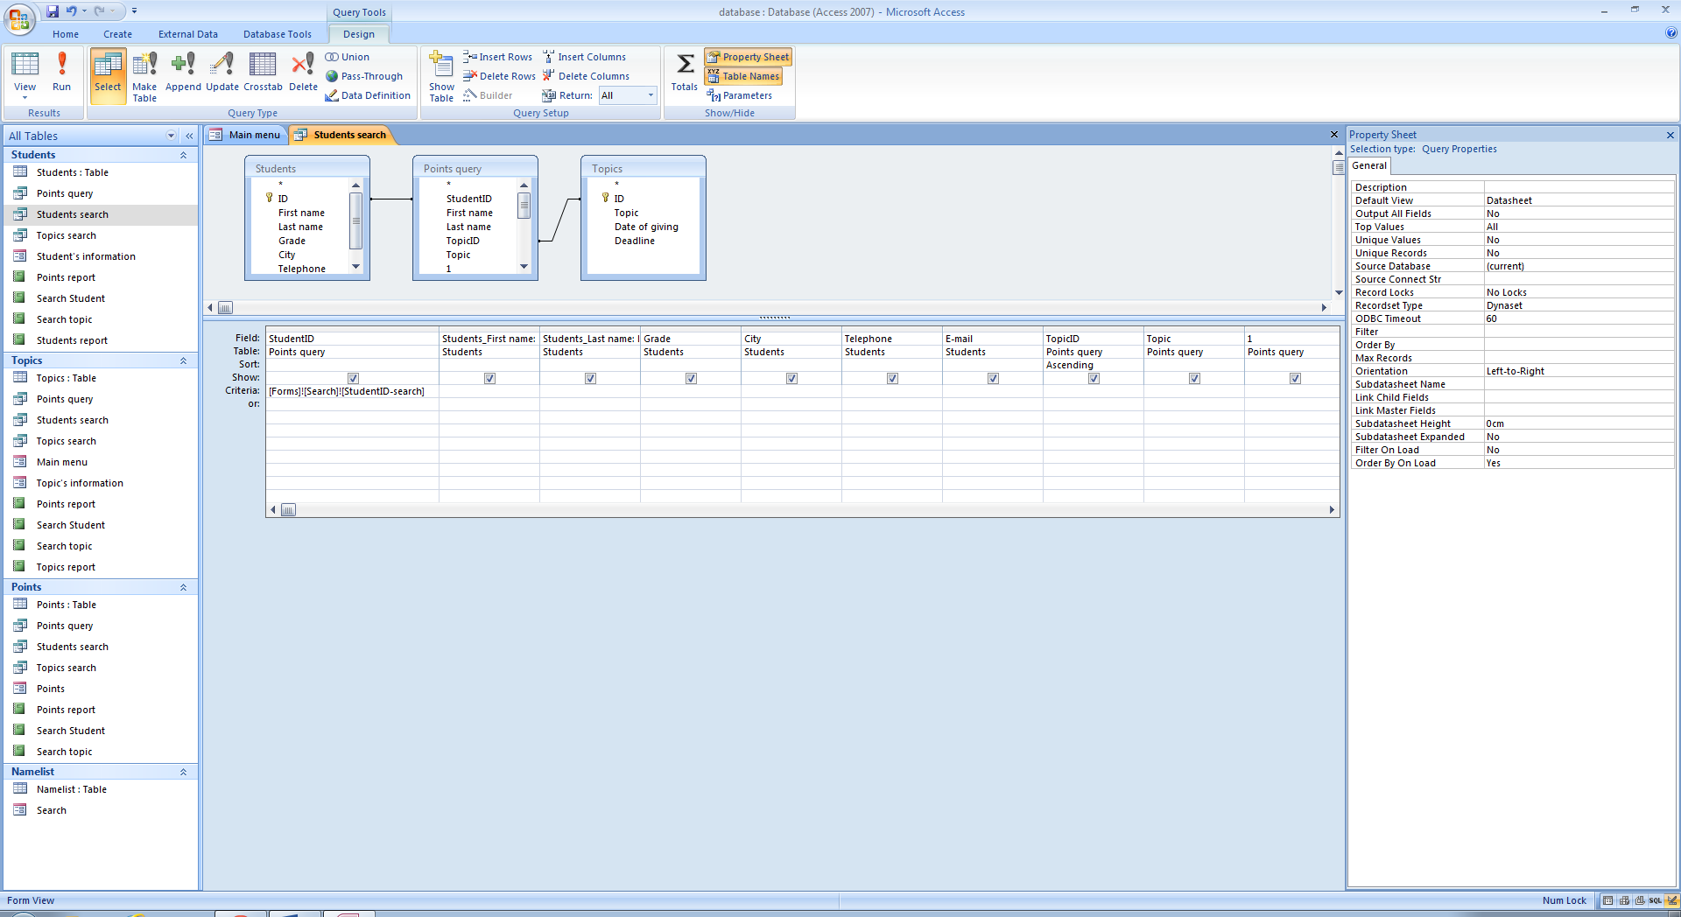

1. The query for searching topic. This query shows all information about chosen Topic: TopicID, Topic, Date of giving, Deadline and points of each student related to this topic.

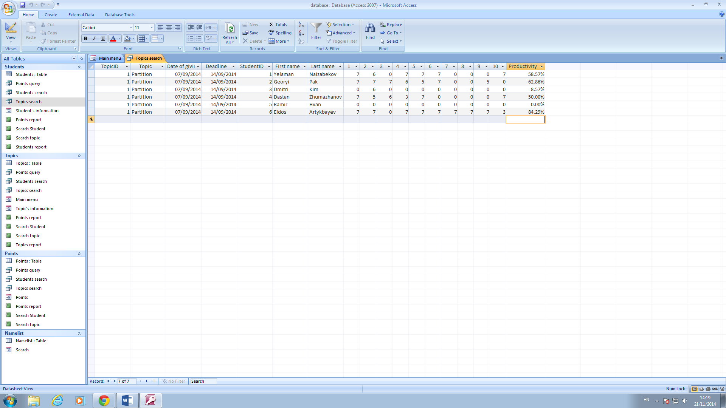

Criteria for TopicID: [Forms]![Search]![TopicID-search]; That is, the query will show only information about topic which’s ID was chosen in Search form.

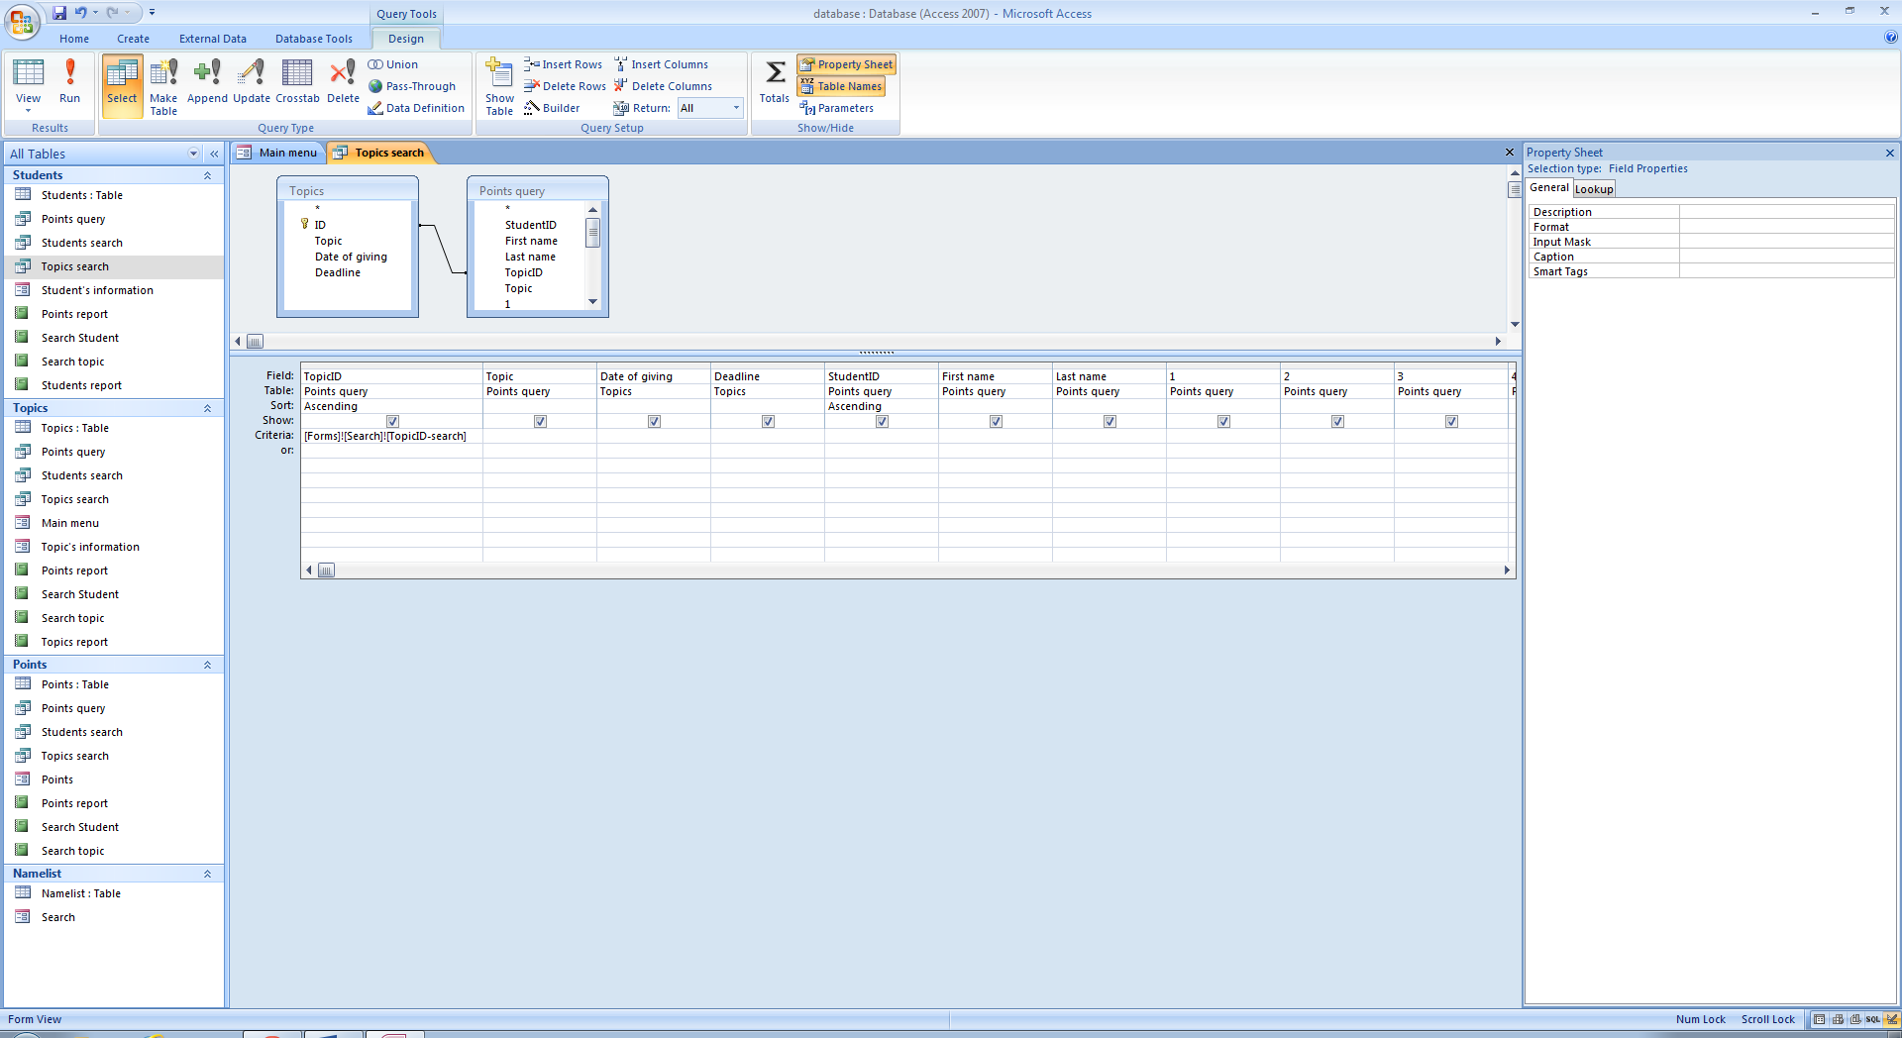

# PROGRAMMING

Login and Password are used for security methods.

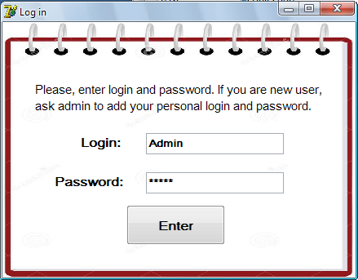

Code of checking login and password is shown below.

procedure TForm1.FormCreate(Sender: TObject*); // operations after opening form1*

begin

Memo1.Lines.LoadFromFile('l.txt'); *// Loading list of logins into Memo1*

Memo2.Lines.LoadFromFile('p.txt'); *// Loading list of passwords into Memo2*

end;

procedure TForm1.BitBtn1Click(Sender: TObject); *// operations after clicking Enter*

var *// a listing of variables*

log, pass:string; *// type of variables log and pass is strings*

i:integer; *// the variable i is integer*

begin

log:=Edit1.Text; *// the variable* *log takes the value of Edit1.text*

pass:=Edit2.Text; *//* *the variable pass takes the value of Edit2.text*

i:=0; *// i takes the value 0*

repeat *// starting the cycle*

If log=memo1.Lines[i] then *// Checking coincidence of the variable log and i-th line of memo1*

Begin

If pass=memo2.Lines[i] then *// Checking coincidence of the variable pass and i-th line of memo2*

begin

memo3.lines[0]:=IntToStr(i); *// Writing* *the value of variable i into zero line of memo2*

memo3.lines.Savetofile('l2.txt'); *// Saving values from memo3 into text file l2.txt*

Form1.Hide; *// hiding the form1*

Form2.showmodal; *// Showing modally the form2*

break; *// stop the cycle*

end

else

begin

ShowMessage('Incorrect login or password!'); *// showing the message 'Incorrect login or password!'*

break; *// stop the cycle*

end;

end

else i:=i+1; // increasing i by 1

If Memo1.Lines[i]='' then ShowMessage('Incorrect login or password!'); *// showing message*

until memo1.Lines[i]=''; *//stop cycle if i-th line of memo1 is empty*

end;

end.

User can change login and password using form which is shown below.



Before changing password and password, the program checks correctness of current password. Then the program checks coincidence of new login with other logins, if there is any coincidences changing will not be saved. Code for changing login and password is shown below.

procedure TForm3.BitBtn1Click(Sender: TObject); *//operation after clicking Cahange*

var  *// listing of variables*

cpass, log, pass:string; *// cpass, log and pass are strings*

k,i:integer; *// k and i are integers*

begin

memo3.Lines.LoadFromFile('p.txt'); *// loading list of logins into memo3*

k:=StrToInt(memo2.Lines[0]); *// k takes the value of zero line of memo2*

cpass:=Edit1.text; *// cpass takes the value of text from Edit1 with changing string value to integer*

log:=Edit2.text; *// log takes the value of text from Edit2 with changing string value to integer*

pass:=Edit3.text; *// pass takes the value of text from Edit3 with changing string value to integer*

If cpass=memo3.Lines[k] then *// if current password correct then do next operations*

Begin

If log='' then showmessage('Enter the login!') *// if new login is empty, show error message*

Else *// if new login is not empty, do next operations*

Begin

if pass='' then showmessage('Enter the password!') *// if new password is empty show error message*

else *// if new password is not empty, do next operations*

begin

i:=0; *// i takes the value 0*

repeat *// start the cycle*

If memo1.lines[i]=log then *// Checking coincidence of the variable log and i-th line of memo1*

begin

if i=k then *// if new login is the same as current, do next operations*

begin

Memo3.Lines[k]:=pass;  *// k-th line of mem3 takes the value of pass*

Memo3.Lines.savetofile('p.txt'); *// Saving values from memo3 into text file p.txt*

Showmessage('Changes were successfully saved!'); *//show message about successful changing*

Edit1.text:=''; *// cleaning text of Edit1*

Edit3.text:=''; *// cleaning text of Edit3*

Timer1.Enabled:=true;  *// start the timer*

Form2.show; *// come back to the form2*

Form3.Close; *// close the Form3*

break; *// stop the cycle*

end

else *// if there coincidence with other login, then do next operations*

begin

ShowMessage('This login is busy!'); *// show message that this login is busy*

break;  *//stop the cycle*

end;

end

else i:=i+1; *// if there is not coincidence with i-th line then go to next line*

If memo1.Lines[i]='' then  *// if the next line is empty, do next operations*

begin

Memo1.Lines[k]:=log; *// exchange current login to new login*

memo1.Lines.SaveToFile('l.txt'); *// save changing of login list into text file l.txt*

Memo3.Lines[k]:=pass; *// exchange current password to new login*

Memo3.Lines.savetofile('p.txt'); *// save changing of password list into text file p.txt*

Showmessage('Changes were successfully saved!'); *// show message about successful changing*

Edit1.Text:=''; *// cleaning text of Edit1*

Edit3.Text:=''; *// cleaning text of Edit3*

Timer1.Enabled:=true; *// start the timer*

Form2.show; *// come back to the form2*

Form3.Close; *// close the Form3*

break; *// stop the cycle*

end;

until memo1.Lines[i]='';  *// stop the cycle if i-th line of memo1 is empty*

end;

end;

end

else

showmessage('Incorrect current password!'); *// if current password is incorrect, show error message*

end;

procedure TForm3.BitBtn2Click(Sender: TObject); *// operation after clicking Cancel*

begin

Edit1.text:=''; *// cleaning text of Edit1*

Edit3.text:=''; *// cleaning text of Edit3*

Timer1.Enabled:=true; *// start the timer*

Form2.show; *// come back to the form2*

Form3.close; *// close the Form3*

end;

procedure TForm3.Timer1Timer(Sender: TObject); *// operations of timer1*

var

k:integer;

begin

If Form3.showing then *// if Form3 was shown, do next operations*

begin

memo1.Lines.LoadFromFile('l.txt'); *// Loading list of logins into Memo1*

Memo2.Lines.LoadFromFile('l2.txt'); *// Loading the ID of the user into memo2*

k:=StrToInt(memo2.Lines[0]); *// k takes the value of ID of user*

Edit2.Text:=memo1.Lines[k]; *// text of Edit2 takes the value of login of user*

Timer1.Enabled:=false; *// stop the timer*

end;

end;

end.

# TESTING

## Tests

|  |  |  |  |  |  |  |
| --- | --- | --- | --- | --- | --- | --- |
| **Test №** | **Test Objective** | **Test Method** | **Test Data used and data type** | **Expected outcome** | **Actual outcome** | **Evidence on page №** |
| 1 | Check outcome if login is incorrect | Enter the wrong login | Admin  Abnormal | Message “Incorrect login or password!” | Successful | 63 |
| 2 | Check outcome if password is incorrect | Enter the wrong password | 456  Abnormal | Message “Incorrect login or password!” | Successful | 64 |
| 3 | Check outcome if both of login and password are correct | Enter the right login and password | Sergey/ss  Normal | Open the next form | Successful | 64 |
| 4 | Check outcome if the current password is incorrect in the changing login or password form | Enter the wrong current password | 123  Abnormal | Message “Incorrect current password!” | Successful | 65 |
| 5 | Check outcome if the new password is empty in changing login and password form and adding new user form | Leave empty the new password | Abnormal | Message “Enter the password!” | Successful | 66 |
| 6 | Check outcome if the new login is empty in changing login and password form and adding new user form | Leave empty the new password | Abnormal | Message “Enter the login!” | Successful | 67 |
| 7 | Check outcome if the new login coincide with other exhausting login in changing login or password form and adding new user form | Enter the exhausting login | Victor  Abnormal | Message “This login is busy!” | Successful | 68 |
| 8 | Check outcome if the new login coincide with current login in changing login or password form | Enter the current login as new login | Sergey  Abnormal | Message “Changes were successfully saved!”, form2 will be shown and new password will be saved | Successful | 69 |
| 9 | Check outcome if the all fields were entered correctly and new login does not coincide with exhausting logins in changing login and password form | Enter the new login which are not coincide with exhausting logins and enter all fields correctly | ss/ Admin/ qwerty  Normal | Message “Changes were successfully saved!”, form2 will be shown and new password and login will be saved | Successful | 69 |
| 10 | Check outcome if all fields were entered correctly in adding new user form | Enter the new login and password of new user | User1/xy  Normal | Message “New user was successfully registered” | Successful | 70 |
| 11 | Check outcome if the city is not from look up in input form Student’s information | Enter the word which is not from look up | AA  Abnormal | Message about mistake | Successful | 70 |
| 12 | Check outcome if the grade do not match to validation rule that that the grade should be between 6 and 12 in the input form Student’s information | Enter the number which is not between 6 and 12 | 1  Abnormal | Message about mistake | Successful | 71 |
| 13 | Check outcome if the grade is exactly 12 in the input form Student’s information | Enter 12 into field grade | 12  Extreme | Change will be saved | Successful | 71 |
| 14 | Check if telephone number do not start with numbers 87 in the input form Student’s information | Enter the telephone number which do not start with 87 | 99077208881  Abnormal | Message “Grade should be a number between 6 and 12” | Successful | 72 |
| 15 | Check outcome if the telephone number do not has 11 numbers in input form Student’s information | Enter not full telephone number | 8707  Abnormal | Message about mistake | Successful | 72 |
| 16 | Check the outcome if the e-mail do not has symbols “@” and “.” In the input form Student’s information | Enter the wrong e-mail address | nnn  Abnormal | Message about mistake | Successful | 73 |
| 17 | Check adding new record in input forms | Enter the correct information | Normal | New records will be added | Successful | 73 |
| 18 | Checking outcome if the date is incorrect in input form Topic’s information | Enter the date which does not fit into general date format | 055  Abnormal | The message about mistake | Successful | 74 |
| 19 | Checking results of searching student and topic | Choose one student then topic | Normal | All information about these student and topic including total productivity in report | Successful | 75 |
| 20 | Check outcome if the point is higher than maximum point in input form Points | Enter the point which is higher than 7 | Abnormal | Message about mistake | Successful | 76 |

## Evidences

1. This is checking the firs form with login and password. I entered incorrect login and correct password. Then the message about mistake was shown as it shown below.

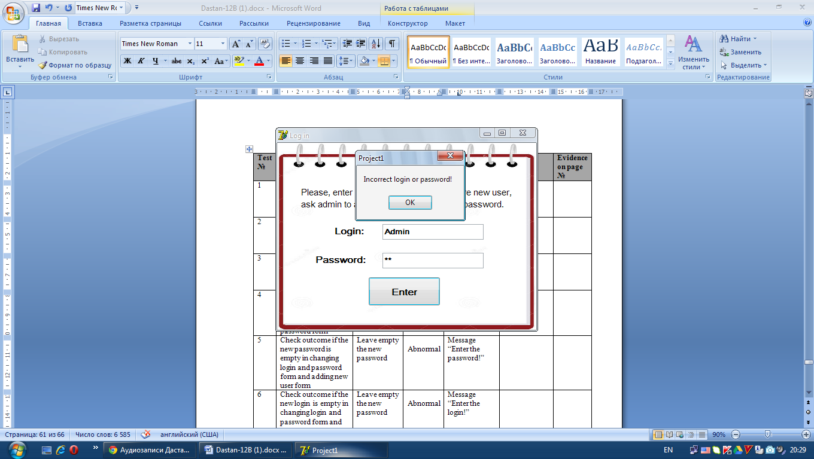

1. This is checking the security. I entered correct login but incorrect password. The message “Incorrect login or password!” was shown.

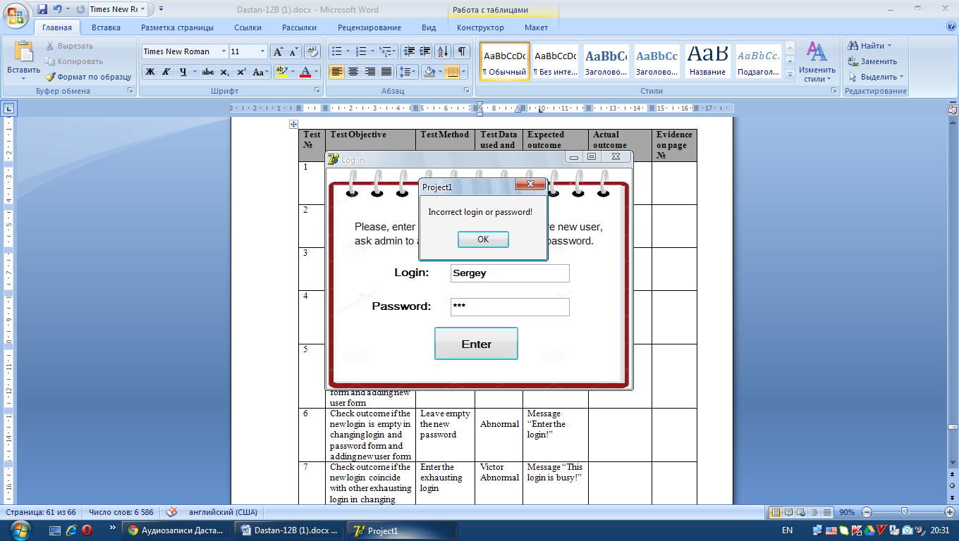

1. To make sure that login and password system works, I enter correct login and password. Then the next form was shown.

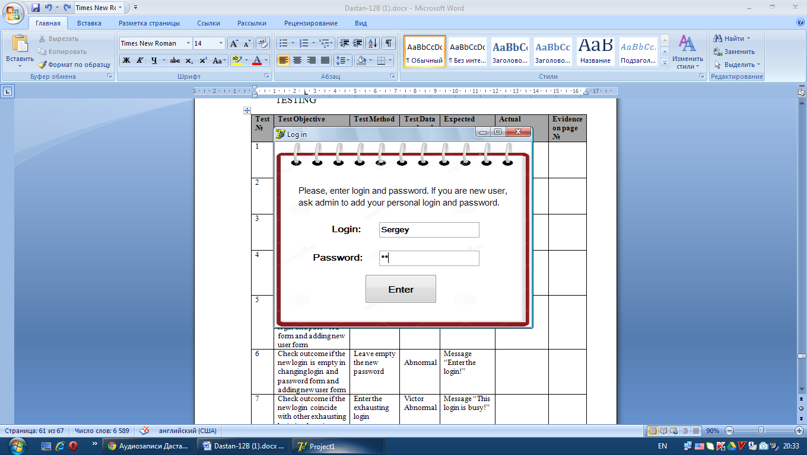

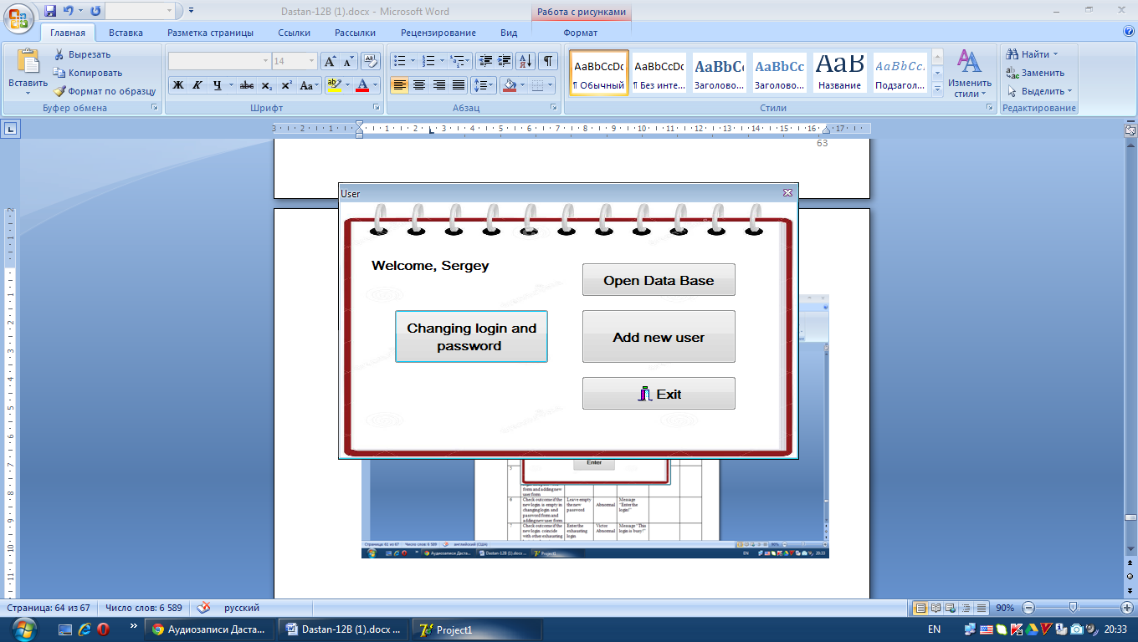

1. This is checking change login and password functions of the new system. I entered incorrect current password of the user, to make sure that if the current password is incorrect, user cannot change login or password. The message that the current password is incorrect was shown and changing was not saved.

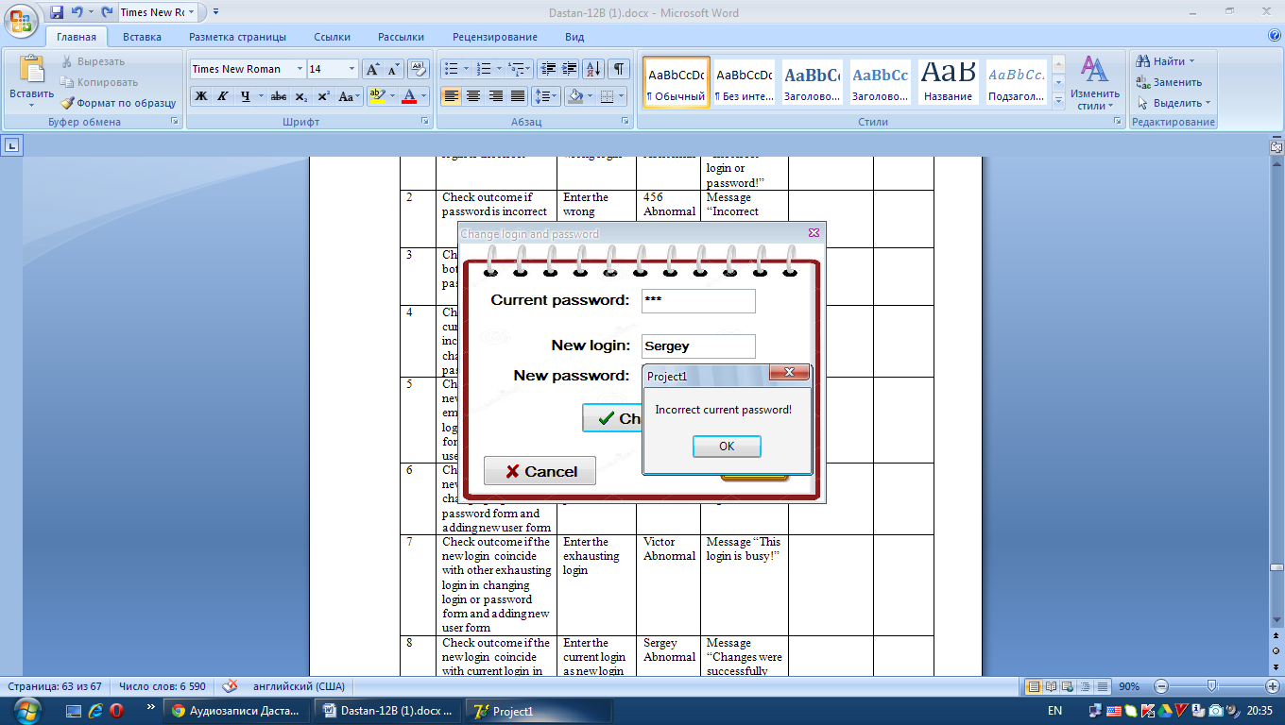

1. Every password must have at least one symbol. So, in order to test this rule, I leave password empty in forms Changing login and password and Adding new user. The system showed the message “Enter the password!”.

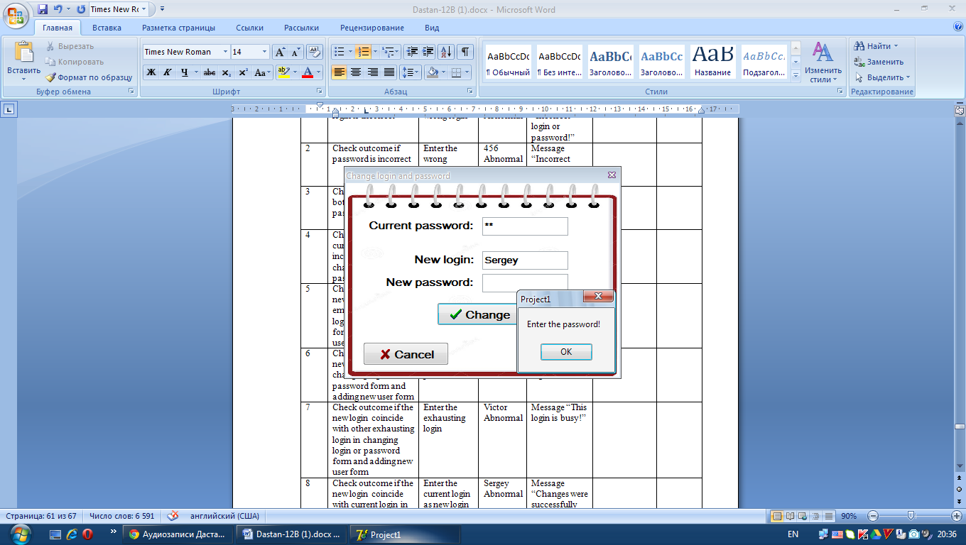

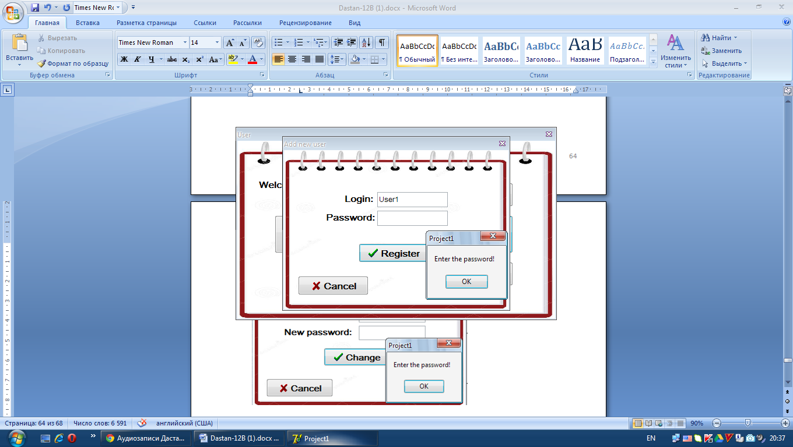

1. Also, logins must have at least one symbol. I leave empty login fields in forms Changing login and password and Adding new user, to check outcome. Then the system showed error message.

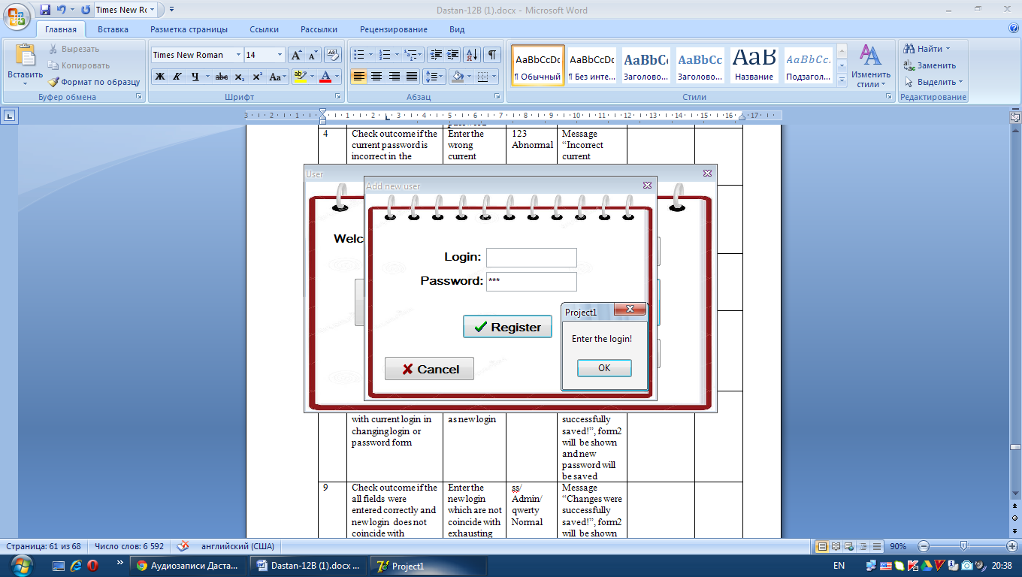

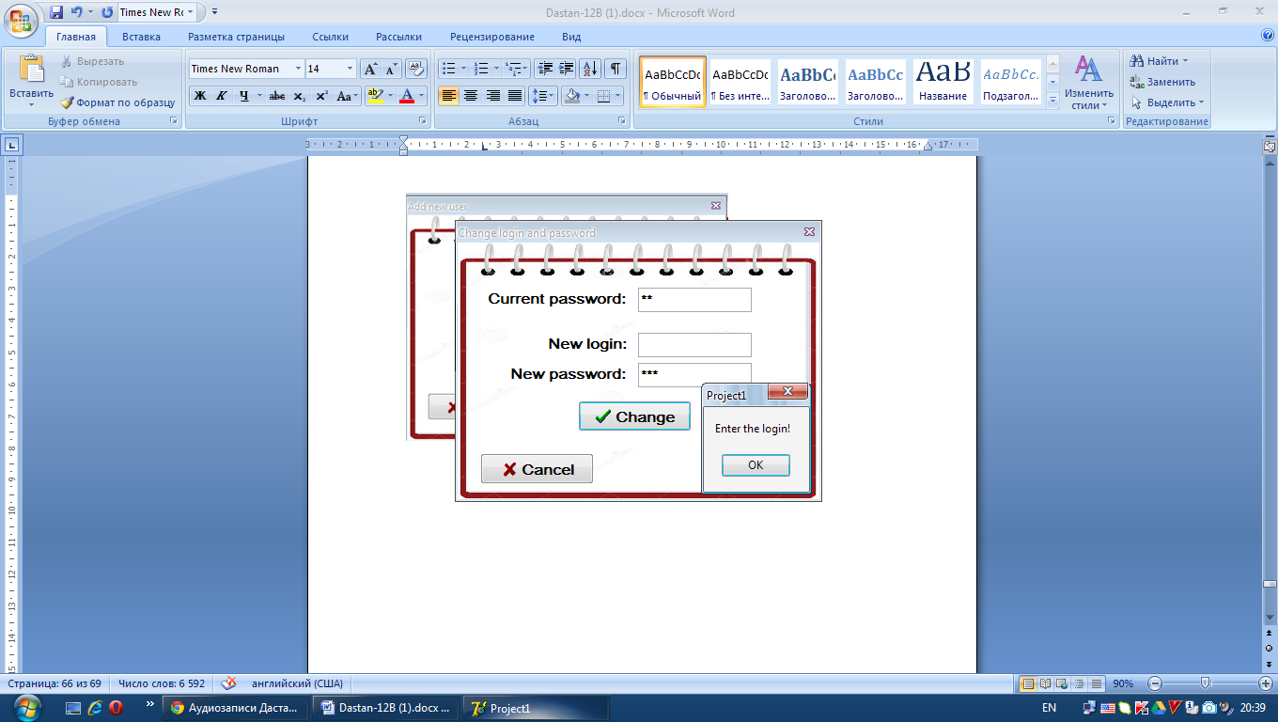

1. Every login must be unique, that is, there cannot be doubling of logins. To check it, I entered the login which already exists. The message that this login is busy was shown and changing was not saved.

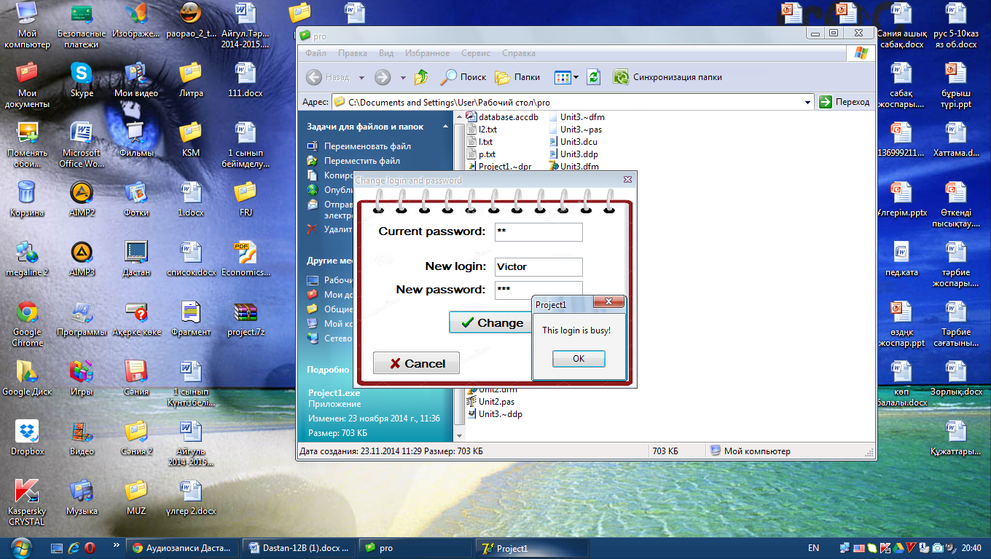

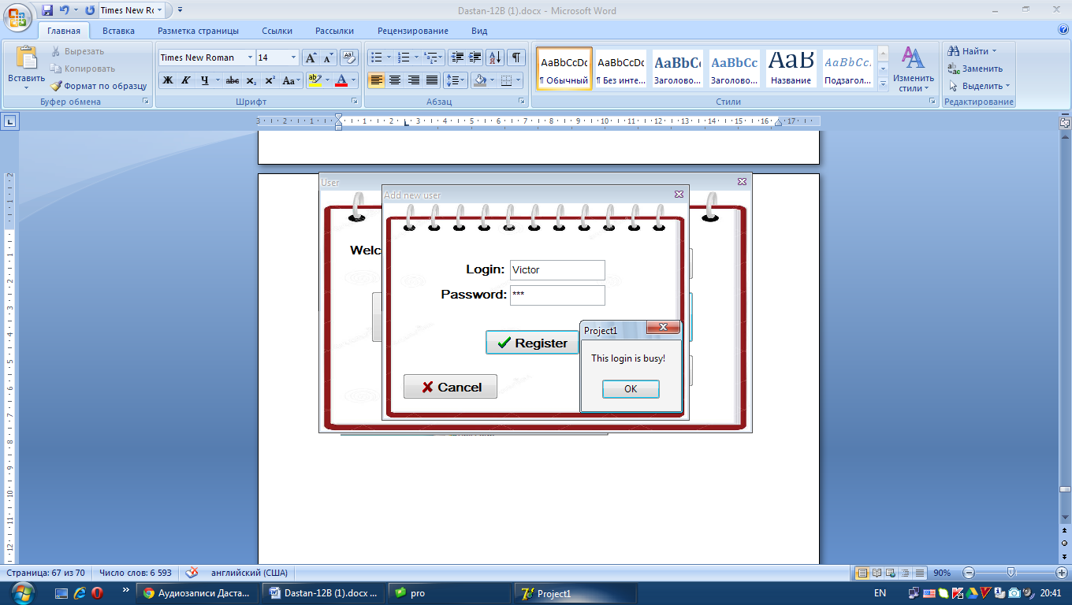

1. The new login can be the same as current. So, the user can change only password. To test it, I entered current password correctly and did not change the login and change the password. Then changing was saved, as it is shown below.

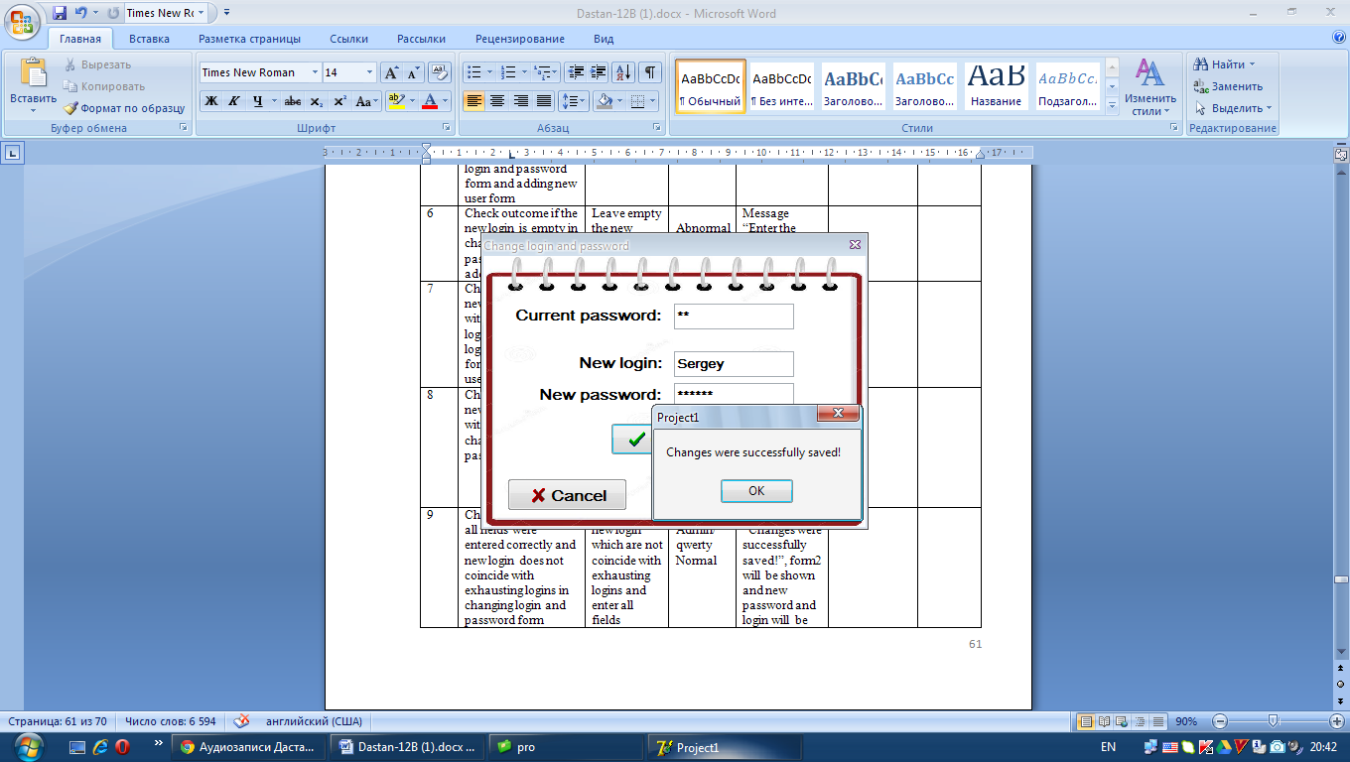

1. To check ability to change both of login and password, I entered the currect password correctly, then changed login and password. The change was saved.

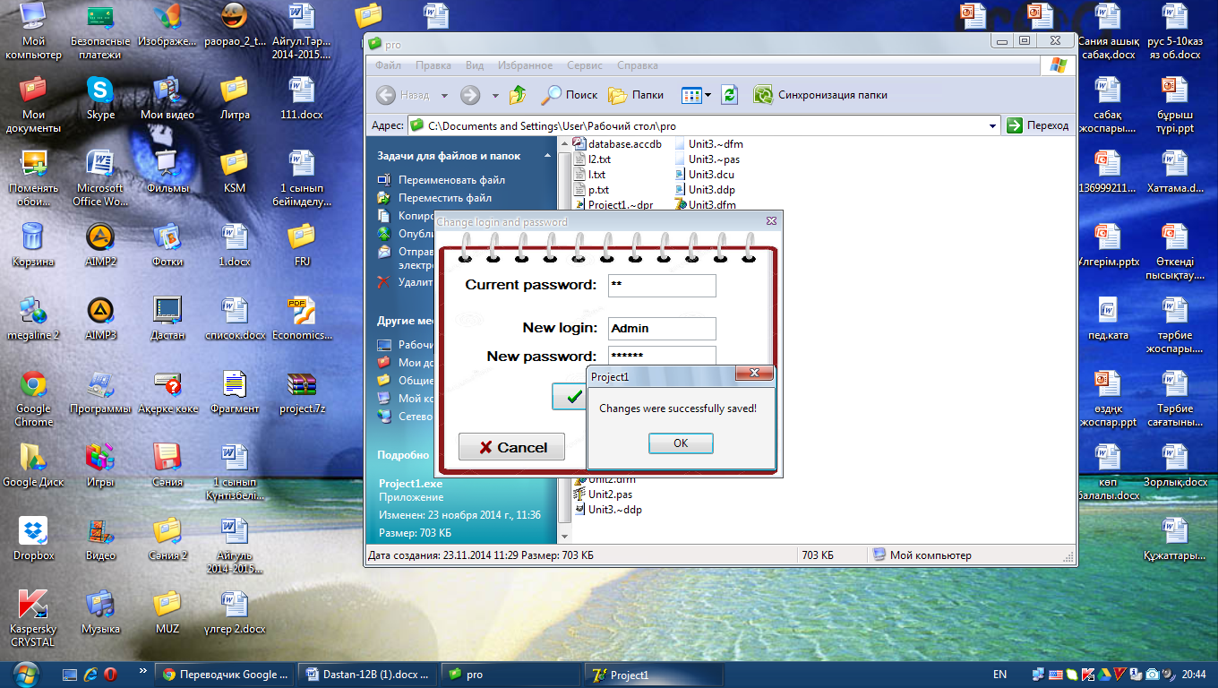

1. To check ability to add new user, I entered the unique login and password. Then changing was successfully saved.

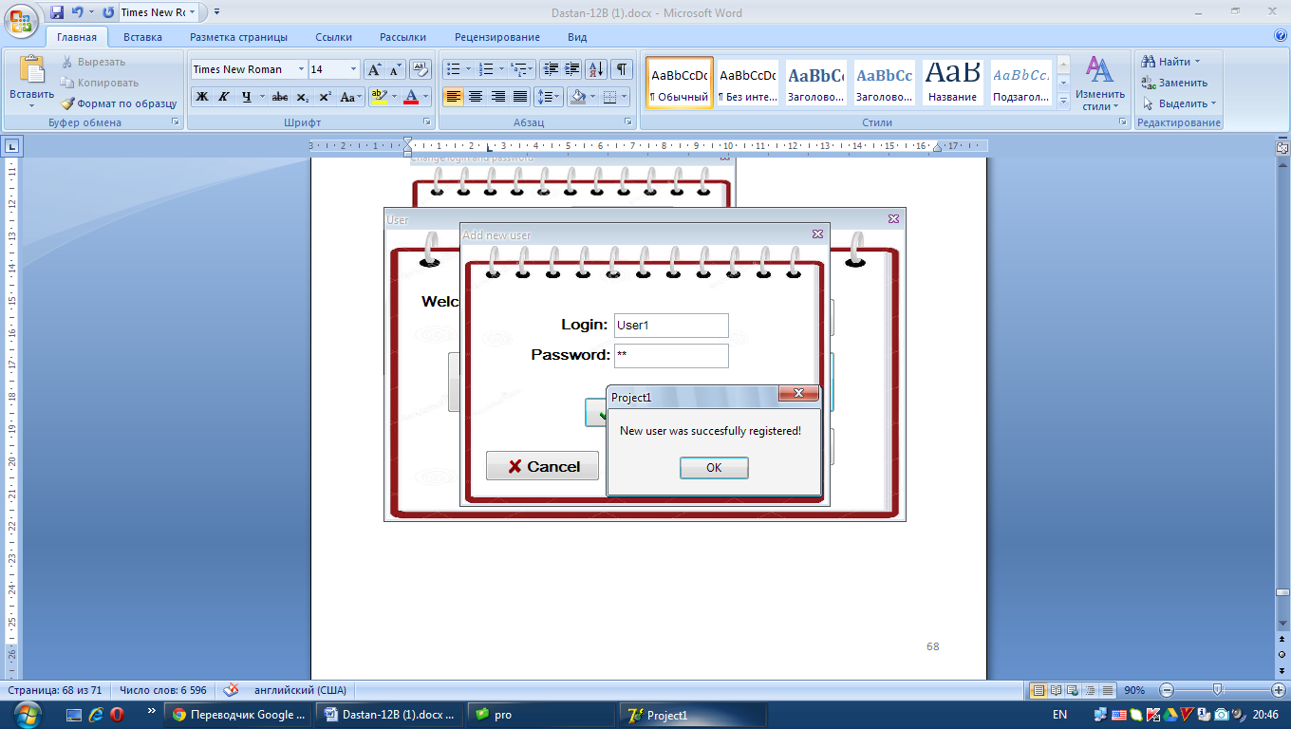

1. To make sure that the user may enter only cities from look up in the input form Student’s information, I entered the word which is not from look up. The message as shown below was shown and changing was not saved.

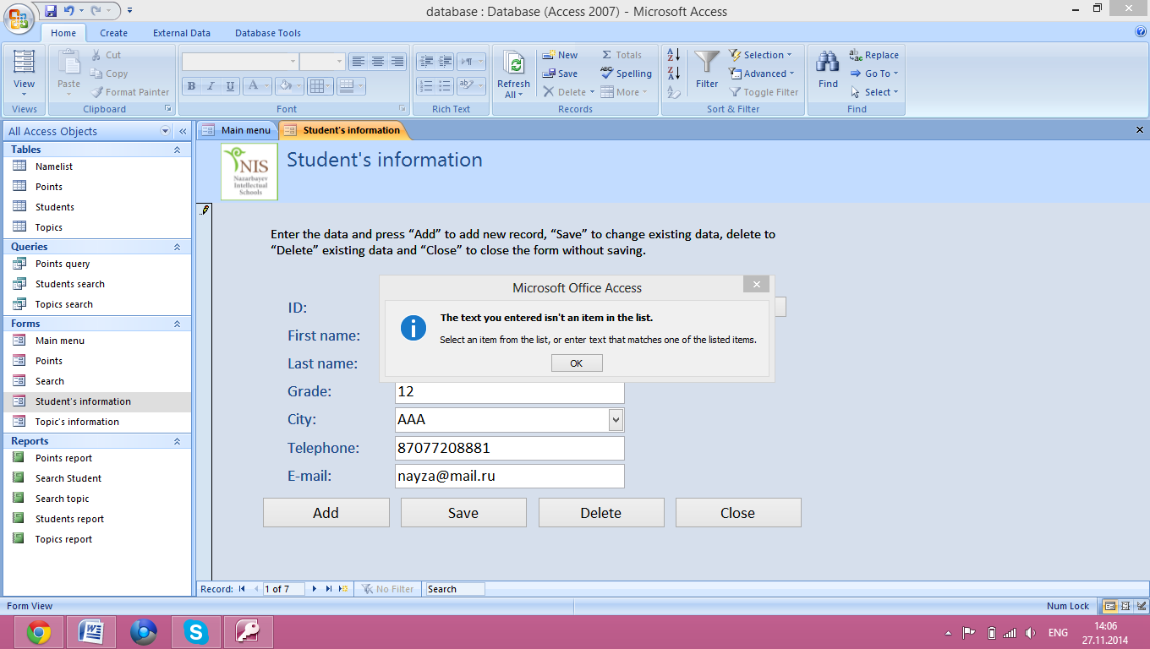

1. There is a validation rule that the grade of student must be between 6 and 12, as my client trains only these grades. I checked it with entering the grade which is not between 6 and 12. The message about mistake was shown and changing was not saved

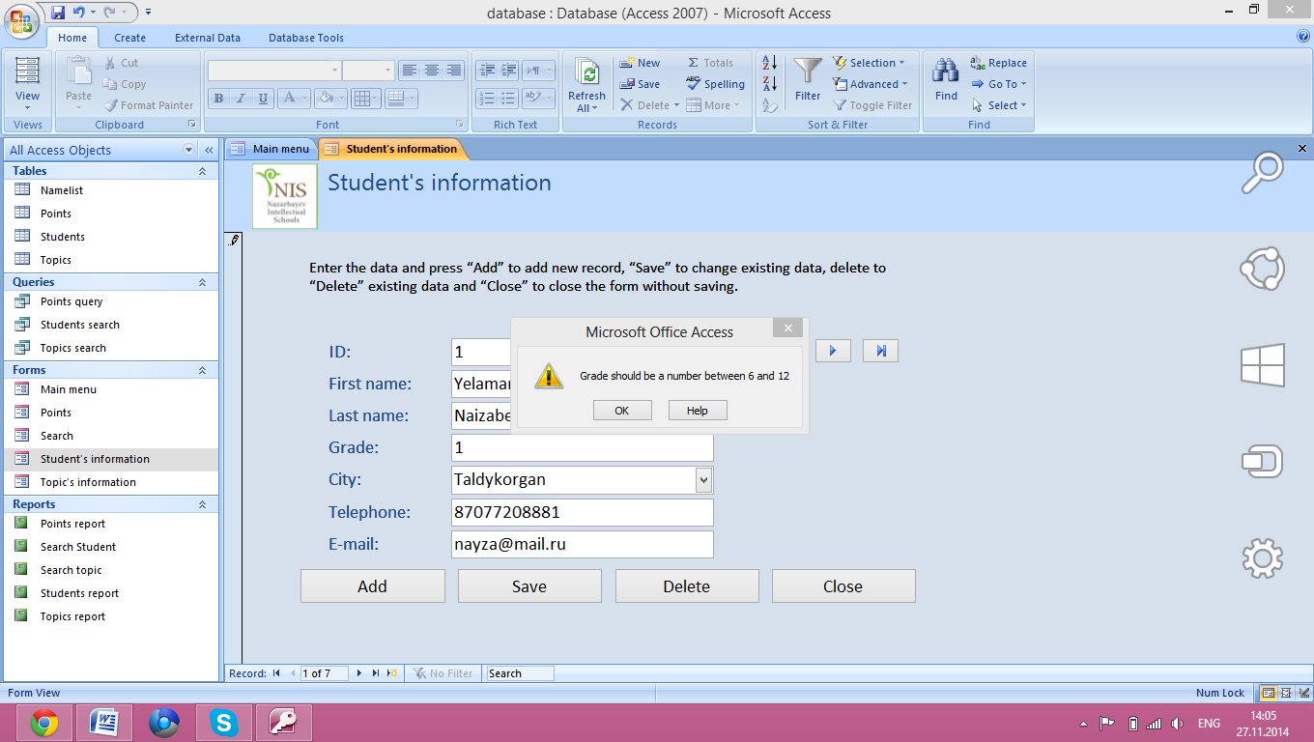

1. To check extreme numbers of the field Grade, I entered the highest grade. The changing was saved without mistakes.

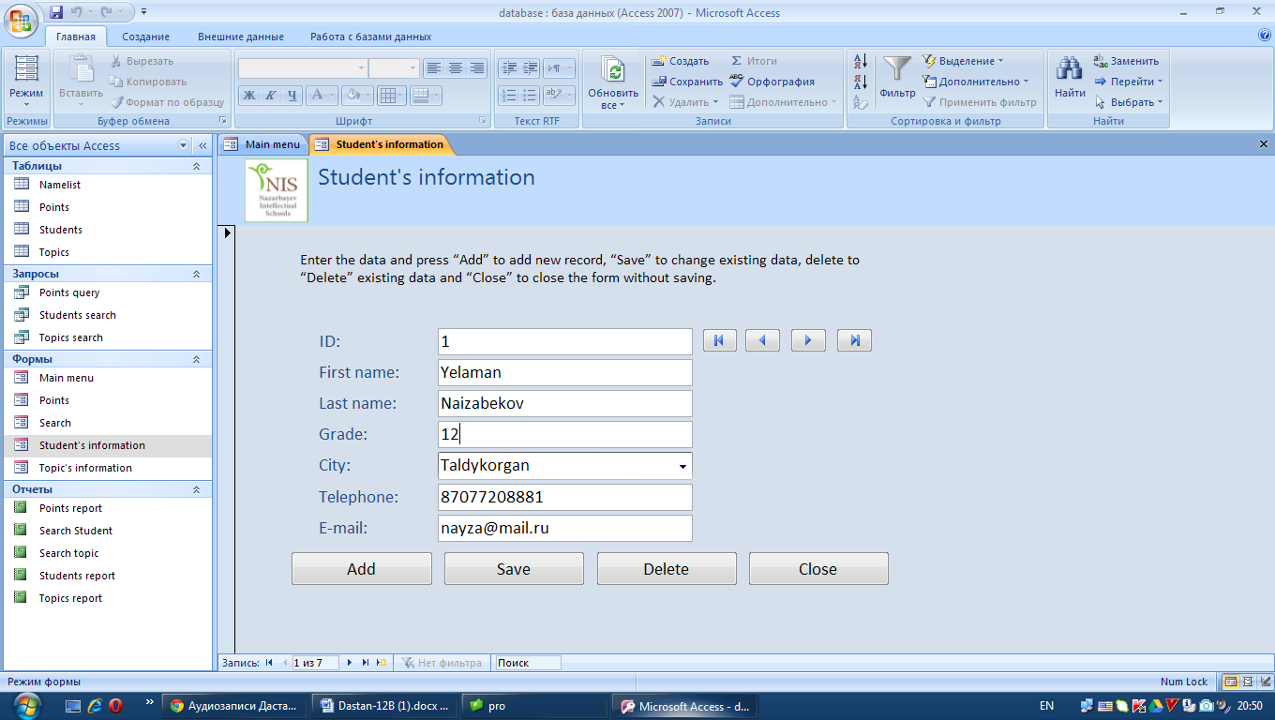

1. All numbers of Kazakhstan must start with numbers 87. To check this rule, I entered the wrong telephone number which does not start with 87. The message “The telephone number should start with numbers 87” was shown and changing was not saved.

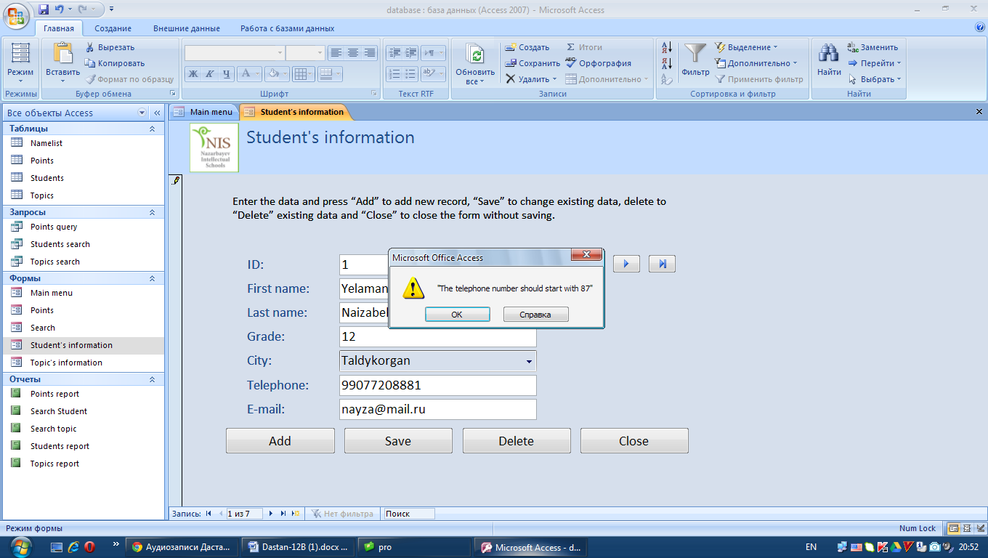

1. To check validation that every telephone number must have 11 numerals, I entered incorrect telephone number which does not have 11 numerals. The system showed message about mistake.

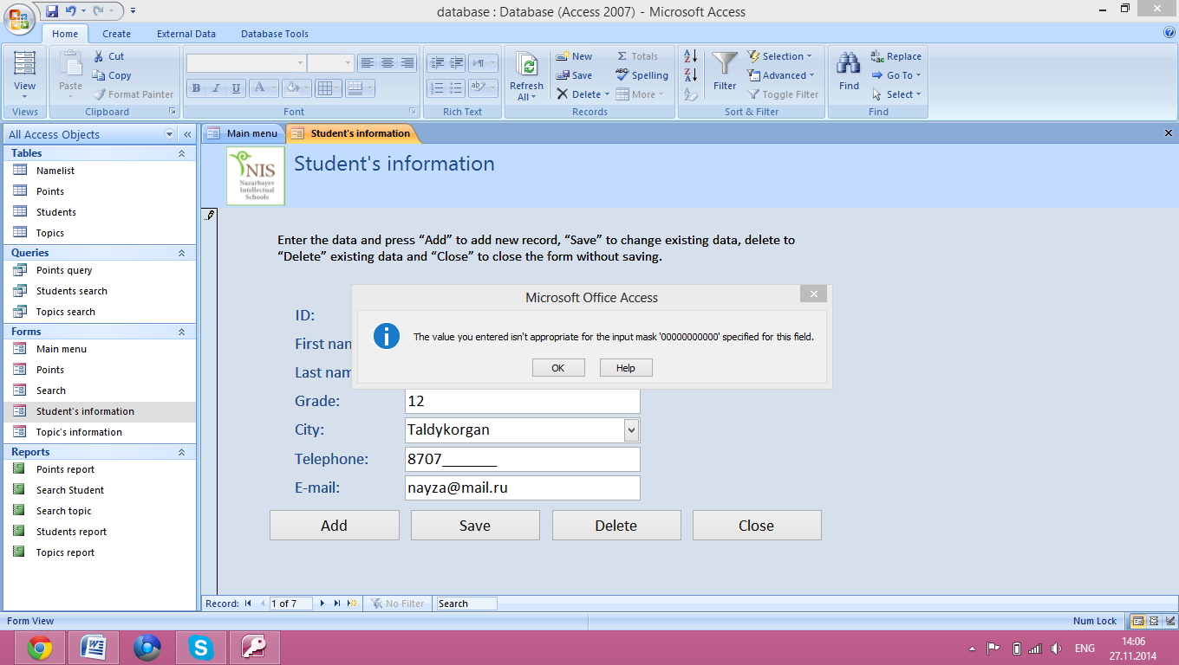

1. Every e-mail address must have symbols “@” and “.”. To check it, I entered invalid e-mail address. Then the mistake was shown.

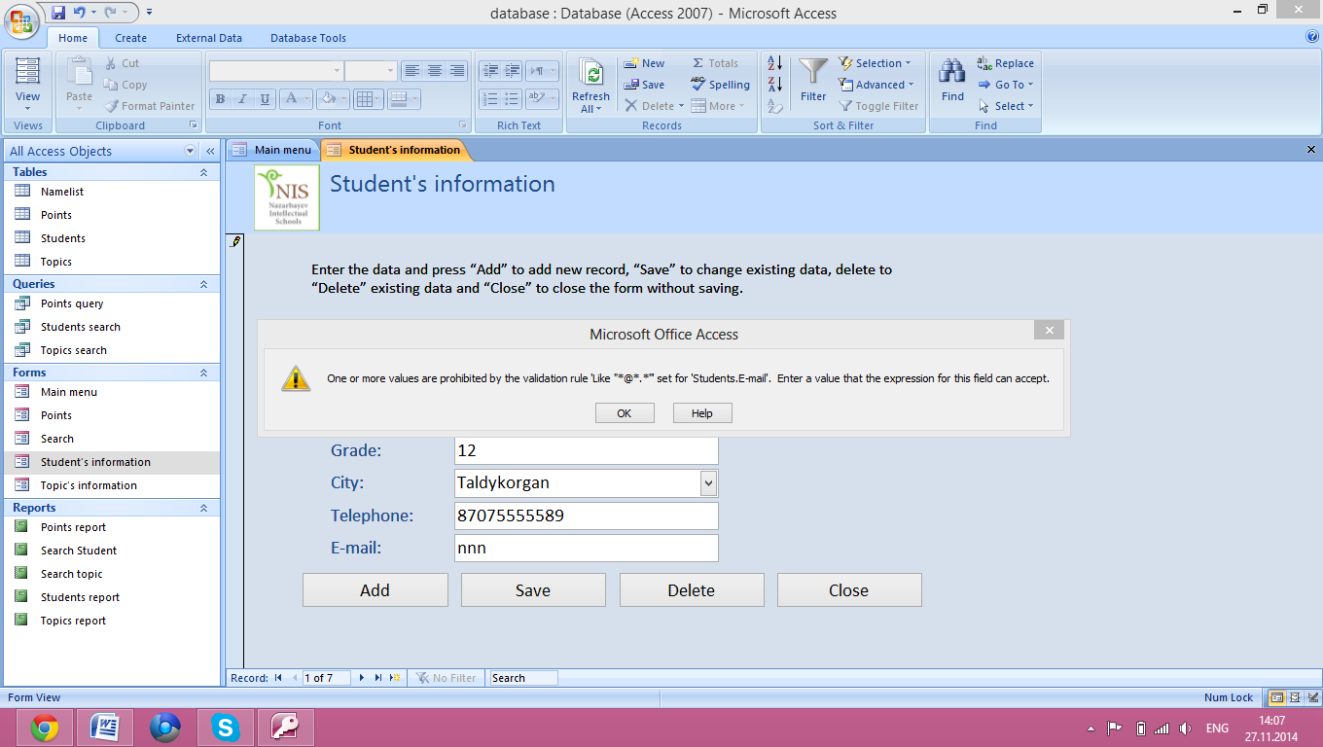

1. To test input forms, that that the record will be saved if all fields was filled correctly, I filled all fields correctly and did it for each input form. Then all records were saved.

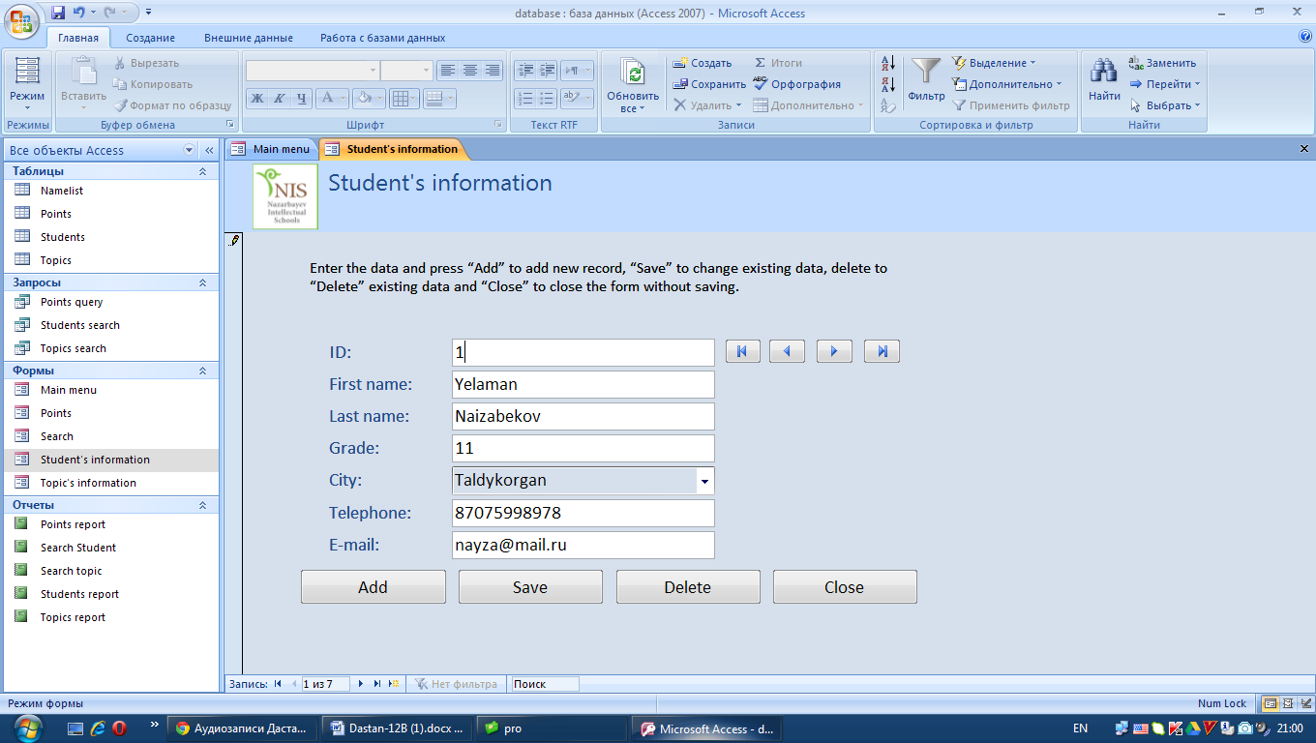

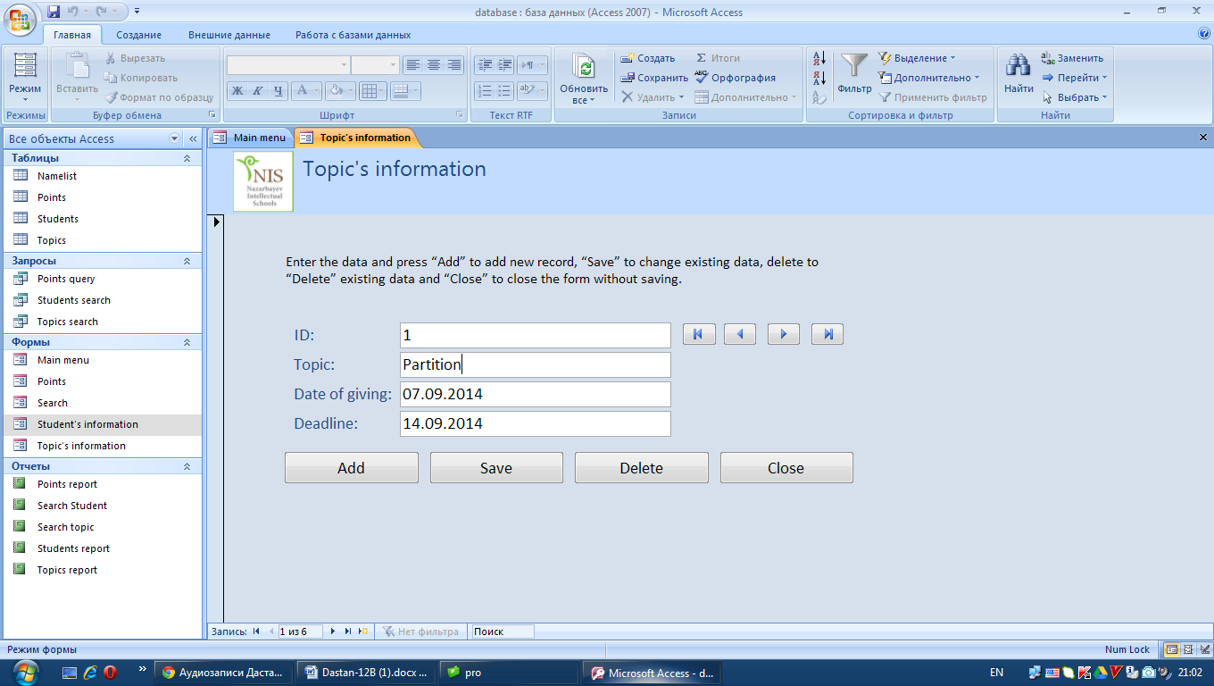

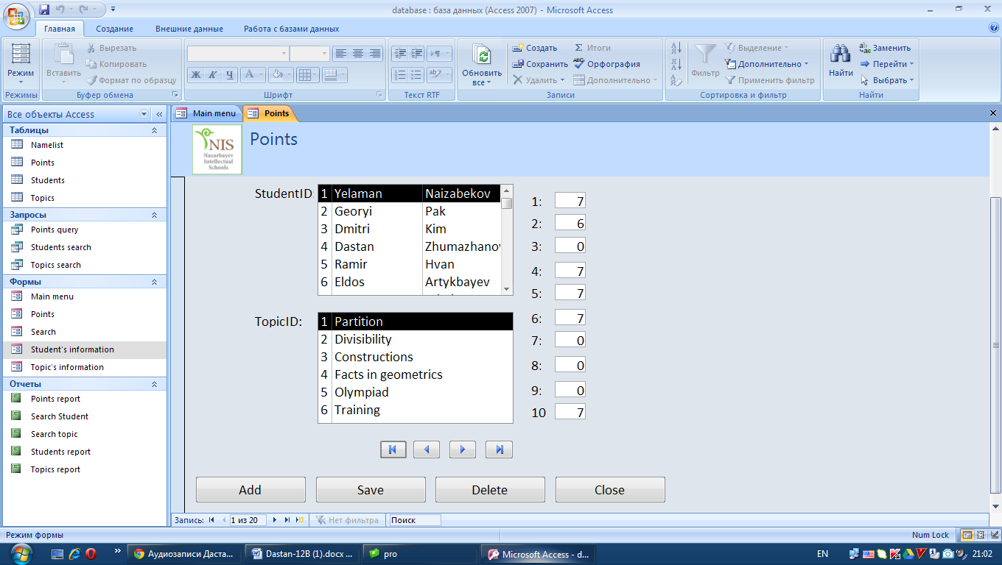

1. The format of the date is general date. To make sure that the user cannot enter the wrong date format, I entered invalid date. Then the mistake was shown as message and changing was not saved.

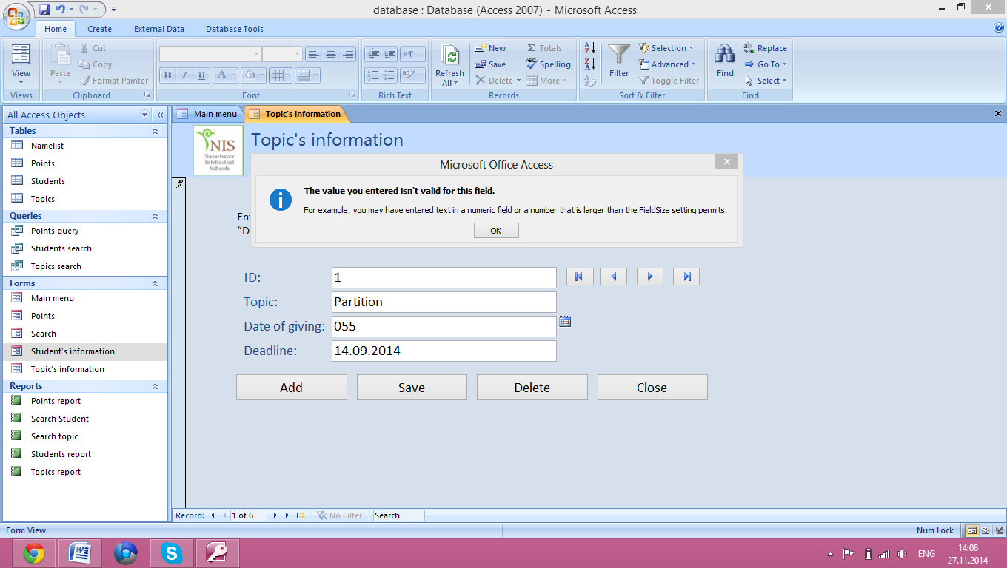

1. To check functions of search, I searched one student and one topic. The system showed all information about chosen student and topic. This information is shown below.

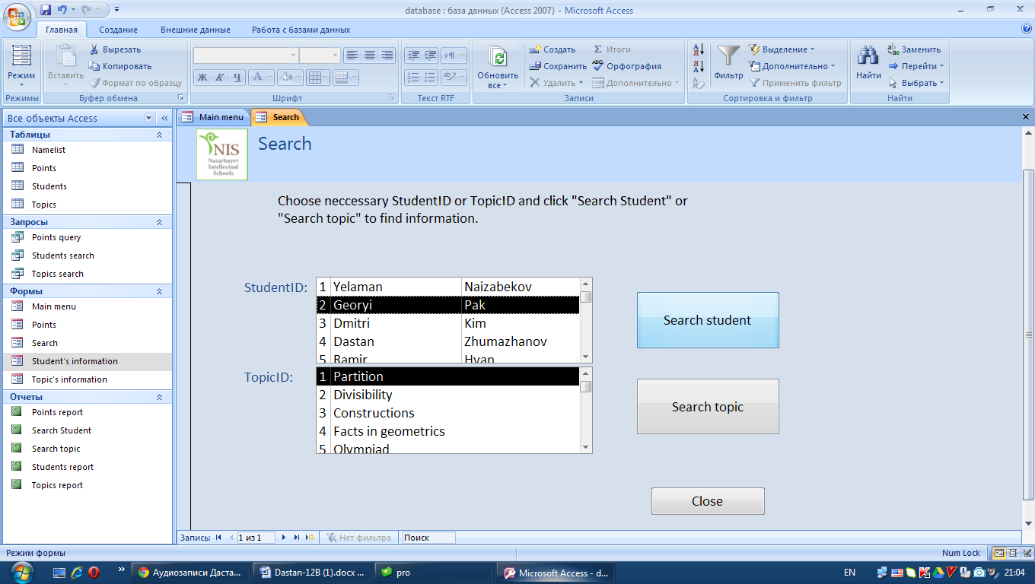

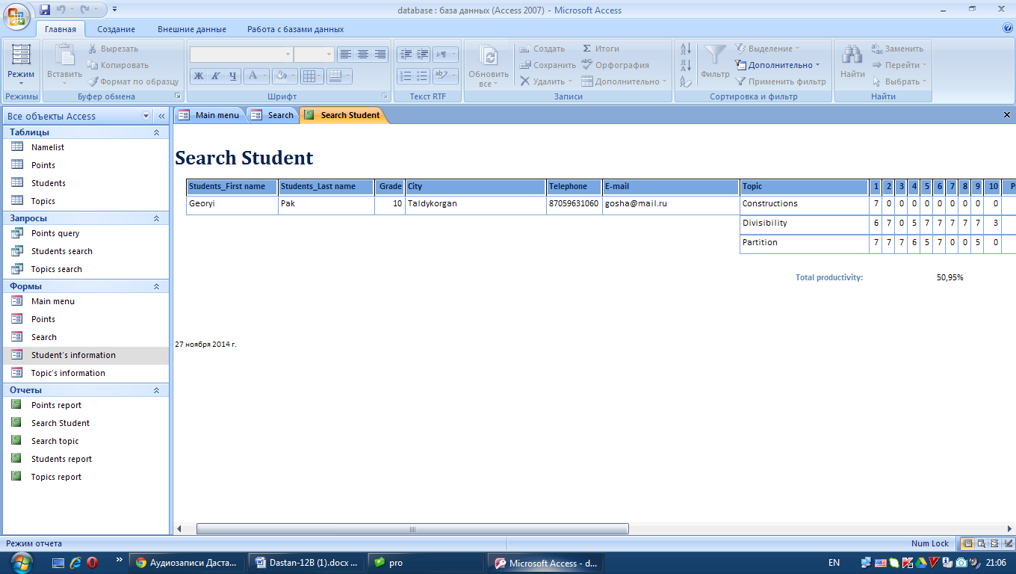

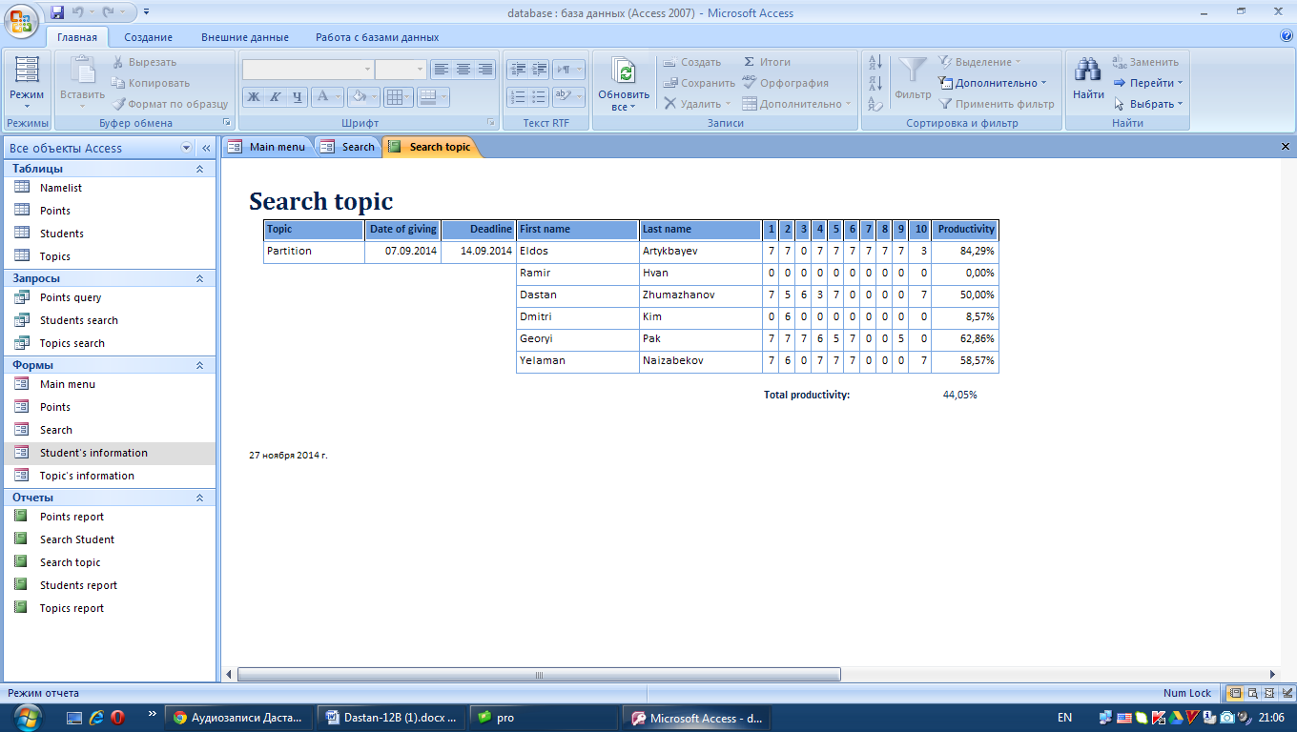

1. The highest point is 7. So, the user cannot enter the number higher than 7. To check it, I entered the number which is higher than 7 into field for setting point. The message about mistake was shown.

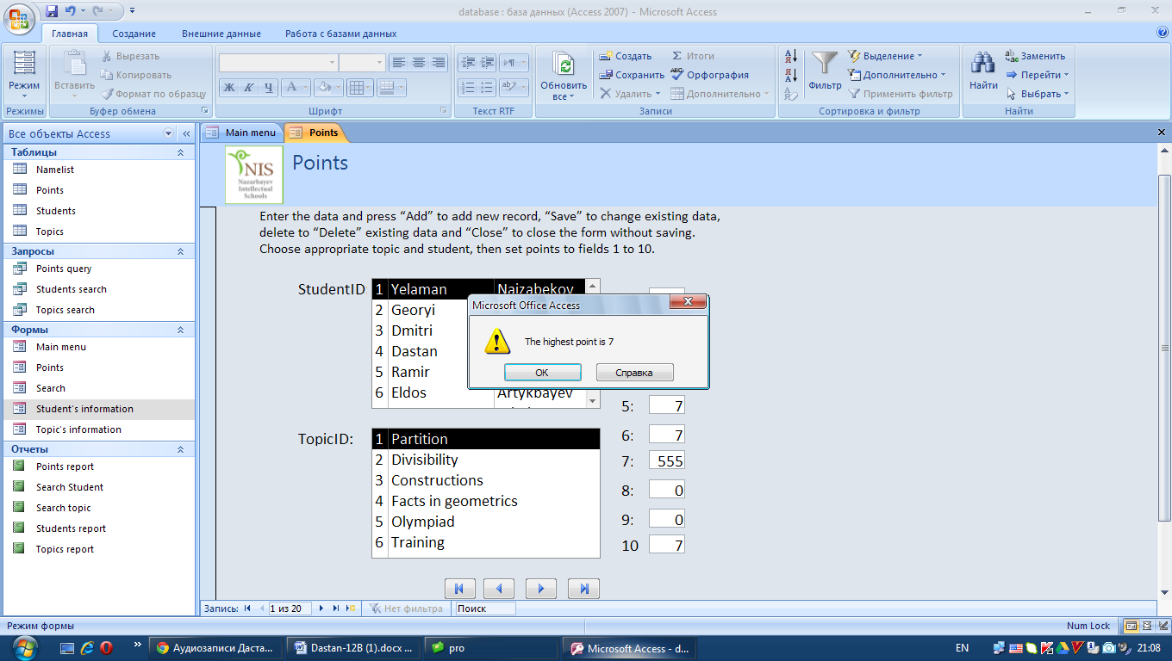

# INSTALLATION

## System changeover

Method of implementation: Direct implementation.

Reason: The new system is not so difficult to implement it much time. In addition, the client needs to use the new system to train students to the regional olympiad which will be in January.

Suggested implementation date: Mid of December.

Reason: It is beginning of time when there will be active preparation to the regional olympiad.

## Installation plan

* Meet with the client and discuss time of installation and training plan
* Give the new system to the client
* Showing the new system and teaching the client to use the new system
* Give time to test the new system from 10 to 12 of December.
* Come back and get results of testing, suggestions and mistakes (if there are mistakes) and answer the questions if the client has questions
* Correct the mistakes
* Transfer all records from old system to the new system
* The client will start to work with the new system
* I will help to my client with using new system while the client will adapt for new system

## Training plan

Suggested training date: 10 of December

Reason: The new system should be used to do rating for training for regional competition. So, staff training should be before training for regional completion in order to be ready to use.

Suggested training method: Teach the teacher to use the new system with describing new functions. First of all, train to enter the program with login and password, changing password and login, and adding new user. Then train to use input forms. Then train to use tables, then reports, then searching function. The teacher will teach other teachers, who will help him to set points, to use the system.

Reason: Only one teacher will use the system mostly and other teachers will help him sometimes.

## Evidence of user testing

The implementation and training plans were discussed in the meeting with the client (teacher). Then I was teaching the client to the new system in planned day. Then the client was testing the new system for two days from 10 to 12 of December. Then I took the letter, which prove that the client was testing the system, and answers to the questionnaire.

It the evidence that the client was testing the new system

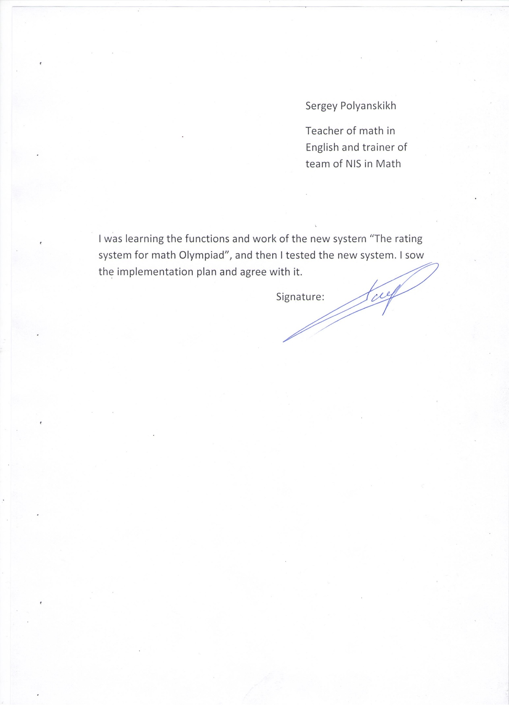

It is the results of questionnaire.

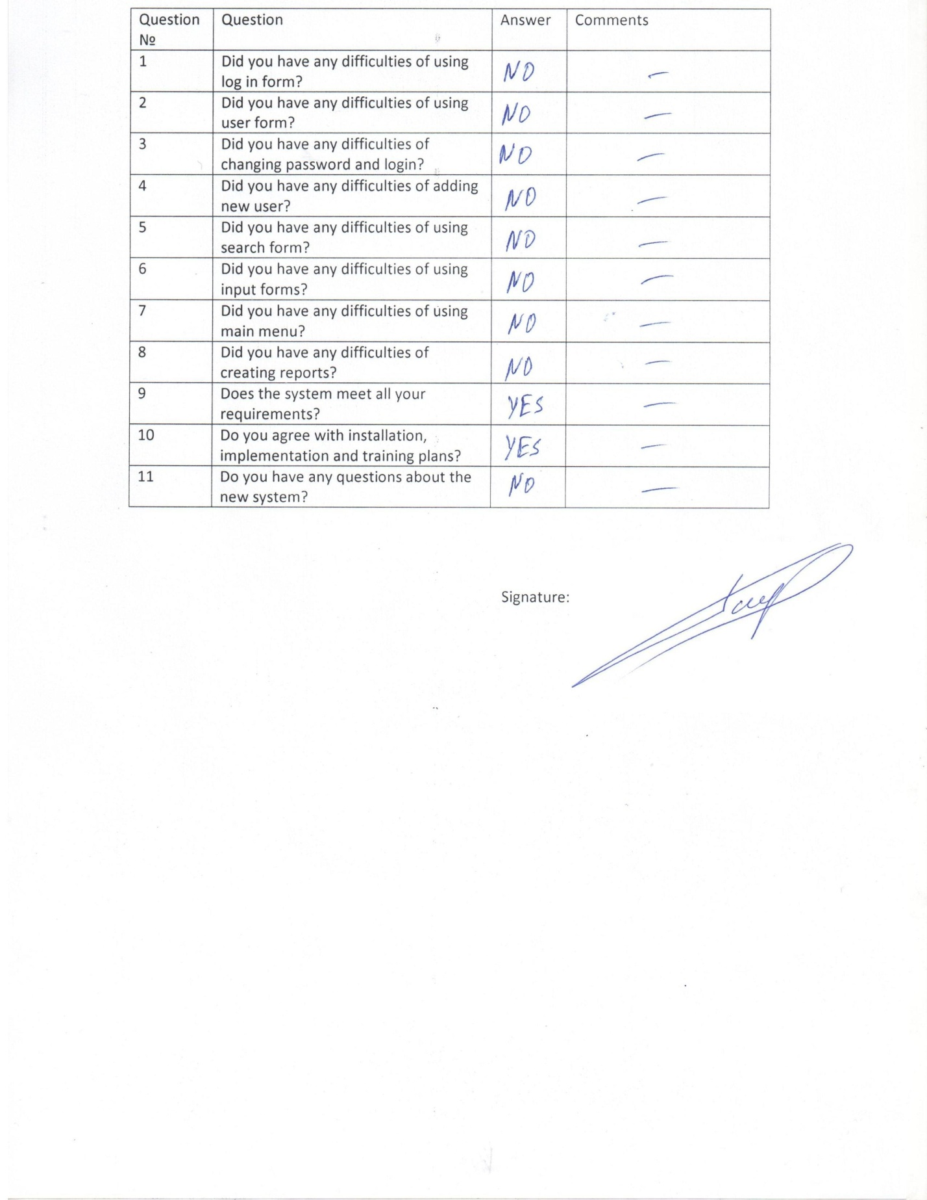

# DOCUMENTATION

## Record and file structures used and other reference example

|  |  |
| --- | --- |
| Section | Page reference |
| Record, File and Data structures | 17-18 |
| Flow chart | 25 |
| Data Flow Diagram | 24 |
| System Design Diagram | 16 |
| Annotated Program Listings (code) | 57-60 |
| Hardware and Software required | 15 |
| Algorithm | 26 |

## Data dictionary

Forms:

|  |  |
| --- | --- |
| Form name | Use |
| Log in | Checks the login and password of the user |
| User | Controls user details: login and password |
| Change login and password | Changes the login and password of the existing user |
| Add new user | Adds new user’s login and password |
| Main menu | Contains the buttons which intended for control the data base |
| Student’s information | Adds information about student |
| Topic’s information | Adds information about topic |
| Points | Sets points |
| Search | Searches student or topic |

Log in form objects

|  |  |  |
| --- | --- | --- |
| Object name | Type | Use |
| Label1 | label | To show that there should be entered the login |
| Edit1 | edit | To enter the login |
| Label2 | label | To show that there should be entered the password |
| Edit2 | edit | To enter the password |
| Label3 | label | Short instruction |
| Memo3 | memo | To save the ID of the user |
| Memo2 | memo | To load the passwords list |
| Memo1 | memo | To load the logins list |
| Image1 | image | The background |
| BitBtn1 | button | To check the login and password and to show the next form |

User form objects:

|  |  |  |
| --- | --- | --- |
| Object name | Type | Use |
| Label1 | label | To show the login of user | |
| Memo2 | memo | To load the ID of the user | |
| Memo1 | memo | To load the logins list | |
| Image1 | image | The background | |
| BitBtn1 | button | To close the program | |
| Button1 | button | To show Change login and password form | |
| Button2 | button | To show Add new user form | |
| Button3 | button | To open the data base in the Access | |
| Timer1 | timer | To wait 0.1secuonds before loading logins | |

Change login and password form objects:

|  |  |  |
| --- | --- | --- |
| Object name | Type | Use |
| Label1 | label | To show that there should be entered the current password |
| Edit1 | edit | To enter the current password |
| Label2 | label | To show that there should be entered the new login |
| Edit2 | edit | To enter the new login |
| Label3 | label | To show that there should be entered the new password |
| Edit3 | edit | To enter the new password |
| Memo3 | memo | To load the ID of the user |
| Memo2 | memo | To load the passwords list |
| Memo1 | memo | To load the logins list |
| Image1 | image | The background |
| Image2 | image | The icon of the lock |
| BitBtn1 | button | To save the login and password |
| BitBtn2 | button | Close the form |

Add new user form objects:

|  |  |  |
| --- | --- | --- |
| Object name | Type | Use |
| Label1 | label | To show that there should be entered the login of the user |
| Edit1 | edit | To enter the login |
| Label2 | label | To show that there should be entered the password of the new user |
| Edit2 | edit | To enter the password |
| Memo2 | memo | To load the passwords list |
| Memo1 | memo | To load the logins list |
| Image1 | image | The background |
| Image2 | image | The icon of registering user |
| BitBtn1 | button | To check the login and password and to show the next form |
| BitBtn1 | button | To save the login and password of the new user |
| BitBtn2 | button | Close the form |

Main Menu form objects:

|  |  |  |
| --- | --- | --- |
| Object name | Type | Use |
| Auto_Title0 | title | To show that it is the main menu |
| Auto_Logo0 | logo | Logo of the school |
| Label30 | label | Short instruction |
| Label8 | label | To show that all buttons below is intended to edit the records |
| Open student-menu | button | To open input form Student’s information |
| Open topic-menu | button | To open input form Topic’s information |
| Open points-menu | button | To open input form Points |
| Label17 | label | To show that all buttons below is intended to view the records |
| View student-menu | button | To show Students table |
| View topic-menu | button | To show Topics table |
| View points-menu | button | To show Points table |
| Label18 | label | To show that all buttons below is intended to do reports |
| Report student-menu | button | To create report for Students table |
| Report topic-menu | button | To create report for Topics table |
| Report points-menu | button | To create report for Points table |
| Search-menu | button | To open the search form |
| Close-menu | button | To close the menu form |

Student’s information input form objects:

|  |  |  |
| --- | --- | --- |
| Object name | Type | Use |
| Auto_Title0 | title | To show that it is the input form Student’s information |
| Auto_Logo0 | logo | Logo of the school |
| Label28 | label | Short instruction |
| Label1 | label | To show that there should be entered the ID |
| ID | edit | To enter the ID |
| Label3 | label | To show that there should be entered First name |
| First name | edit | To enter First name |
| Label5 | label | To show that there should be entered Last name |
| Last name | edit | To enter Last name |
| Label7 | label | To show that there should be entered Grade |
| Grade | edit | To enter Grade |
| Label17 | label | To show that there should be entered City |
| City | Look up | To enter City |
| Label11 | label | To show that there should be entered Telephone number |
| Telephone | edit | To enter Telephone number |
| Label13 | label | To show that there should be entered E-mail |
| E-mail | edit | To enter e-mail |
| First-student | button | Go to the first record |
| Previous-student | button | Go to the previous record |
| Next-student | button | Go to the next record |
| Last-student | button | Go to the last record |
| Add-student | button | Add new record |
| Save-student | button | Save changes |
| Delete-student | button | Delete the record |
| Close-menu | button | To close the form |

Topic’s information input form objects

|  |  |  |
| --- | --- | --- |
| Object name | Type | Use |
| Auto_Title0 | title | To show that it is the input form Topic’s information |
| Auto_Logo0 | logo | Logo of the school |
| Label9 | label | Short instruction |
| Label1 | label | To show that there should be entered the ID |
| ID | edit | To enter the ID |
| Label3 | label | To show that there should be entered the name of the topic |
| Topic | edit | To enter the name of the topic |
| Label5 | label | To show that there should be entered Date of giving |
| Date of giving | edit | To enter Date of giving |
| Label7 | label | To show that there should be entered Deadline |
| Deadline | edit | To enter Deadline |
| First-student | button | Go to the first record |
| Previous-student | button | Go to the previous record |
| Next-student | button | Go to the next record |
| Last-student | button | Go to the last record |
| Add-student | button | Add new record |
| Save-student | button | Save changes |
| Delete-student | button | Delete the record |
| Close-menu | button | To close the form |

Points input form objects:

|  |  |  |
| --- | --- | --- |
| Object name | Type | Use |
| Auto_Title0 | title | To show that it is the input form Points |
| Auto_Logo0 | logo | Logo of the school |
| Label39 | label | Short instruction |
| Label27 | Label | To show that there should be entered the StudentID |
| StudentID | Look up | To enter StudentID |
| Label28 | label | To show that there should be entered the TopicID |
| TopicID | Look up | To enter TopicID |
| Label29 | label | To show that there should be entered points for problem №1 |
| 1 | edit | To enter points for problem №1 |
| Label30 | label | To show that there should be entered points for problem №2 |
| 2 | edit | To enter points for problem №2 |
| Label31 | label | To show that there should be entered points for problem №3 |
| 3 | edit | To enter points for problem №3 |
| Label32 | label | To show that there should be entered points for problem №4 |
| 4 | edit | To enter points for problem №4 |
| Label33 | label | To show that there should be entered points for problem №5 |
| 5 | edit | To enter points for problem №5 |
| Label34 | label | To show that there should be entered points for problem №6 |
| 6 | edit | To enter points for problem №6 |
| Label35 | label | To show that there should be entered points for problem №7 |
| 7 | edit | To enter points for problem №7 |
| Label36 | label | To show that there should be entered points for problem №8 |
| 8 | edit | To enter points for problem №8 |
| Label37 | label | To show that there should be entered points for problem №9 |
| 9 | edit | To enter points for problem №9 |
| Label38 | label | To show that there should be entered points for problem №10 |
| 10 |  | To enter points for problem №10 |
| First-student | button | Go to the first record |
| Previous-student | button | Go to the previous record |
| Next-student | button | Go to the next record |
| Last-student | button | Go to the last record |
| Add-student | button | Add new record |
| Save-student | button | Save changes |
| Delete-student | button | Delete the record |
| Close-menu | button | To close the menu form |

Search form objects:

|  |  |  |
| --- | --- | --- |
| Object name | Type | Use |
| Auto_Title0 | title | To show that it is the input form Points |
| Auto_Logo0 | logo | Logo of the school |
| Label6 | label | Short instruction |
| Label1 | Label | To show that there should be entered the StudentID |
| StudentID | Look up | To enter StudentID |
| Label3 | label | To show that there should be entered the TopicID |
| TopicID | Look up | To enter TopicID |
| Search student | button | To search student |
| Search topic | button | To search topic |
| Close-menu | button | To close the menu form |

Tables:

|  |  |
| --- | --- |
| Table name | Use |
| Students | Information about students |
| Topics | Information about topics |
| Points | Set points of students for topics |

Students table fields:

|  |  |  |
| --- | --- | --- |
| **Object name** | **Type** | **Use** |
| StudentID  (primary key) | Auto number | Make the record unique |
| First name | text | To show the first name of student |
| Last name | text | To show the last name of student |
| Grade | number | To show the grade of student |
| City | text | To show the city where student study |
| Telephone | text | To show the student’s phone number |
| E-mail | text | To show the e-mail address of student |

Topics table fields:

|  |  |  |
| --- | --- | --- |
| **Object name** | **Type** | **Use** |
| TopicID  (primary key) | Auto number | Make the record unique |
| Topic | text | To show the name of topic |
| Date of giving | Date/time | To show the date when the topic is given |
| Deadline | Date/time | To show the date of deadline |

Points table fields:

|  |  |  |
| --- | --- | --- |
| **Object name** | **Type** | **Use** |
| StudentID | Auto number | To show the ID of student |
| TopicID | Auto number | To show the ID of topic |
| 1 | number | To show the points for problem №1 |
| 2 | number | To show the points for problem №2 |
| 3 | number | To show the points for problem №3 |
| 4 | number | To show the points for problem №4 |
| 5 | number | To show the points for problem №5 |
| 6 | number | To show the points for problem №6 |
| 7 | number | To show the points for problem №7 |
| 8 | number | To show the points for problem №8 |
| 9 | number | To show the points for problem №9 |
| 10 | number | To show the points for problem №10 |

## Adaptive maintenance

The system can be adapted for other users by adding new user or changing the existing login and password of user. For example, teachers of other subjects can use the system by adapting it.

There should be some additions to improve the system:

* Do the system online so that several users could use the system from different places
* Special query for final rating which contains only ID, first name, last name and total productivity of each student
* Ability to delete login and password of user
* The query which shows students who have more than entered points (the client will enter the number and the system will show students who earned more than this number of points)
* Working directly with txt file instead of using memos for loading login and password lists (it will optimize the work of the system)
* Viewing of tables in the input forms
* Searching by city and grade
* Function to send the report to e-mail

## Back-Up procedure and storage media

Storage media

* Dropbox will be used to do backups. Dropbox is online storage, where the user can store the data. The folder will not take so much space in the dropbox folder, it will take less than 20mb. Every user gets 2Gb space for free in the dropbox. That is why, there will be enough space in the dropbox for the folder of the system.

Storage media use

* After the end of each week the client should enter all results for this week and save all records.
* Then the client should send the system folder to the dropbox folder and replace the previous buck ups with new.
* If it is necessary that the client can download system folder from the internet, because the client should have access to the system everywhere, where are computer and the internet. The system is not intended for smart phones or for other devices which has not windows operation system.

# USER DOCUMENTATION

Index

User guide 88

Running the system 88

Log in form 89

User form 89

Change login and password form 90

Add new user form 90

Main menu form 91

Input forms 92

Tables 95

Reports 96

Search form 98

Error Guide 98

Back-up 99

Glossary 100

## User guide

### Running the system

To run the program, find the icon of the program with name RSMO.exe in the desktop, and click twice on this icon with left button of mouse.

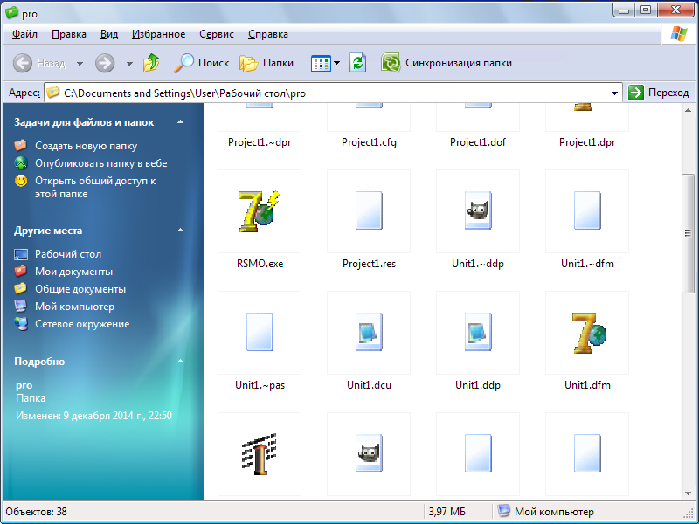

After running the program you will see Log in form.

### Log in form:

* Enter the login and the password which you get when you get the new system or you own login and password
* Click on “enter”

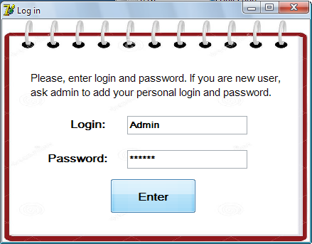

### User form:

* Click on “Change login and password” to change login and password
* Click on “Add new user” to add new user
* Click on “Exit” to close the program
* Click on “Open Data Base” to open the main menu in Access



### Change login and password form:

* Enter the current password
* Enter the new login
* Enter the new password
* Click on “Change” to save changes
* Click on “Cancel” to back to user form without changes

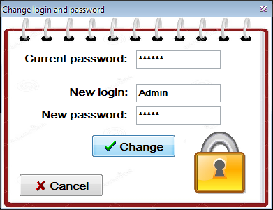

### Add new user form:

* Enter the login of the new user (the login should be unique)
* Enter the password of the new user
* Click on “Register” to save the login and password of the new user
* Click on “Cancel” to come back to user form without saving

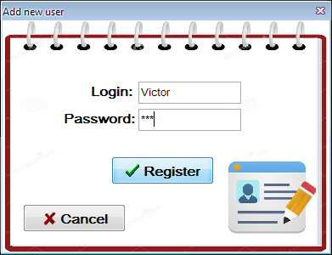

### Main menu form:

After opening the data base in access you will see Main Menu form in Access. Before starting to use the menu, click on options on the top of the main menu. Then choose “Enable this content” and click ok. Then you can use main menu form. Do not clock on buttons and so not change any settings which are outside of form.

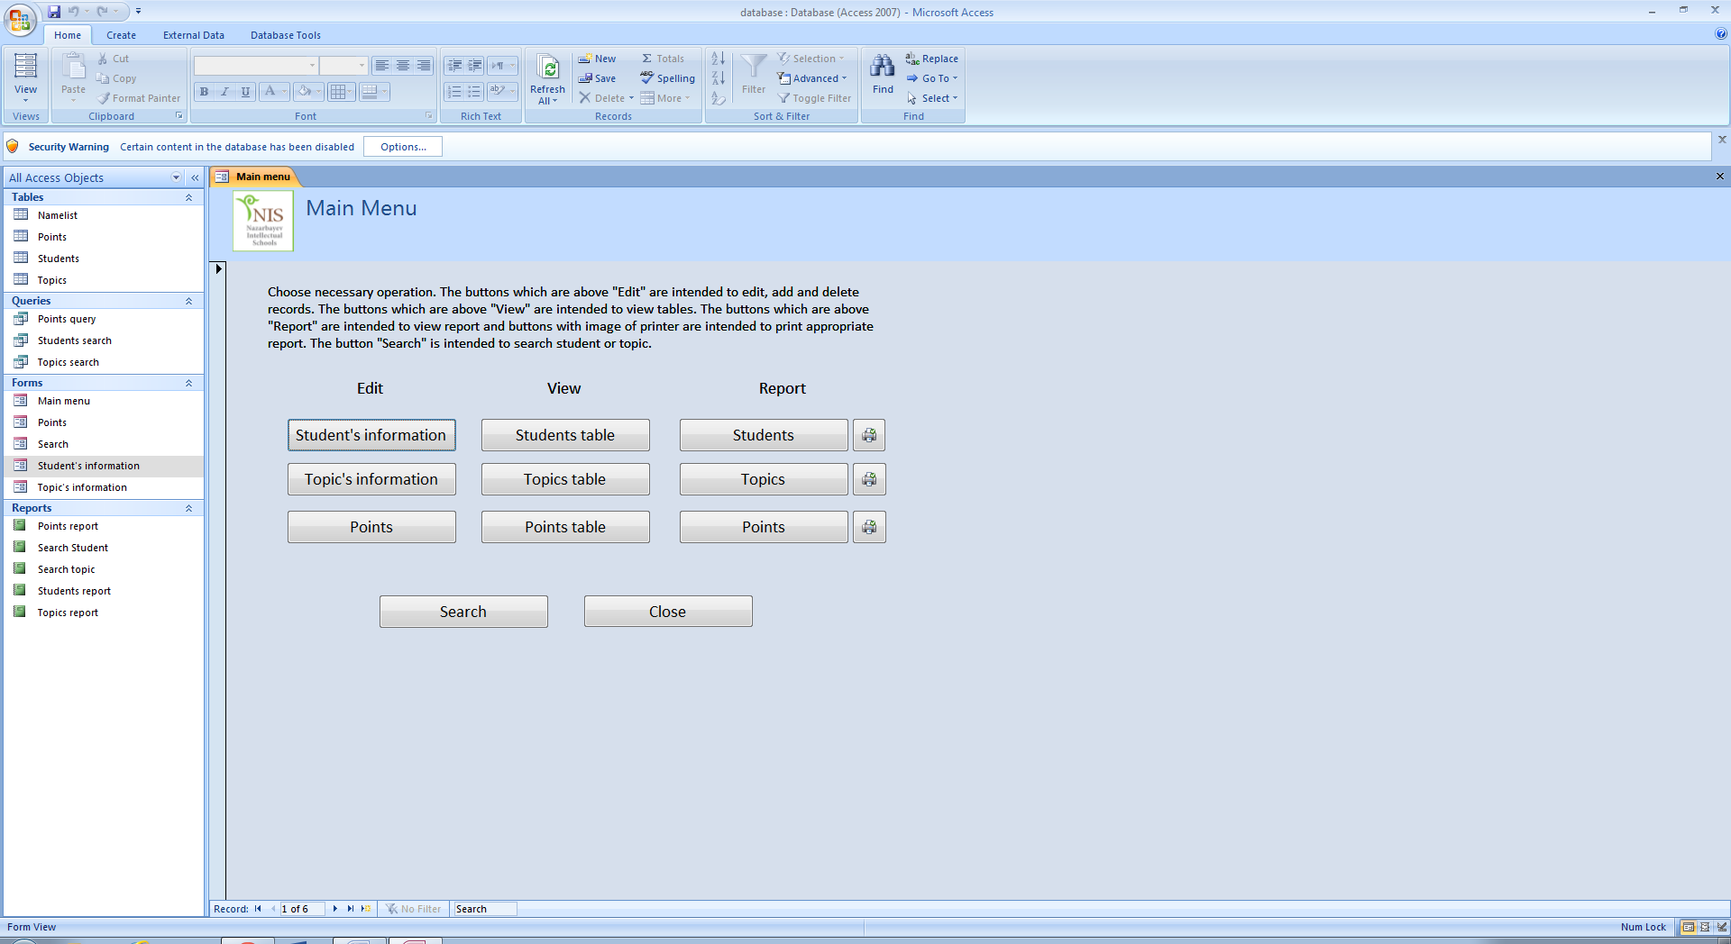

If you are using the system at first time, read the instruction. Choose necessary operation. The buttons which are above "Edit" are intended to edit, add and delete records. The buttons which are above "View" are intended to view tables. The buttons which are above "Report" are intended to view report and buttons with image of printer are intended to print appropriate report. The button "Search" is intended to search student or topic.

* Click Student’s information below “edit” to add, change of delete the information about student
* Click Topic’s information below “edit” to add, change of delete the information about topic
* Click Points below “edit” to set points
* Click Students table below “view” to view the students table. (You can change or add records using tables)
* Click Topics table below “view” to view the topics table
* Click Points table below “view” to view the points table
* Click Students below “report” to create the report of list of students. Click the button with printer to print appropriate report.
* Click Topics below “report” to create the report of list of topics.
* Click Points below “report” to create the report which contains all points of all students and productivity
* Click Search to do search by name of student or by topic
* Click Close to close the Access and come back to User form

### Input forms:

There are three input forms: Student’s information, Topic’s information, and Points. There are short instructions for each input form. Read the instruction before starting to use.

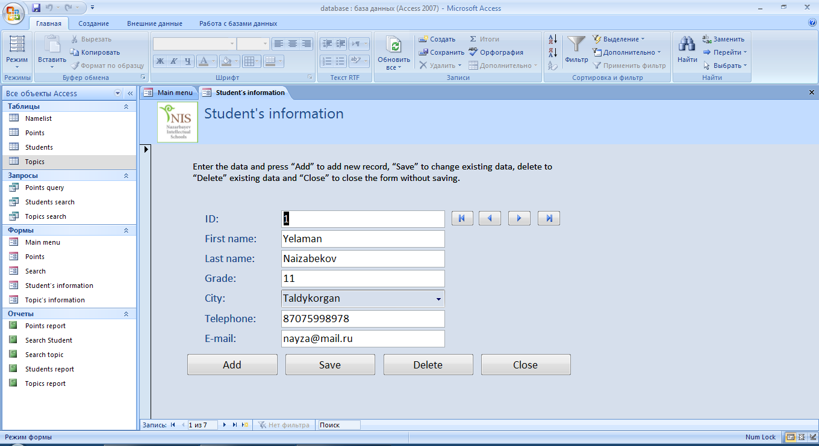

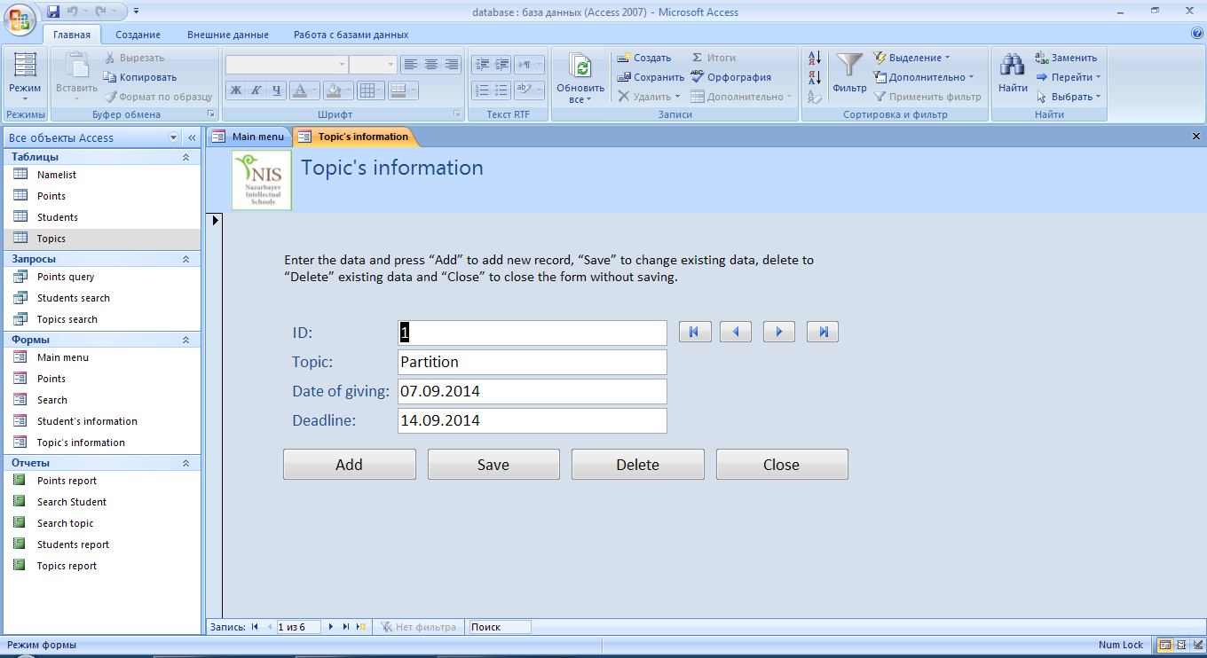

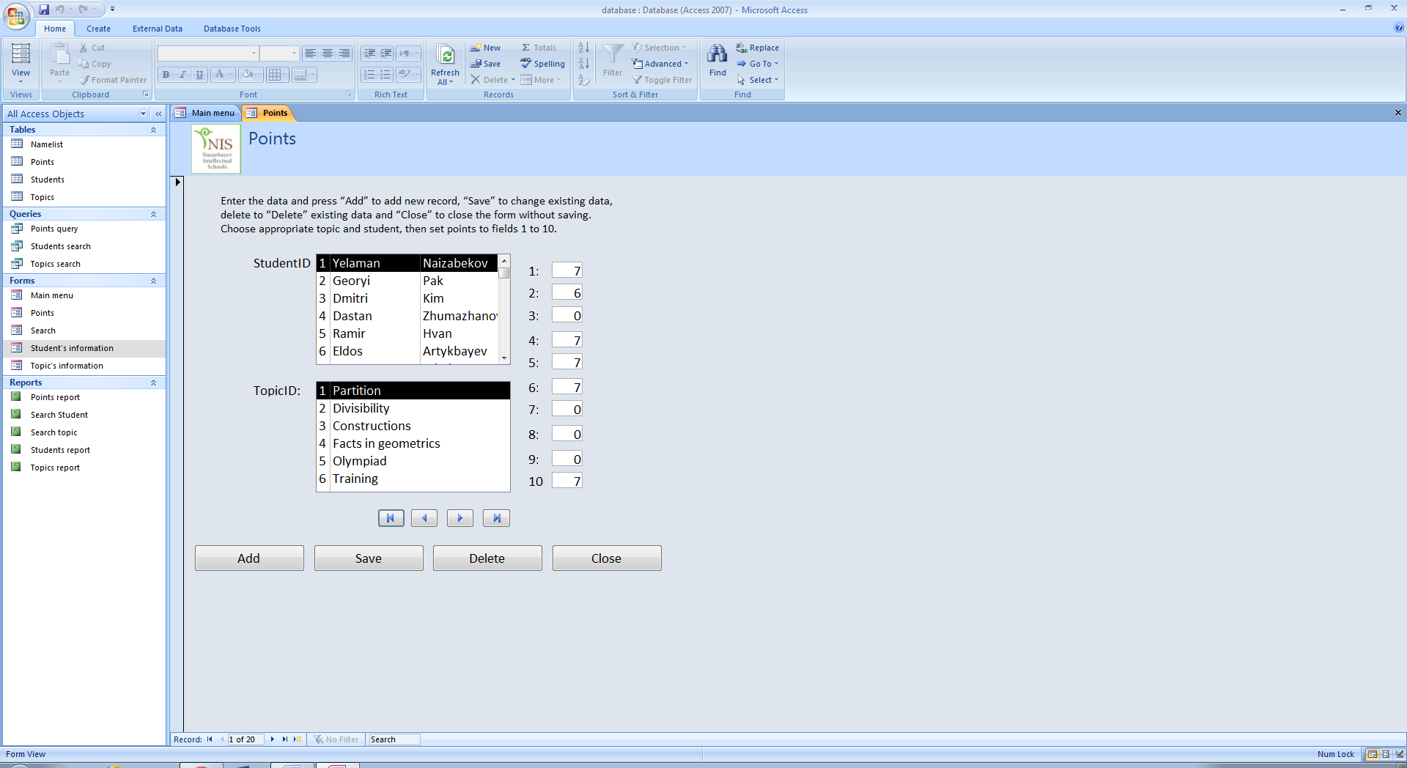

Each input form has buttons for navigating records, as shown below.

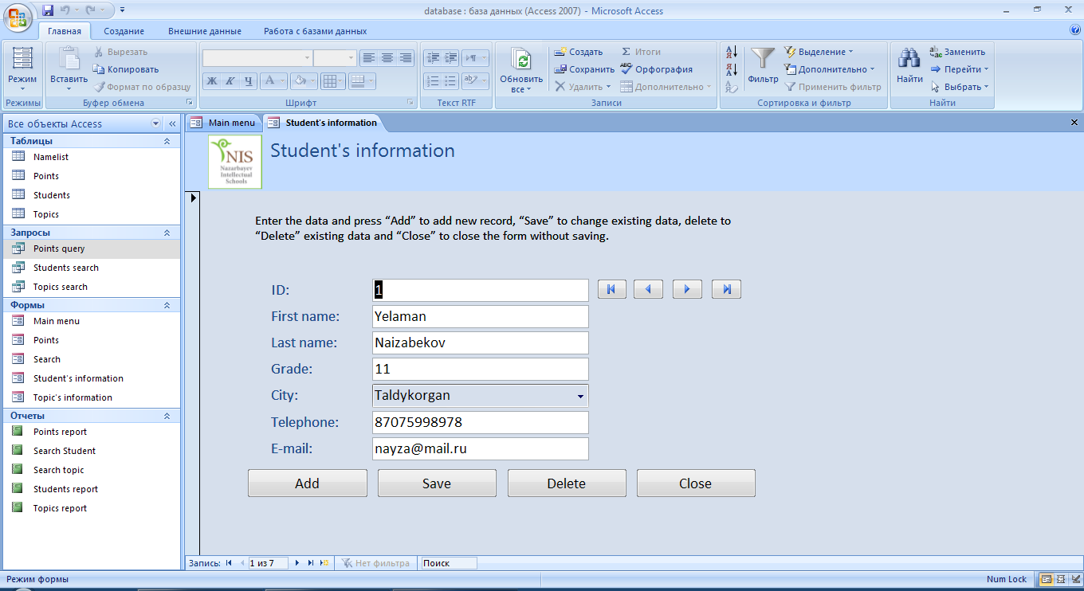

Click  to view the first record, click  to view the previous record, click  to view the next record, click  to view the last record.

Also, each input form contains buttons Add, Save, Delete and Close.



* Click Add to add new record. Then fill all fields correctly (you do not need to enter the primary key (ID) in input forms Student’s information and Topic’s information, the primary key will be entered automatically) and click Save to save changes or click close to come back to main menu without changes.
* After navigating and finding necessary record, you can change any information. After changing click or click close to come back to main menu without changes.
* Also, you can delete the record by clicking Delete
* Click Close to come back to main menu

There is some look up wizards in input form Student’s information. You can choose the city using look up wizard by clicking on button 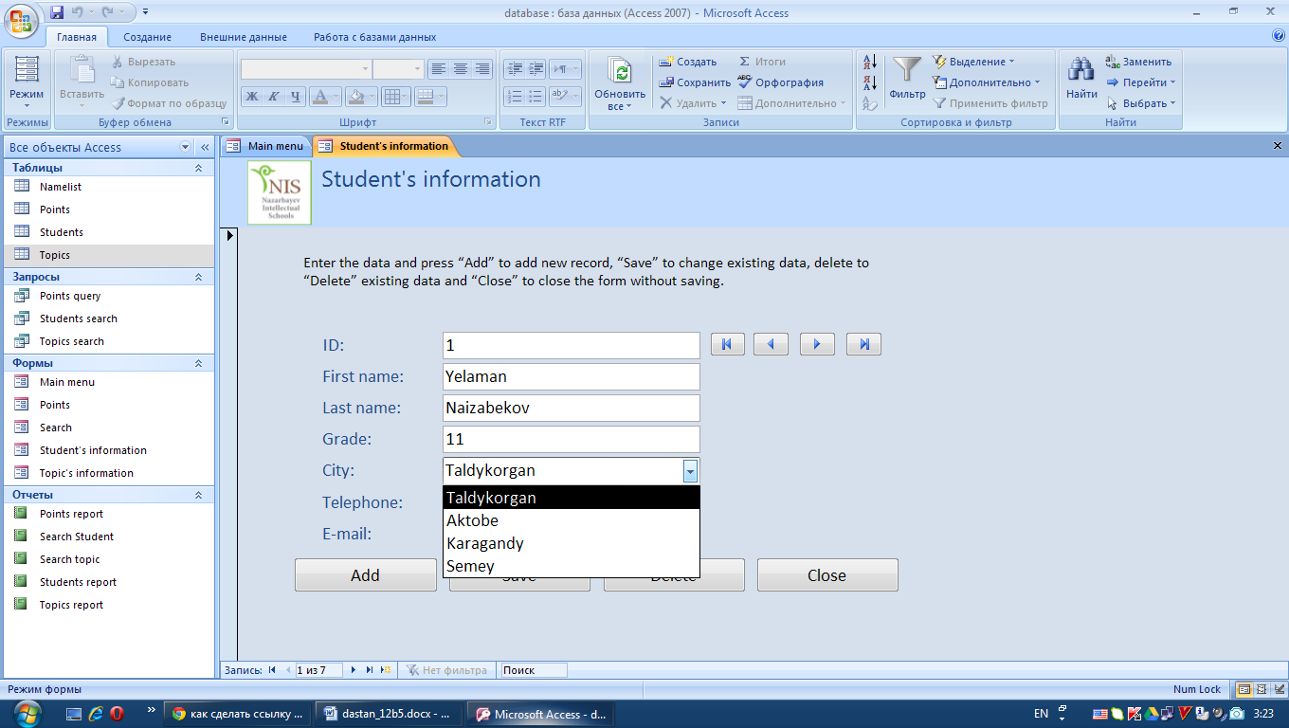.



There are some fields where you should choose the ID of student or topic in input form points.

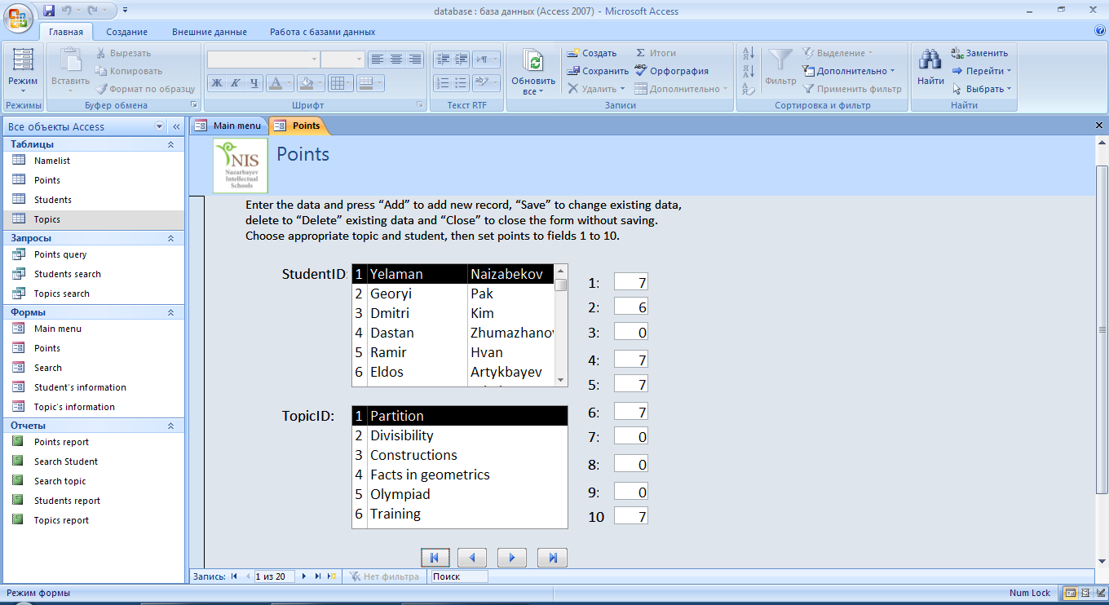

### Tables

There are three tables: Students, Topics, and Points.

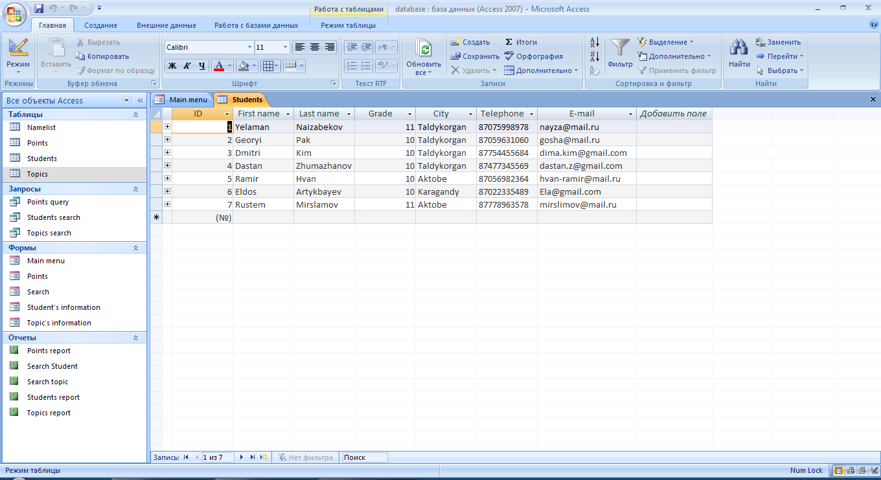

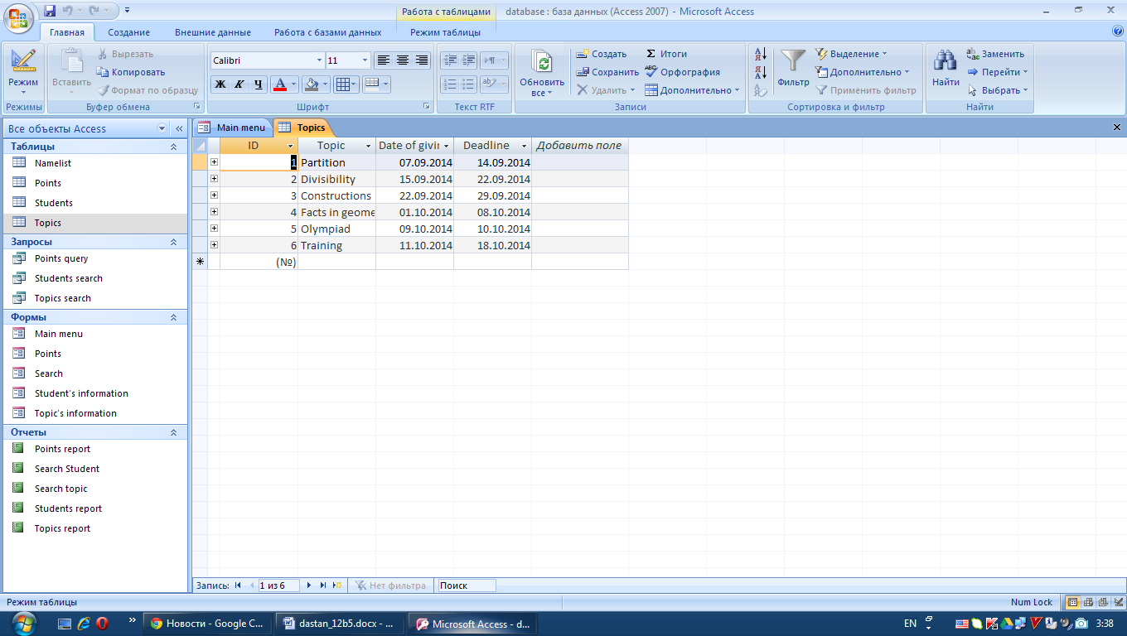

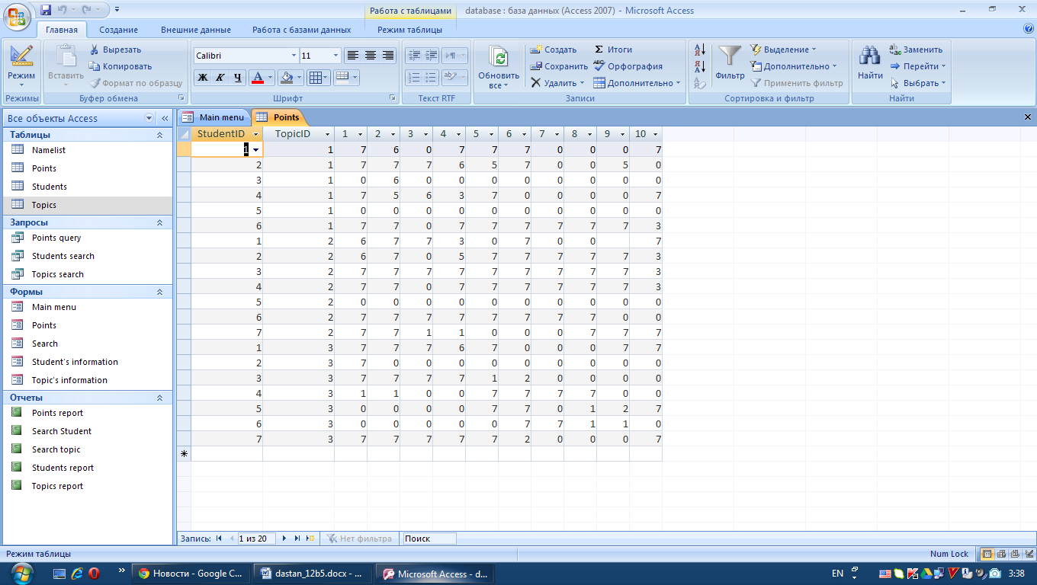

You can change records by using tables. All validation rules, input masks and look up wizards, which are used in input forms, are also used in tables. However, please, do not add new fields and do not change the names of fields or their properties.

To close the table and come back to main menu, click button , which is on right top of the table.

### Reports

There are three reports (report for each table), excluding reports about results of search: Students, Topics, and Points.

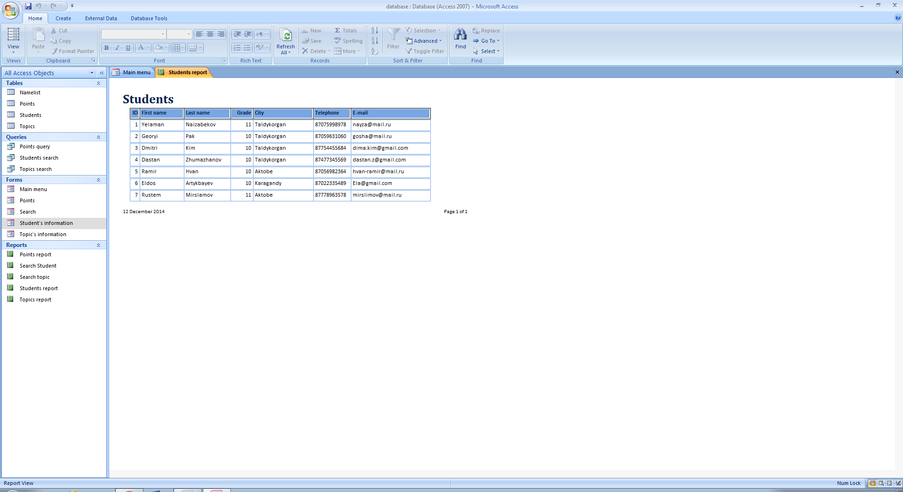

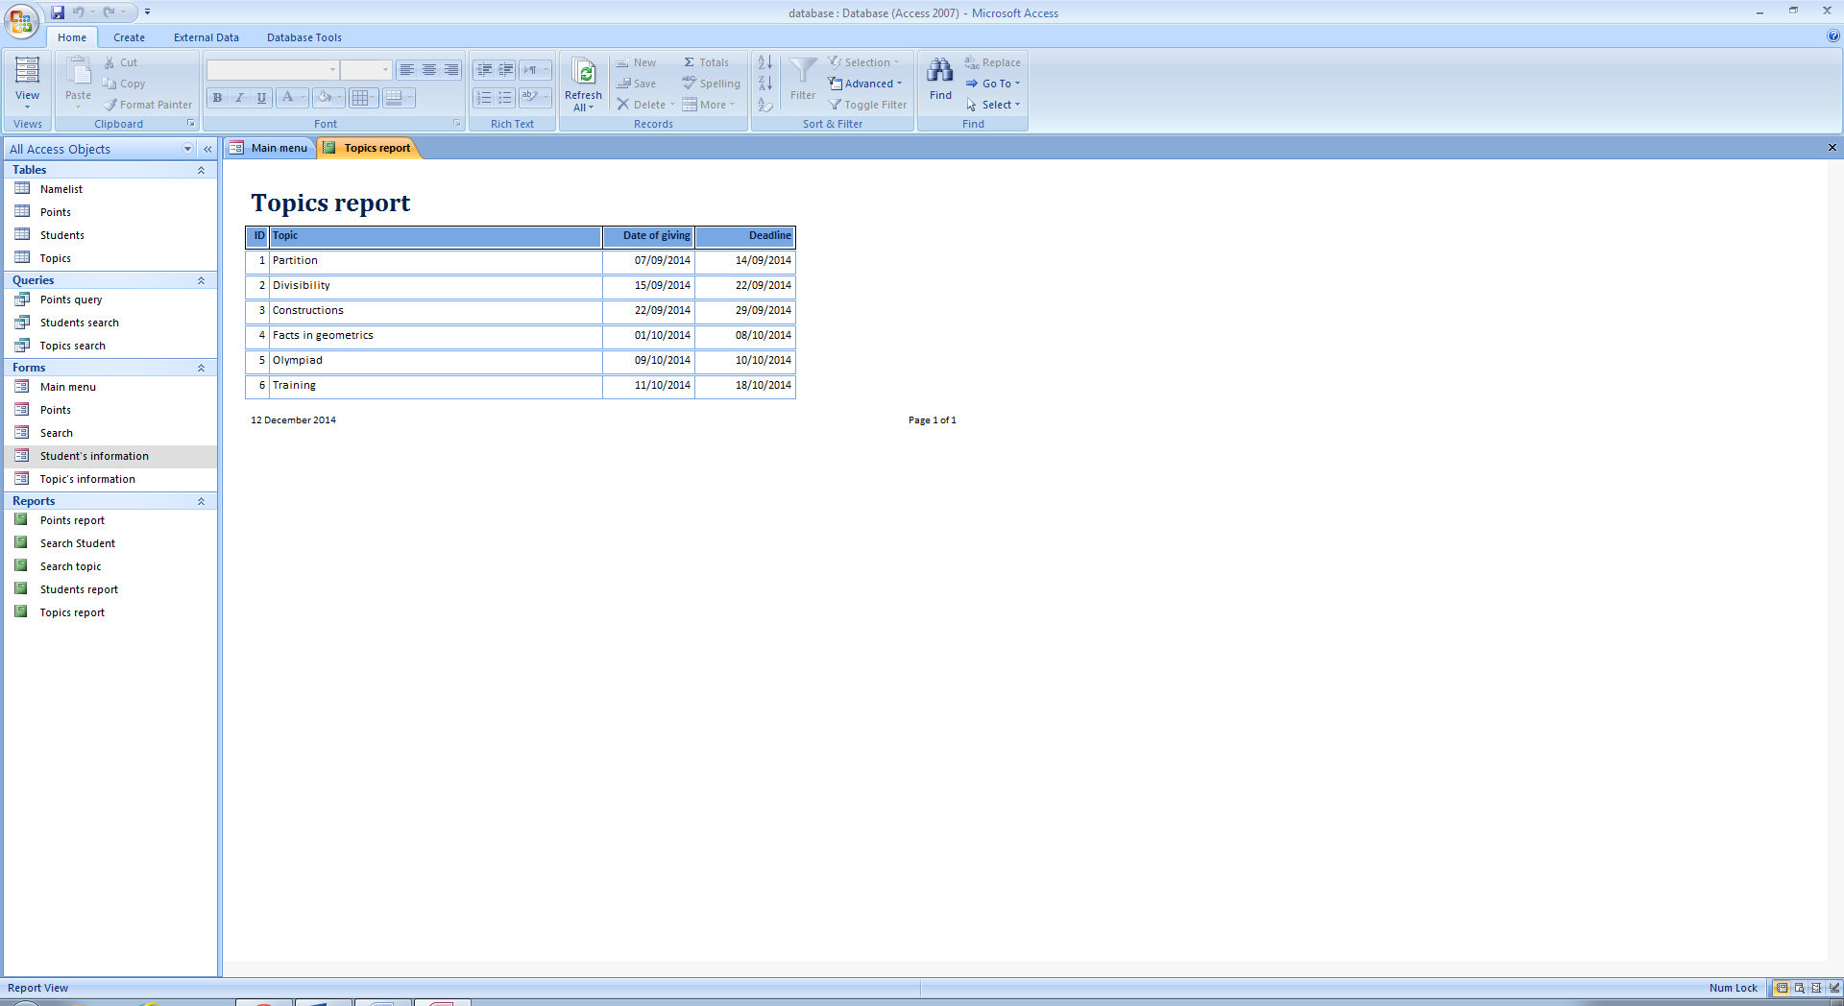

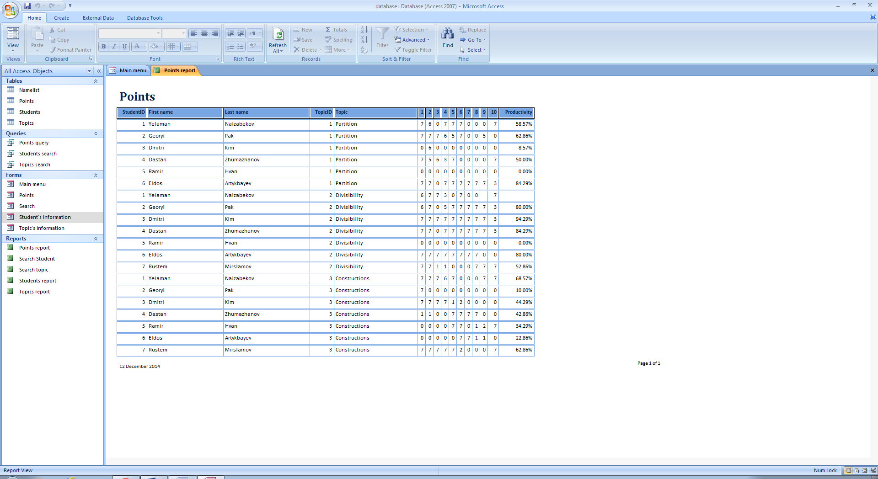

To close the report and come back to main menu, click button , which is on right top of the report. To print the report, come back to main menu and click button 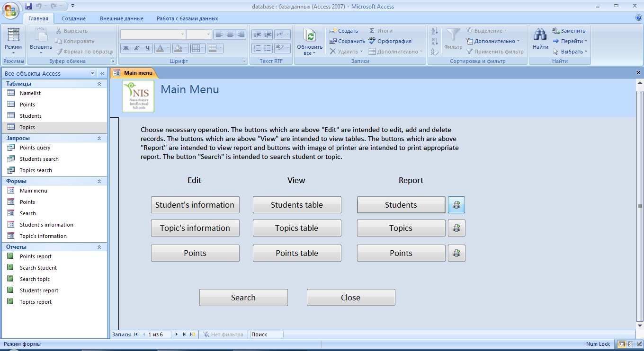 which is next to the button with the appropriate report.

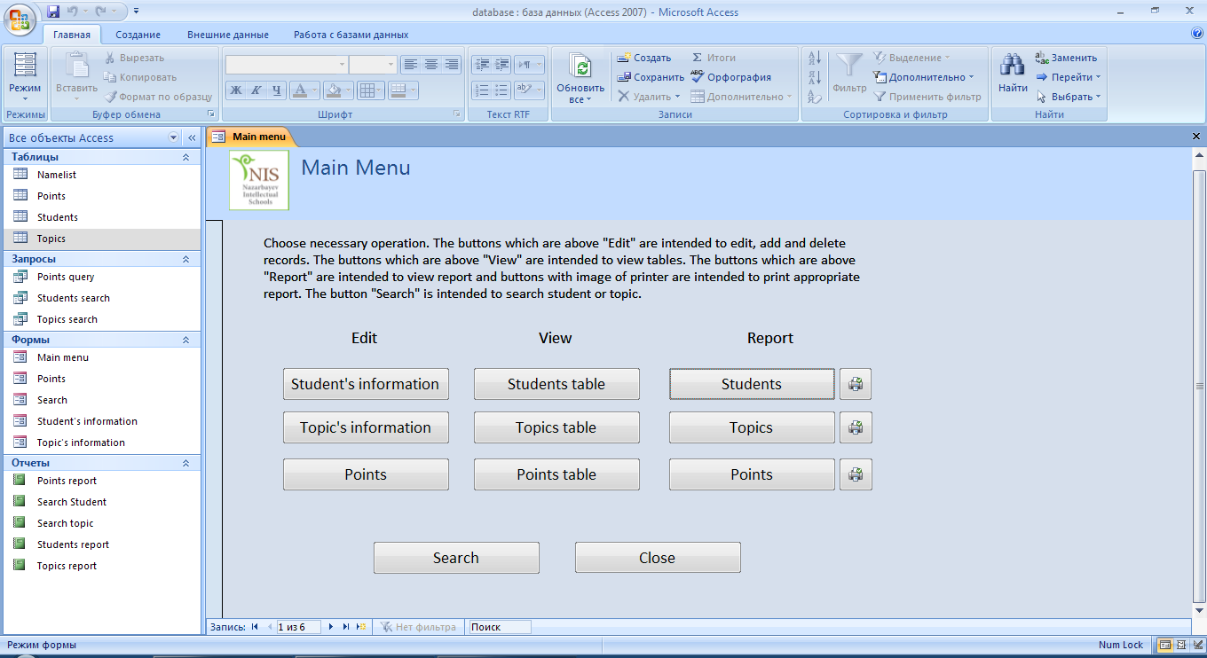

### Search form

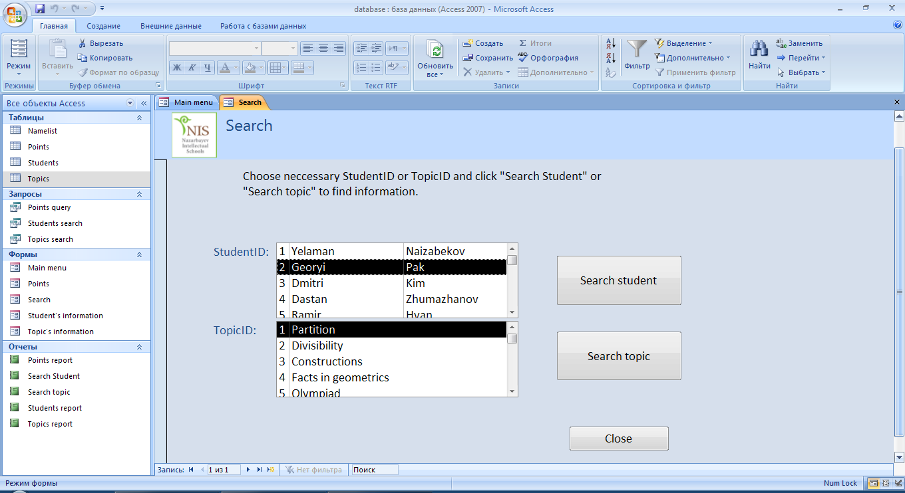

To search the student, choose appropriate Student ID and then click Search student. To search the topic, Choose appropriate Topic ID and then click Search topic. Click Close to come back to main menu. After clicking search student or table, you will see the report which contains the results of the search.

To close the report and come back to Search form click button , which is on right top of the report.

## Error Guide

|  |  |  |
| --- | --- | --- |
| **Error** | **Cause** | **Solution** |
| Message “Incorrect login or password!’” | The login or password which was entered in the log in form is incorrect | Click ok and try to enter correct login and password |
| Message “Incorrect current password!” | The current password which was entered in the change login and password form is incorrect | Click ok and enter the correct current password |
| Message “Enter the password!” | The password field was leaved empty | Click ok and enter the password |
| Message “Enter the login!” | The login field was leaved empty | Click ok and enter the login |
| Message “This login is busy!” | You entered exhausting login in Change login and password form or in Add new user form | Click ok and enter another login |
| Message “Grade should be a number between 6 and 12” | The grade ,which was entered in input form student’s information, is not appropriate to grade range | Click ok and enter the correct garde |
| Message “The telephone number should start with 87” | The telephone number is incorrect | Click ok and enter correct telephone number |
| Message “The text you entered is not an item in the list.” | Incorrect City | Choose the city from list |
| Message “The value you entered is not appropriate for input mask ‘0000000000’ specified for the field” | The telephone number is not correct | Enter the correct telephone number |
| Message “One or more values prohibited by the validation rule ‘Like “*@*.*” set for ‘Students.E-mail’.” | The e-mail address is not correct | Enter the right e-mail address |
| Message “The highest points is 7” | The entered points is higher than maximum points. | Click ok and enter the number which is less than 7 |
| Printer do not print the report | The printer is not connected or works incorrectly or there are incorrect settings of printer | Check the connection of printer, check settings and try again |

## Back-up

After the end of each week, after that you entered all points for week, you should do buck-ups. For it, you should find the folder of the system in your desktop, and click by right button of mouse. Then choose “Send to Dropbox”, then choose copy and replace, if it is necessary.

If you do not have dropbox, follow this link: https://www.dropbox.com/, register and install dropbox (follow all steps which give you dropbox).

You can download the system folder anytime and anywhere (with the internet). You should just go to https://www.dropbox.com/, log in, and click to download the folder. The folder will be downloaded as archive file, so, you need to unzip this file.

## Glossary

* Button – visible component of form which do operations after clicking on it
* Form – the window which has buttons and other components and which is intended to control the system
* Input form – specific type of form which is intended to change records
* Look up wizard – the list of possible answers
* Primary key – the unique code of each record
* Report – organized final output of the data
* Login – unique word of user to access
* Password - secret characters which supports the login

# EVALUATION

## Discussion of the degree of success in meeting the original objectives

Objectives:

1. Use understandable and easy interface to show forms and the data.
2. Provide operations such as adding records, deleting, editing.
3. Do automatic storage.
4. Create the data without duplication. There were many repetitions of the data in the current system, and my client had to write the data more times.
5. Use data verification and validation to avoid mistakes. There were too many mistakes because of absence validation in current system.
6. Provide effective and fast system.
7. Completely replace the current system with adding new operations and simplifying.
8. Automatically calculate average productivity. In current system client had to do all calculations manually.
9. Provide security method using login and password to enter the data. There were not security methods in current system, therefore the data was at risk.
10. To be able to do reports. The current system had not this function.

Evaluation:

The table below shows the degree of success in way to achieve the objectives from Design section. There are evaluation and evidence for each objective.

|  |  |  |
| --- | --- | --- |
| № | Evaluation | Evidence |
| 1 | All forms were made so that it is easy to use. There are short instructions for each form and all font sizes of texts are so that they can be easily seen. Not so many colors were used. I used buttons and edits, which do different functions, in forms, and put all components so that it was easy to notice and use. | Design (19-22), User documentation (88-94) |
| 2 | Each input form has buttons add, save, and delete. Each button does appropriate operation adding, saving edits, and deleting record. User can add or edit record by entering necessary information into fields. Also, user can delete the record by finding its primary key. | User documentation (92-94) |
| 3 | After closing the program all changes will be saved automatically. So, the user need not to do saving after closing the program. | User documentation (88-98) |
| 4 | The user can view the tables or can search the student or topic. That is why the user will see the duplications easy. And can delete if there are any duplications. Also the primary key is used. So, every record is unique. | Design (17-18) |
| 5 | Some look up wizards, validation rules and input masks were used were it is possible in input forms. Also, each field has data type, in order to make sure that the information which was entered complies with data type. So, the user will not make so many mistakes. For example, I used validation rule for points in points table. I wrote that it should be less than or equal to 7, because 7 is the heist point. | Development (46-50) |
| 6 | There were not any glitches when the system was used. All forms work. I used so few forms as it possible and there are not difficult operations. That is why the system is not so heavy program for Windows, and the system works fast. | Testing (61-76) |
| 7 | The client does not need to do manual calculations and use Microsoft Word which was used in the old system. So, completely replace the current system. And I added additional functions such as security method. It is login and password. Also, I added automatic calculation of productivity. | User documentation (88-98) |
| 8 | The new system automatically calculates the average productivity of each student for each topic. To do it, I wrote special code of calculating in new field in query wizard of Points table. | Development (52-56) |
| 9 | There are security methods. It is, the user must enter the login and password before getting access to the data base. The system finds the login of user in logins list , which is written in text file, then checks appropriate password, which is also written in passwords list in text file. The system will show the next form, if login and password of the user was found in lists. | User documentation (89) |
| 10 | The new system has buttons to do reports. The user can do report for each table. I added buttons with name Students, Topics and Points below the label “Reports” in the Main Menu form. These buttons do reports for appropriate tables Students table, Topics table, and Points table. Also there are buttons with image of printer next to each button for doing report, to print the appropriate report. | User documentation (96-97) |

Degree of success:

As it is shown above, all objectives were achieved. The new system meets all requirements. New functions and operations were added, and the new system can do automatic calculations such as productivity of student. The user can do search by using search form. So, the project was successful.

## Evaluate the client’s and user’s response to the system

Client’s recall letter:

The recall letter from my client is shown below. In this case, the client and user are the same person.

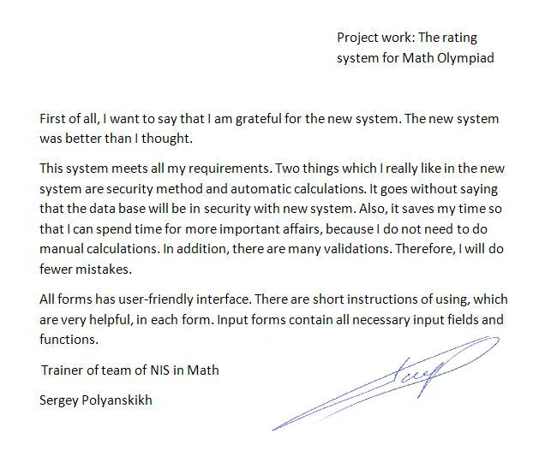

Analysis of client's response:

The client has used the new system for one week. The system is not so big and difficult, that is why the client had enough time to check all functions and to test. After testing, we discussed about the new system and I asked the client to write recall. He wrote a recall letter, which is shown above. There were not any questions and faults of using.

According to his recall, he is satisfied with new system and the system meets all his requirements. It was written in the first paragraph.

The client wrote that all requirements were achieved. Security method and automatic calculations were the main two things which the client likes. He emphasized that the data base will be in security with security method, and automatic calculations will save his time. Also, he said that thanks to validation, he will not do so many mistakes.

According to client’s response, the interface and design of the system are user-friendly, and short instructions are very helpful. The client said that all input fields and tables contain necessary fields and buttons.

The client wrote the recall letter 17 December of 2014. According to client’s recall, the next items were stated:

* The client grateful for the system. “I am grateful for the new system”. For it, I achieved all objectives and user requirements.
* The new system complies with all requirements. “This system meets all my requirements”. I read carefully every item of user requirement and then build the system according to these items.
* Security method was successful. “It goes without saying that the data base will be in security with new system”. Ito achieve it, I did so that when the user run the system, he or she should enter the login and password.
* Automatic calculations are very useful. “It saves my time so that I can spend time for more important affairs, because I do not need to do manual calculations”. I used formulas and wrote it in query wizards.
* Validations are very helpful. “There are many validations. Therefore, I will do fewer mistakes”. I used validation rules where it is possible.
* Interfaces of forms are friendly. “All forms has user-friendly interface”. I put all buttons and other components so that it is easy to use, and used not so many colors in order to do the system simple.
* Instructions, which exist in each form, are also helpful. “There are short instructions of using, which are very helpful, in each form”. I put short instruction in label in each form. These instructions show the function of each button.
* Input forms contain all necessary fields. “Input forms contain all necessary input fields and functions”. I created edits for all necessary information. I chose necessary information from the old system.

**APPENDIX A**

## Objectives of the data

* Use understandable and easy interface to show forms and the data.
* Provide operations such as adding records, deleting, editing.
* Do automatic storage.
* Create the data without duplication. There were many repetitions of the data in the current system, and my client had to write the data more times.
* Use data verification and validation to avoid mistakes. There were too many mistakes because of absence validation in current system.
* Provide effective and fast system.
* Completely replace the current system with adding new operations and simplifying.
* Automatically calculate average productivity. In current system client had to do all calculations manually.
* Provide security method using login and password to enter the data. There were not security methods in current system, therefore the data was at risk.
* To be able to do reports. The current system had not this function.

Objectives of the data were discussed with me and I agree with objectives of the data.

Sergey Polyanskih